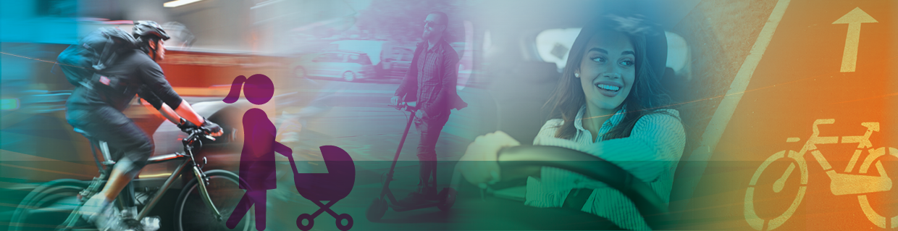****

**Sett inn riktig frise her via «Sett inn -> «Forside»**

Attitudes towards road pricing and road tolls

Survey design and data description

Askill Harkjerr Halse, Alice Ciccone, Olivia Potash

2062/2023

**Form/Check List for TØI Report**

Dette skjemaet skal følge hver rapport fram til den foreligger ferdig trykket. Konsulenten som er gitt ansvaret for fremstillingen av rapporten, har ansvaret for at opplegget for fremstillingen blir fulgt.

|  |  |  |  |  |  |  |  |  |  |  |
| --- | --- | --- | --- | --- | --- | --- | --- | --- | --- | --- |
| **Prosjektnr.** | | 5000 | | | | | | | | |
| **Prosjektleder** | | Alice Ciccone | | | | | | | | |
| **Kvalitetsansvarlig** | | Kvalitetsansvarlig | | | | | | | | |
| **Oppdragsgiver(e)** | | Norges forskningsråd | | | | | | | | |
|  | | | | | | | | | | |
| **Rapportens tittel** | | Attitudes towards road pricing and road tolls. Survey design and data description | | | | | | | | |
| **Forfatter(e)** | | Askill Harkjerr Halse, Alice Ciccone, Olivia Potash | | | | | | **Rapport nr.** | 2062/2023 | |
|  | | | | | | | | | | |
| Standardrapport | | | | |  | |
| Særskilt utforming | | | | |  | |
| Samarbeid med andre | | | | |  | |
|  | | | | | | | | | | |
| Utgis kun i elektronisk utgave | | | | |  | |
| Utgis både i elektronisk- og papirutgave | | | | |  | |
|  | | | | | | | | | | |
| Antatt sideantall | | | | | 66 | |
| Eksemplarer sendes oppdragsgiver (standard 25) | | | | |  | |
|  | | | | | | | | | | |
| Rapporten er: | | | | | | | | | | |
| **Offentlig** | **Konfidensiell** | | **Eventuell sperrefrist for offentliggjøring** | | | | | | | **Frigitt - dato** |
|  |  | |  | | | | | | | Sett inn frigitt dato |
|  | | | | | | | | | | |
| **Kvalitetssjekk** | | | | **Ansvarlig** | | **Kvalitetssjekk** | | | | |
| Seniorkonsulent | | | | KFM | | 30.10.2024, Kamilla Flem Mathisen | | | | |
|  | | | | LK | | 14.10.2024 Lana Krehic | | | | |
| Forskningsleder/kvalitetsansvarlig | | | | Sett inn initialer | | Sett inn dato og fullt navn når kvalitetssikret | | | | |
| Avdelingsleder | | | | TMD | | 09.11.2024 | | | | |
| Lest av oppdragsgiver | | | | Sett inn initialer | | Sett inn dato og fullt navn når kvalitetssikret | | | | |
| Administrerende direktør | | | | BJG | | Sett inn dato og fullt navn når kvalitetssikret | | | | |

|  |  |
| --- | --- |
| **Sjekkliste TØI-rapport** | **Annen informasjon** |
| **Forside** | **Kryss av**  *Forside* |
| Rapportnummer |  |
| Årstall |  |
| Tittel evt. undertittel |  |
| Forfattere |  |
| Oslo dato og årstall |  |
| **Faktaside + registreres i Rappark** | **Kryss av** |
| Tittel |  |
| Forfatter(e) |  |
| Rapportnummer |  |
| Oslo, dato og årstall |  |
| Antall sider |  |
| ISBN nummer (elektronisk og evt. trykket) |  |
| ISSN 2535-5104 (elektronisk og evt. trykket) |  |
| Finansieringskilde(r) |  |
| Prosjektnr. og navn |  |
| Prosjektleder |  |
| Emneord (iht. bibl. emneordliste) |  |
| Language of report | Language of report |
| **Forord** | **Kryss av** |
| Oslo dato og årstall |  |
| Administrerende direktør |  |
| Avdelingsleder/forskningsleder |  |
| **Innholdsfortegnelse** | **Kryss av** |
| Sammendrag / summary |  |
| Kapittelnavn og sidenr. |  |
| **Sammendrag og Summary** | **Kryss av** |
| Rapportnr. og årstall |  |
| Forfatter(e) |  |
| Oslo årstall antall sider |  |
| Bunnteksten med copyright |  |
| **Annet** | **Kryss av** |
| Kildehenvisninger tabeller og figurer |  |
| Figurer er ikke koblet |  |
| Spor endringer viser ikke kommentarer |  |
| Gule lapper sjekket og evt. fjernet |  |
| Copyright bunntekst rapportsidene + år |  |
| Nummerering av sidene |  |
| Gule lapper sjekket og evt fjernet |  |
| Overføre rapporten til TOIARKIV |  |
| Er evt datafiler overført til datarkiv |  |
| Er lagt ut på TØIs internettside |  |

|  |  |
| --- | --- |
| **Title:** | Attitudes towards road pricing and road tolls. |
| **Tittel:** | Holdninger til veiprising og bompenger. Undersøkelsesopplegg og beskrivelse av data |
| **Author:** | Askill Harkjerr Halse, Alice Ciccone, Olivia Potash |
| **Date:** | 11.2024 |
| **TØI Report:** | 2062/2023 |
| **Pages:** |  |
| **ISSN Electronic:** | 2535-5104 |
| **ISBN Electronic:** | 978-82-480-2306-7 |
| **Project Number:** | F. eks. NFR + prosjektnummer, skill med komma |
| **Funded by:** | Norges forskningsråd |
| **Project:** | 5000 – Prosjekttittel |
| **Project Manager:** | Alice Ciccone |
| **Quality Manager:** | Kvalitetsansvarlig |
| **Research Area:** | Velg et element. |
| **Keywords:** | Hentes fra Rappark, skill med komma |



|  |  |
| --- | --- |
| **Summary** | **Kort sammendrag** |
| In this report, we document the design and data collection and present selected results of a large survey on support for universal distance-based road pricing in Norway. Many respondents are negative towards universal road pricing and do not expect the policy to have positive effects. Still, slightly more respondents are positive towards road pricing than towards current road tolls. Attitudes vary considerably by gender, education, travel mode and political party. Interestingly, many respondents seem quite uninformed about what they currently pay in road tolls. We also evaluate the representativeness of the survey and discuss implications. | I denne rapporten dokumenterer vi utformingen og datainnsamlingen, samt presenterer utvalgte resultater fra en stor undersøkelse om oppslutningen om allmenn distansebasert veiprising i Norge. Mange respondenter er negative til universell veiprising og forventer ikke at politikken vil ha positive effekter. Likevel er litt flere positive til veiprising enn til dagens bompenger. Holdningene varierer betydelig etter kjønn, utdanning, reisemåte og politisk parti. Interessant nok virker mange respondenter ganske uinformerte om hva de i dag betaler i bompenger. Vi vurderer også hvor representativ undersøkelsen er og diskuterer implikasjoner av dette. |

Preface

This study is part of a larger project, Acceptable PoLicies for the optimAl balaNce between driving and activE Transport (A-PLANET), founded by the Norwegian Research Council (FRIPRO 315490). A-PLANET focuses on addressing the tradeoff between policy effectiveness and acceptability in the transport sector, in search of an optimal balance. This is an interdisciplinary project aiming at filling important knowledge gaps within the fields of transport, behavioral, environmental and political economics.

This report is the result of work carried out in working package 2, which focuses on investigating policy acceptability through online choice experiments, in order to map factors that help improve the likelihood of success of policy implementation.

Senior research economist Alice Ciccone (project leader) and Chief research economist Askill H. Halse (work package leader) and Olivia Potash have worked on this project. Askill and Alice have designed the survey in collaboration with Alberto Antonioni and Francesca Lipari from University Carlos III in Madrid, collected the data in Norway and contributed to the analysis and writing of this report. Olivia S. Potash contributed with the translation, data analysis and writing of this report during her visiting period in Oslo as part of the Valle Scholarship and Scandinavian Exchange Program. We wish to thank research economist Lana Krehic for the good feedback and quality check.

Oslo, Month/Year  
Institute of Transport Economics

Bjørne Grimsrud Trine Dale  
Managing Director Director of Research

Contents

**Summary**

**Sammendrag**

1 Introduction 1

1.1 Background 1

1.2 Purpose of the report 1

1.3 Limitations 2

1.4 Structure of the Report 2

2 Survey design 3

2.1 Structure of the questionnaire 3

2.2 Geography and travel behavior 3

2.3 Choice experiment 3

2.4 Attitudinal questions 3

2.5 Sociodemographic characteristics 5

3 Data collection 6

3.1 Pilot survey in Norway 6

3.2 Main survey in Norway 7

3.3 Data cleaning and filtering 8

4 Results 9

4.1 Basic sample characteristics 9

4.2 Geography and travel behavior 13

4.3 Attitudinal questions 24

5 Conclusion and discussion 38

5.1 Summary of results 38

5.2 Discussion 39

5.3 Further Research 40

References 41

Appendix 42

Exhibit 1. Questionnaire 42

Exhibit 2. Official statistics 53

Exhibit 3. Supplemental Figures 54



ENGLISH Summary

|  |
| --- |
| Attitudes towards road pricing and road tolls |
| Survey design and data description |
| TØI Report 2062/2023 • Authors: Askill Harkjerr Halse, Alice Ciccone, Olivia Potash • Oslo 2024 • pages |
|  |

In this report, we document the design and data collection and present selected results of a large survey on support for universal distance-based road pricing in Norway. In the pilot survey, a link to the questionnaire was shared on social media (Facebook). In the main survey, a sample of Norwegian individuals were recruited using the population register. The main survey sample is quite representative of the Norwegian population, but there is a slight over-representation of urban residents, people with high education and income and voters of environmental parties. Many respondents are negative towards universal road pricing and do not expect the policy to have positive effects. Still, slightly more respondents are positive towards road pricing than towards current road tolls. Attitudes vary considerably by gender, education, travel mode and political party. Interestingly, many respondents seem quite uninformed about what they currently pay in road tolls.

Road tax reform is high on the political agenda in Norway and other European countries. This report documents the results from a study on public support for universal distance-based road pricing and attitudes towards transport policies more generally. This is the first time such a survey has been conducted in Norway. This data has been and will be utilized in several publications. The objectives of this report are:

1. Document the survey design and data collection
2. Describe the samples in terms of socio-demographic characteristics
3. Show descriptive results regarding location of the trip, travel behavior and road toll costs (self-reported and calculated)
4. Show descriptive results on attitudes towards road pricing and road tolls as well as other political views
5. Evaluate the representativeness of the samples and discuss implications for survey methodology

Attitudes towards road tax reform must be interpreted in light of the policies currently in place. In Norway, car drivers pay road tolls on many trips, both in urban areas and on inter-urban highways. In the questionnaire, we remind respondents about the current policies and explain how universal road pricing will replace these. Since opposition towards road pricing could potentially be related to concerns about distributional effects and privacy, we include questions about attitudes towards inequality and trust in institutions.

Our questionnaire was developed for a similar study in Spain (Madrid) and revised in several rounds. The final questionnaire consists of the following parts:

1. Introductory questions about place of residence and car ownership
2. A simplified travel survey about a typical daily trip
3. Questions about perception of and attitudes towards economic inequality
4. Introduction to road pricing and a stated choice experiment with different road pricing policies
5. Questions about voting behavior, trust in institutions and attitudes towards transport pricing policies
6. Questions about socio-demographic characteristics

In this report, we do not show the results from the stated choice experiment (d) but focus on travel behavior and attitudes towards transport pricing policies more generally.

We first carried out two pilot surveys in Madrid, then one pilot survey in Norway prior to the main survey in Norway. The pilot survey in Norway was carried out using a sponsored post on Facebook. This means that potential respondents could have gotten information about the survey either because they were targeted by the sponsored post or because someone in their network shared it or interacted with it. In the main survey, we contacted a representative sample from the Norwegian population register, using the e-mail register of the Directorate of Digitalization (*Kontaktregisteret).*

The net samples included 3,839 respondents for the main survey in Norway and 1,719 respondents for the pilot survey in Norway. Because of the recruitment method used in the pilot, this sample is unlikely to be representative of the population. We therefore focus on the main survey when presenting the results. However, since we have a considerable sample size also in the pilot, and because there could be benefits from combining different data collection strategies, we compare the two samples in terms of sample characteristics and selected results.

Representativeness of our net samples

* The net sample in the main survey is fairly representative for the Norwegian population in terms of gender and average age. The net sample in the pilot, on the other hand, has a vast majority of male respondents, and the average age is also somewhat higher than the national average. The net samples in both surveys have an overrepresentation of those who are employed, have high income or education, do not have children and live in Oslo or neighboring regions. This over-representation is more severe in the pilot sample.
* The main survey is more representative than the pilot when it comes to mode of transport. Compared to the National Travel Survey the main sample is somewhat overrepresented by public transport, while the pilot survey is overrepresented by private car driving and biking.
* Respondents who did not vote in the previous election are strongly underrepresented in both samples, compared to official election statistics. Among those who voted, the survey from the main sample has a slight over-representation of voters for left-wing and/or environmental parties. The pilot sample is more “polarized” as it has an over-representation of both voters who support an environmental party and voters who support a party labeled as populist (The Progress Party and the Industry and Business Party).

Results: Travel behavior and mode access

* The majority of pilot and main survey respondents own or have access to a car. However, household car ownership/access is slightly underrepresented in the main survey compared to the national average according to other sources.
* In the pilot survey, 72% of respondents use a private car for their reported daily trip. In contrast, 56% of the main survey respondents use a private car.
* Car is the dominant (more than 50%) mode share for workplace trips in both surveys.
* 13% of the main survey respondents, and 18% in the pilot, state they have no alternative transportation mode for their trip. Among private car and motorcycle/moped users who do have an alternative option, 63% of main survey respondents (53% of pilot) indicate that the alternative is “somewhat” or “much worse” than their usual mode.
* Slightly less than half of main and pilot survey respondents who use a private car pay road tolls on their daily trip according to the road toll calculator from AutoSync (formerly Fremtind Service). When asked what they pay in road tolls, respondents from the main survey tend to report higher tolls than what the calculator suggests (see Figure S 1).

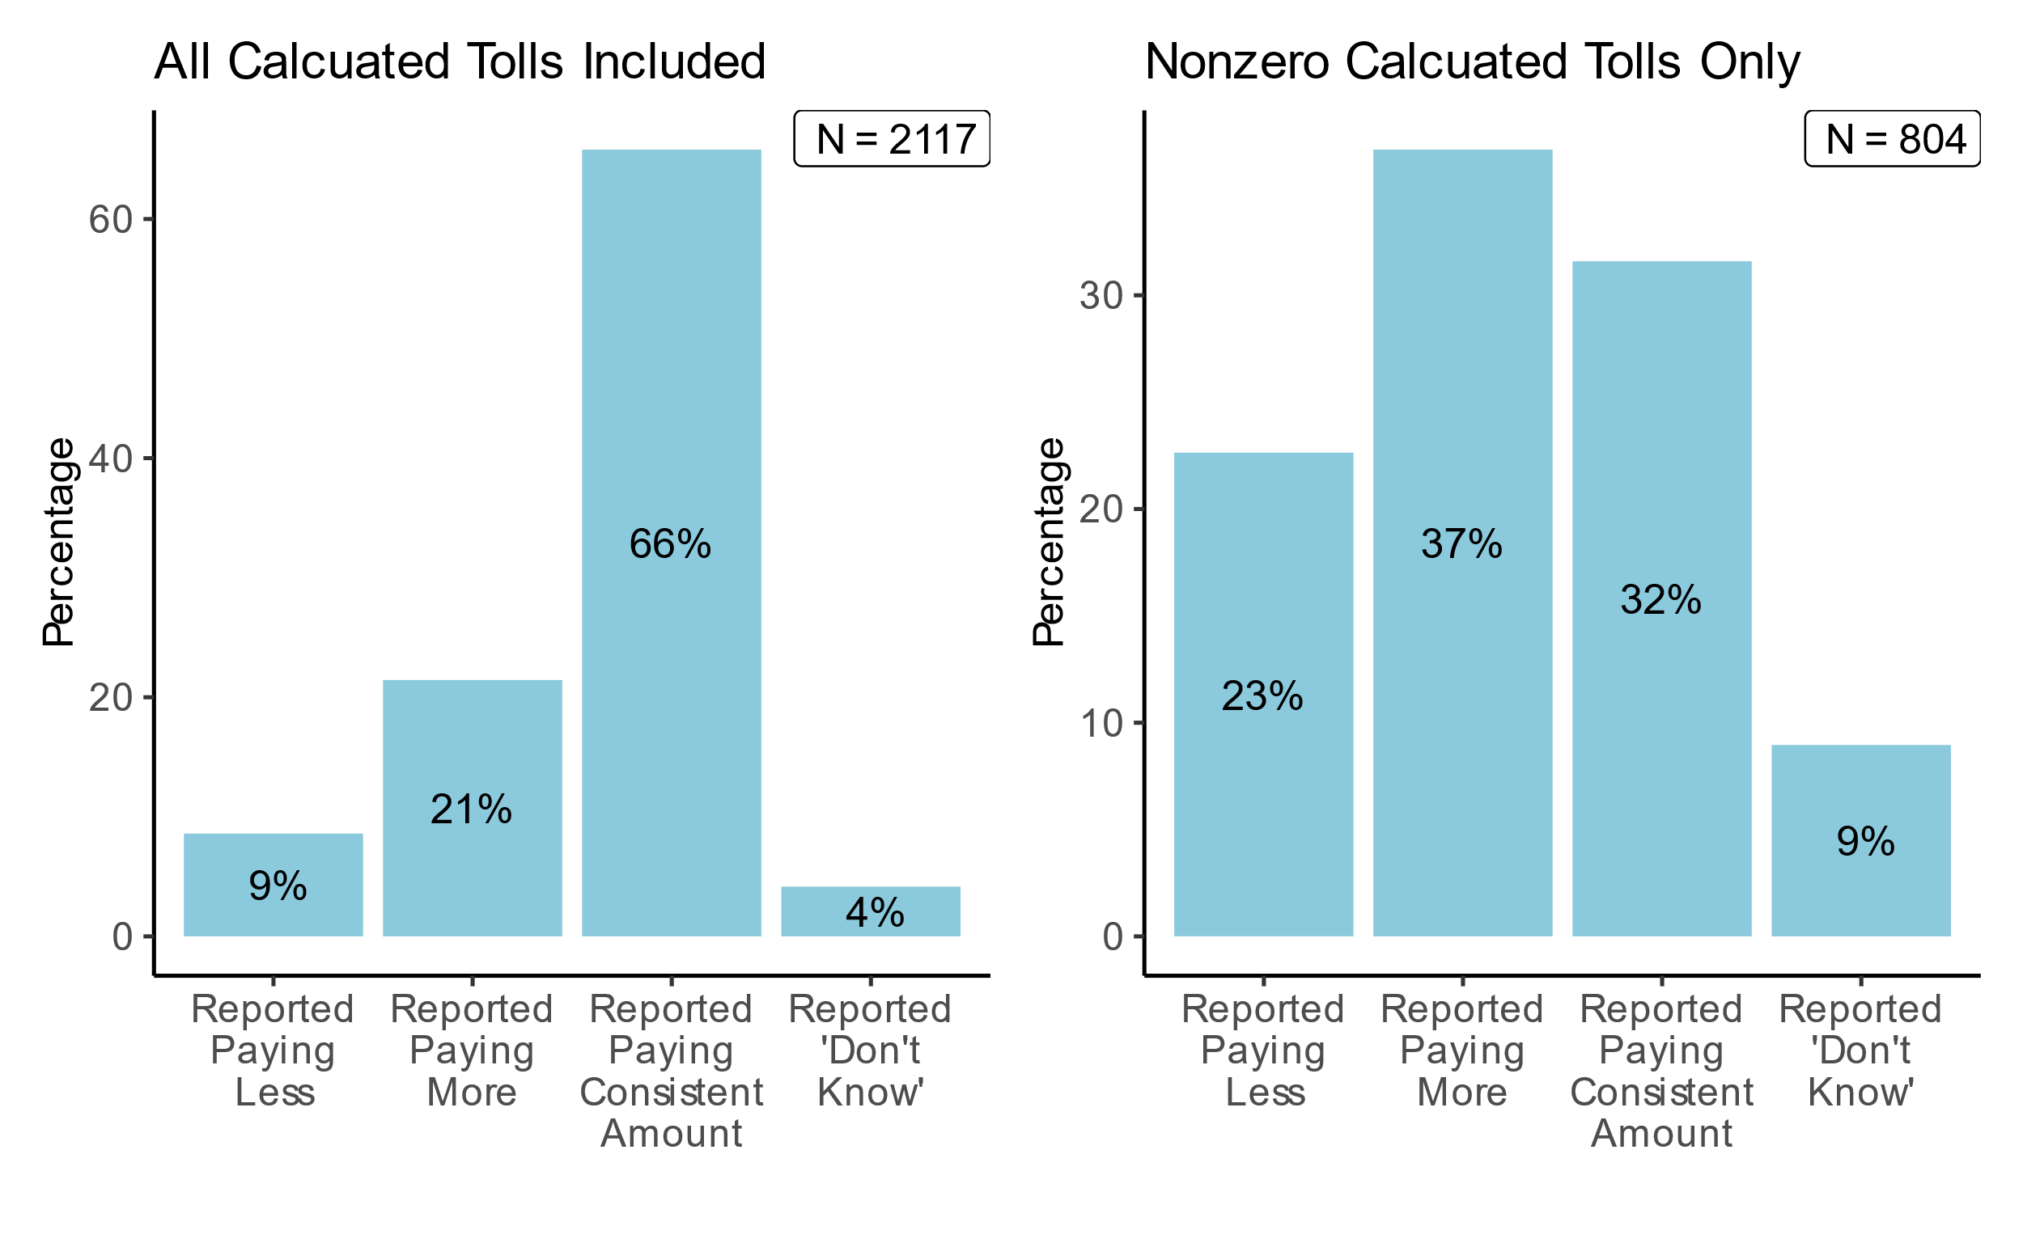

Figure S 1: Share of consistency in self-reported toll costs compared to calculated toll costs in the main survey, based on the road toll calculator from Fremtind Service. Car drivers only.

Results: Political views, attitudes toward inequality and trust

* There are large differences between the pilot and main survey regarding political views and attitudes, also when gender representation is considered.
* Concerning economic inequality, about half of the respondents think that Norway is a society where most people are in the middle of the distribution. When asked about how society should be, the vast majority want a society where most people are in the middle or near the top. Those who vote for populist parties tend to think that society is more unequal.
* Concerning trust in institutions, the main survey respondents on average have higher trust in the respective institutions than the pilot survey respondents. Both survey samples tend to have relatively lower trust in politicians and higher trust in other authorities and institutions (see Figure S 2).

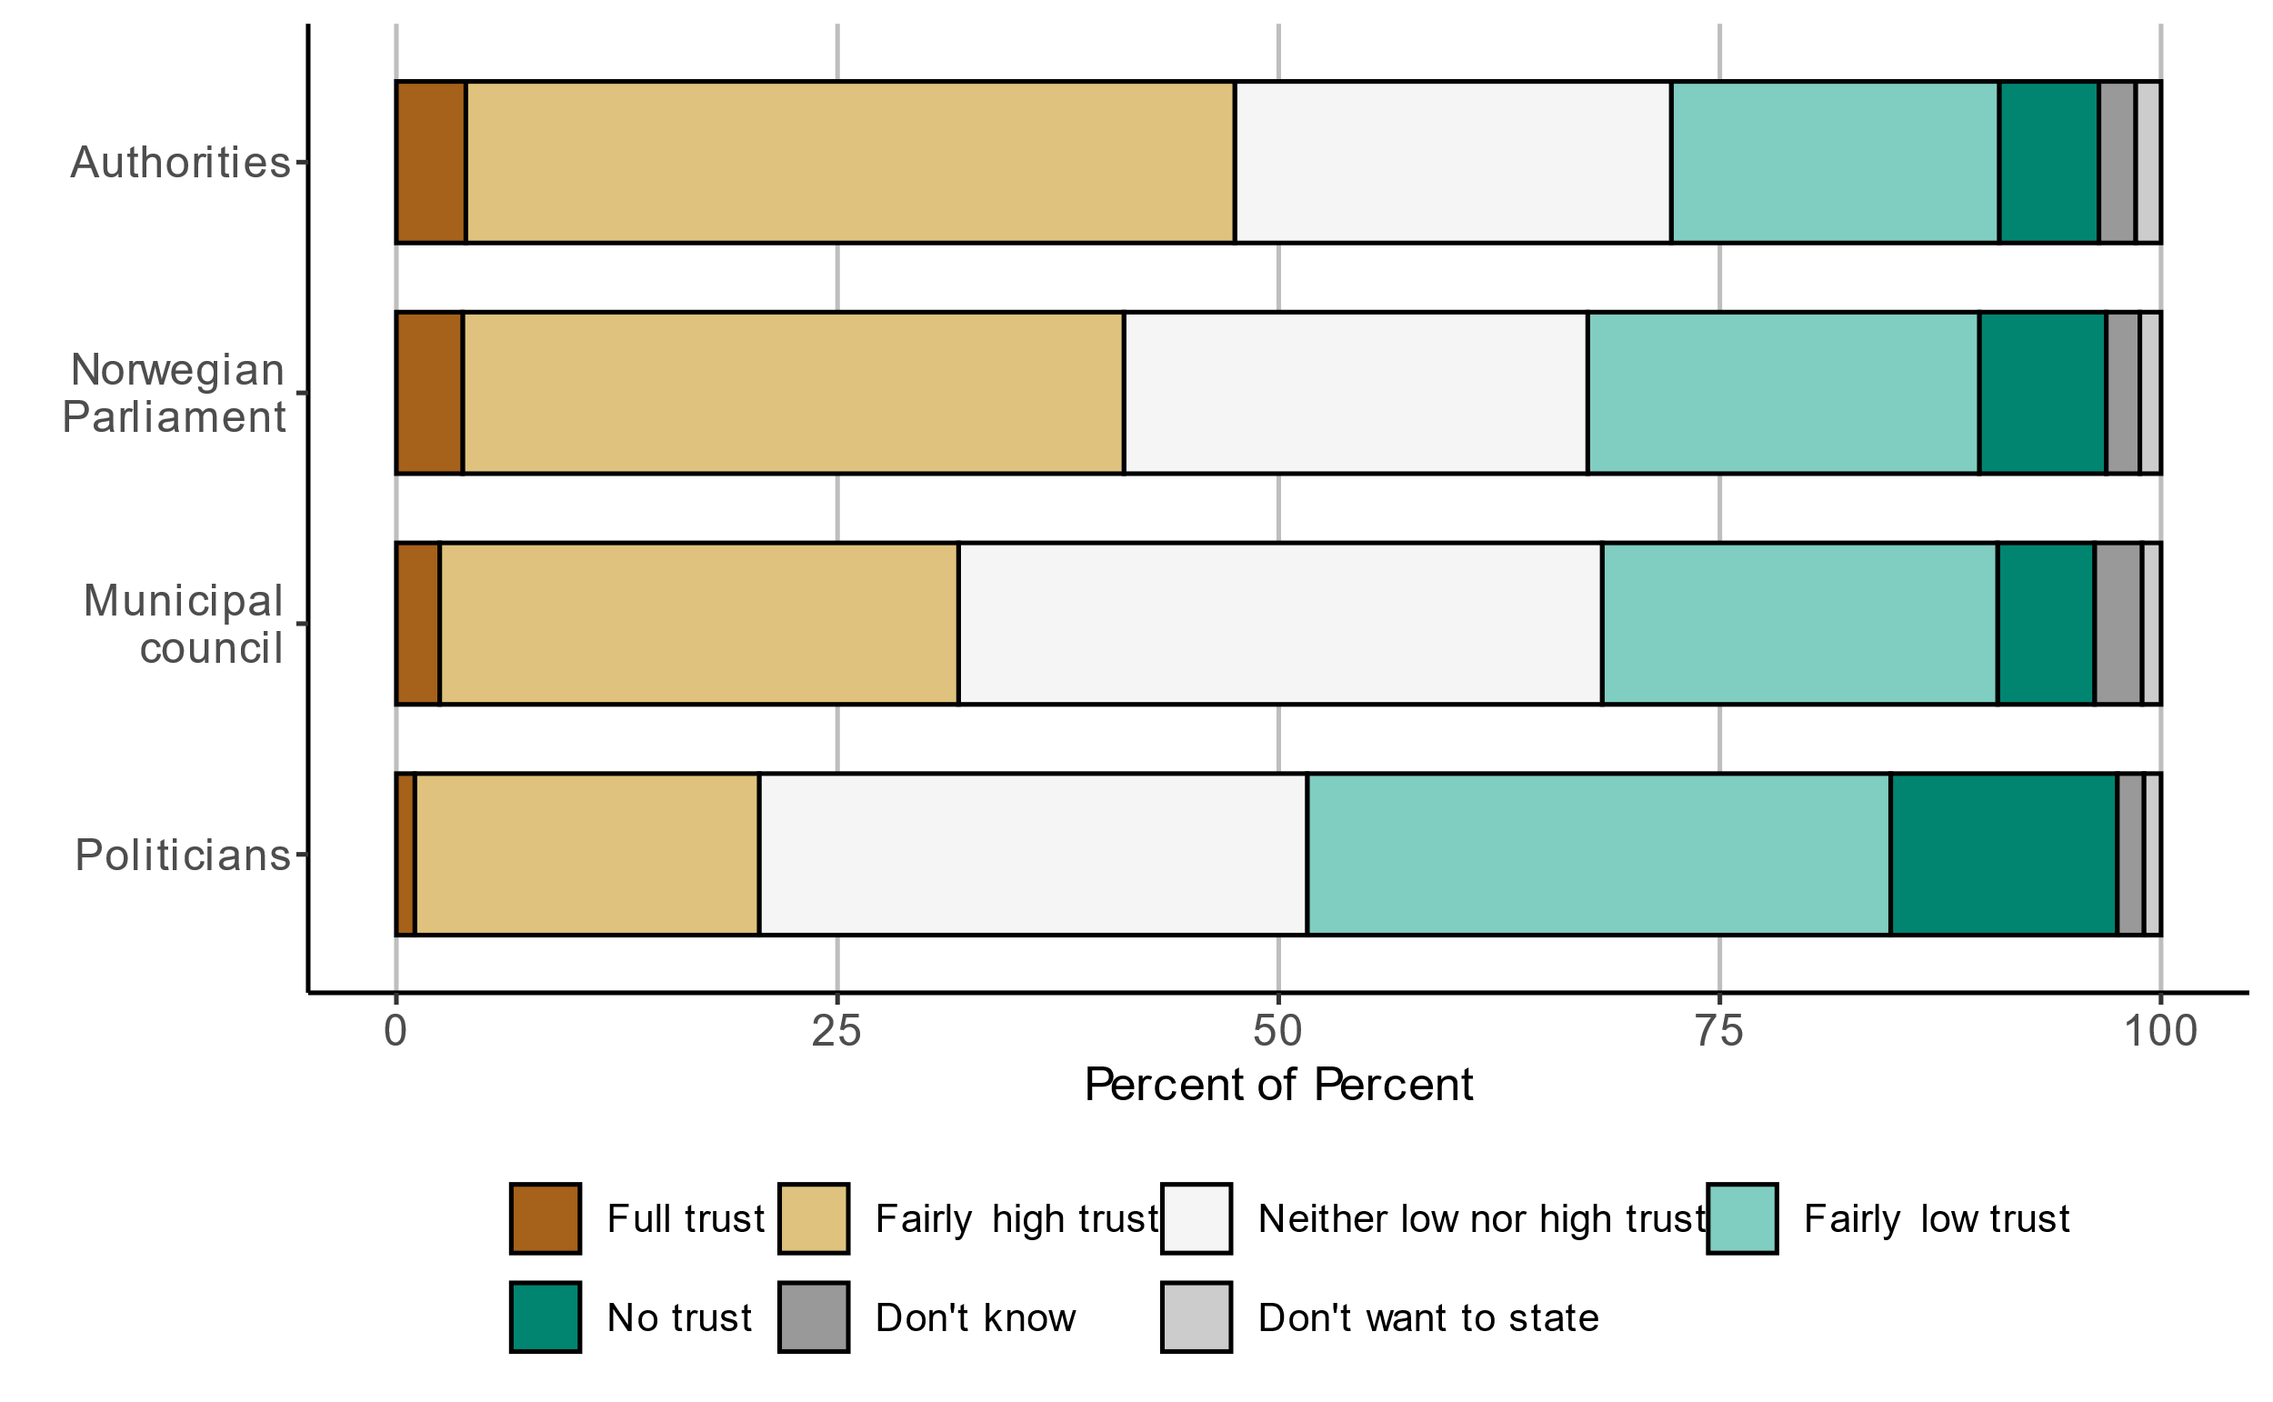

Figure S 2: Trust in institutions for the main survey.

Results: Attitudes toward transport pricing policies

* A considerable share of respondents do not think that road pricing will reduce traffic congestion problems, local air pollution and greenhouse gas emissions.
* The majority of respondents indicate that they believe people with low incomes will be most negatively impacted by road pricing.
* Many respondents are negative towards both universal road pricing and current road tolls. The share that is very or somewhat positive is slightly higher for road pricing than current road tolls (see Figure S 3). However, the share that is very negative is also higher. Men are more negative than women towards both polices.
* Those who vote for the populist party bloc indicate more negative attitudes towards both road pricing and the toll system, compared to respondents who vote for the other party blocs.
* Transport mode is strongly correlated with attitudes toward policies: car drivers are the least positive, while public transit riders, pedestrians and cyclists are more positive overall towards road pricing and road tolls.
* Those with lower education are more negative towards road pricing.
* Most respondents prefer that road pricing revenues are spent on road investments, followed by investments in public transport, walking and cycling.

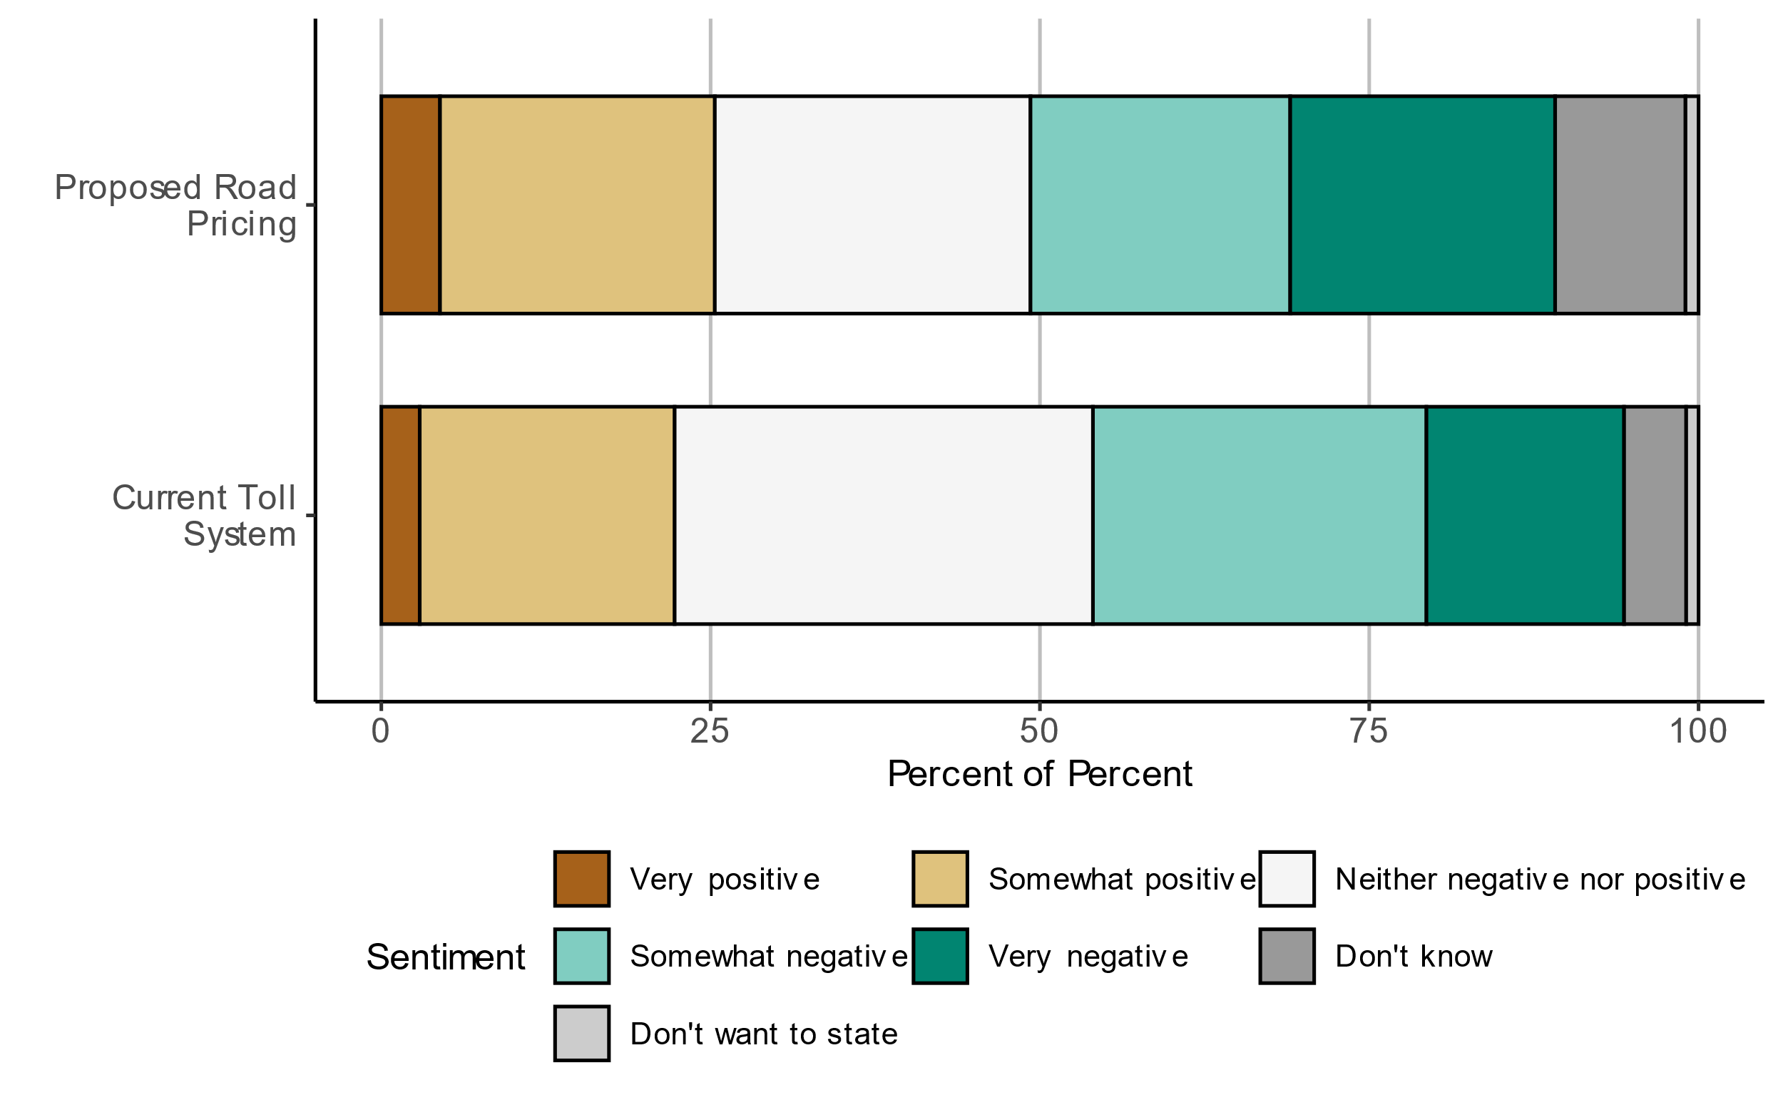

Figure S 3: Attitudes towards the road pricing proposal and the current toll system.

Conclusions

Our results suggest that opinions on road tolls and road tax reform are quite divided. Many respondents are negative towards both the current road tolls and universal road pricing, and do not expect road pricing to have positive effects. Respondents who for instance have low education, drive a car on their daily trip or vote for populist parties are more negative towards road tolls and road pricing with low education. Given that these groups are somewhat underrepresented in our sample, opposition towards these policies in the population is likely to be somewhat stronger in the general population. However, there is also a large group of respondents who are undecided towards road pricing or road tolls, or do not know what their opinion is. Moreover, respondents are slightly more positive towards road pricing than the current road tolls. This is interesting given that about half of car drivers do not pay road tolls today, while everyone would have to pay something under universal road pricing.

Attitudes towards both road pricing and road tolls vary considerably by gender, education, travel mode and political party. Among car drivers, there is no clear tendency that those who pay high road tolls today are more in favor of replacing road tolls with road pricing. However, these findings are just bivariate correlations, not causal relationships. In future work, one should look more closely into causal explanations of support for or opposition against road pricing, and what this implies for the prospects of a road tax reform being successful. Interestingly, not all drivers seem to be aware of what they pay in road tolls, which could have implications both for travel behavior and public support.

We have also compared the characteristics of the net samples of the pilot survey and main survey. As pointed out above, the recruitment method of the pilot survey is unlikely to lead to a representative net sample. In terms of observable characteristics, those with high income and education and those who vote in elections are overrepresented in both net samples. On the other hand, the samples are quite different with respect to travel behavior and party support. This can only partly be explained by the fact that men are highly overrepresented in the net sample from the pilot survey.



NORSK Sammendrag

|  |
| --- |
| Holdninger til veiprising og bompenger |
| Undersøkelsesopplegg og beskrivelse av data |
| TØI rapport 2062/2023 • Forfattere: Askill Harkjerr Halse, Alice Ciccone, Olivia Potash • Oslo, 2024 • sider |
|  |

I denne rapporten dokumenterer vi utformingen og datainnsamlingen, samt presenterer utvalgte resultater, fra en stor undersøkelse om oppslutningen om allmenn distansebasert veiprising i Norge. I pilotundersøkelsen ble en lenke til spørreskjemaet delt på sosiale medier (Facebook). I hovedundersøkelsen ble et utvalg norske personer rekruttert ved hjelp av Folkeregisteret. Nettoutvalget i denne undersøkelsen er ganske representativt for den norske befolkningen, men det er en liten overrepresentasjon av urbane innbyggere, personer med høy utdanning og inntekt og velgere som stemmer på miljøpartier. Mange respondenter er negative til universell veiprising og forventer ikke at politikken vil ha positive effekter. Likevel er litt flere positive til veiprising enn til dagens bompenger. Holdningene varierer betydelig etter kjønn, utdanning, reisemåte og politisk parti. Interessant nok virker mange respondenter ganske uinformerte om hva de i dag betaler i bompenger.

Reform av veiavgiftene står høyt på den politiske dagsorden i Norge og andre europeiske land. Denne rapporten dokumenterer resultatene fra en studie om norske innbyggeres oppslutning om allmenn avstandsbasert veiprising og holdninger til transportpolitikk mer generelt. Dette er første gang en slik undersøkelse er gjennomført i Norge. Disse dataene har blitt, og vil bli, brukt i flere publikasjoner. Målene med denne rapporten er:

1. Dokumentere undersøkelsens utforming og datainnsamling
2. Beskrive utvalgene med hensyn til sosiodemografiske kjennetegn
3. Vis resultater med hensyn til reisested, reiseadferd og bompenger (selvrapportert og beregnet)
4. Vise resultater om holdninger til veiprising og bompenger samt andre politiske synspunkter
5. Vurdere representativiteten til utvalgene og diskutere implikasjoner for undersøkelsesmetodikk

Holdninger til nye veiavgifter må tolkes i lys av dagens politikk. I Norge betaler bilreisende bompenger på mange turer, både i byområder og på motorveier mellom byer. I spørreskjemaet minner vi respondentene om gjeldende politikk og forklarer hvordan allmenn veiprising vil erstatte disse. Siden motstand mot veiprising potensielt kan relateres til bekymringer for fordelingseffekter og personvern, inkluderer vi spørsmål om holdninger til ulikhet og tillit til institusjoner.

Spørreskjemaet vårt ble utviklet for en tilsvarende studie i Spania (Madrid) og revidert i flere runder. Det endelige spørreskjemaet består av følgende deler:

1. Innledende spørsmål om bosted og bileierskap
2. En forenklet reiseundersøkelse om en typisk daglig reise
3. Spørsmål om oppfatning av og holdninger til økonomisk ulikhet
4. Introduksjon til veiprising og et samvalgseksperiment med ulike veiprisingsalternativer
5. Spørsmål om stemmeatferd, tillit til institusjoner og holdninger til transportprispolitikk
6. Spørsmål om sosiodemografiske kjennetegn

I denne rapporten viser vi ikke resultatene fra samvalgseksperimentet (d), men fokuserer på reiseatferd og holdninger til transportprispolitikk mer generelt.

Vi gjennomførte først to pilotundersøkelser i Madrid, deretter en pilotundersøkelse i Norge før hovedundersøkelsen i Norge. Pilotundersøkelsen i Norge ble gjennomført ved hjelp av et sponset innlegg på Facebook. I hovedundersøkelsen kontaktet vi et representativt utvalg fra Det norske folkeregisteret, ved hjelp av Kontaktregisteret til Digitaliseringsdirektoratet*.*

Det nettoutvalget bestod av 3 839 respondenter for hovedundersøkelseog 1 719 respondenter for pilotundersøkelsen i Norge. Siden vi har en betydelig utvalgsstørrelse i piloten, og fordi det kan være fordeler ved å kombinere ulike datainnsamlingsstrategier, presenterer vi resultater fra begge undersøkelsene. Men ettersom utvalget i hovedundersøkelsen ser ut til å være mer representativt, legger vi mer vekt på dette når vi diskuterer funnene våre.

Representativiteten i nettoutvalgene våre

* Nettoutvalget i hovedundersøkelsen er nokså representativt når det gjelder kjønn og gjennomsnittsalder på respondentene, . Pilotutvalget har derimot et stort flertall av mannlige respondenter, og gjennomsnittsalderen er også noe høyere enn landsgjennomsnittet. Begge utvalgene er noe overrepresentert av sysselsatte, høytlønnede, høyt utdannede uten barn bosatt i Oslo eller nærområdene. Denne overrepresentasjonen er sterkere i pilotutvalget.
* Hovedundersøkelsen er mer representativ enn piloten når det gjelder reisemåte. Sammenliknet med Den nasjonale reisevaneundersøkelsen er hovedutvalget noe overrepresentert av kollektivtransport, mens pilotundersøkelsen er overrepresentert av personbilkjøring og sykling.
* Respondenter som ikke stemte ved forrige valg er sterkt underrepresentert i begge utvalgene, sammenlignet med offisiell statistikk. Blant de som stemte, har nettoutvalget til hovedundersøkelsen t en liten overrepresentasjon av velgere som stemmer på venstreorienterte partier og/eller miljøpartier. Pilotutvalget er mer «polarisert», på den måten at det har en overrepresentasjon både av velgere som støtter et miljøparti og velgere som støtter et parti som er definert som populistisk (Fremskrittspartiet og Industri- og Næringspartiet).

Resultater: Reiseatferd og modustilgang

* Flertallet av respondentene i pilot- og hovedundersøkelsen eier eller har tilgang til bil. Husholdningenes bileierskap/tilgang er imidlertid litt lavere i hovedundersøkelsen sammenlignet med landsgjennomsnittet ifølge andre kilder.
* I pilotundersøkelsen bruker 72 % av respondentene privatbil på den daglige turen som de har oppgitt. I hovedundersøkelsen bruker 56 % privatbil.
* Bil er det dominerende (mer enn 50 %) transportmiddelet på arbeidsreiser i begge undersøkelsene.
* 13 % av respondentene i hovedundersøkelsen, og 18 % i piloten, oppgir at de ikke har noen alternativ transportmåte for reisen. Blant privatbil- og motorsykkel-/mopedbrukere som har et alternativ, indikerer 63 % av respondentene i hovedundersøkelsen (53 % i piloten) at alternativet er "noe" eller "mye verre" enn deres vanlige modus.
* I underkant av halvparten av respondentene i hoved- og pilotundersøkelsen som bruker privatbil betaler bompenger på sin daglige tur, ifølge bompengekalkulatoren fra AutoSync (tidligere Fremtind Service). Når de blir spurt hva de betaler i bompenger, oppgir respondentene fra hovedundersøkelsen gjerne høyere bompenger enn det kalkulatoren antyder (se Figur S 1).



Figur S 1: Grad av konsistens mellom selvrapporterte bompengekostnader og beregnede bompengekostnader i hovedundersøkelsen, basert på bompengekalkulatoren fra AutoSync. Kun bilførere.

Resultat: Politiske synspunkter, holdninger til ulikhet og tillit

* Det er store forskjeller mellom pilot- og hovedundersøkelsen når det gjelder politiske synspunkter og holdninger, også når en tar hensyn til kjønnsfordeling.
* Når det gjelder økonomisk ulikhet, mener om lag halvparten av respondentene at Norge er et samfunn der folk flest befinner seg midt i fordelingen. På spørsmål om hvordan samfunnet bør være, ønsker de aller fleste et samfunn der folk flest er i midten eller nær toppen. De som stemmer på populistiske partier har en tendens til å mene at samfunnet er mer ulikt.
* Når det gjelder tillit til institusjoner, har respondentene i hovedundersøkelsen i gjennomsnitt høyere tillit til de aktuelle institusjonene enn respondentene i pilotundersøkelsen . I begge er tilliten typisk lavereFigur S ).



Figur S 2: Tilliten til institusjoner i hovedundersøkelsen.

Resultater: Holdninger til prising av transport

Holdningsspørsmål til transportpolitikk er annerledes i piloten enn i hovedundersøkelsen. Hovedundersøkelsen inneholder forbedrede spørsmål s, og vi fokuserer derfor på hovedundersøkelsen for følgende resultater:

* En betydelig andel av respondentene tror ikke at veiprising vil redusere problemer med køproblemer, lokal luftforurensning og klimagassutslipp.
* Flertallet av respondentene indikerer at de tror personer med lav inntekt vil påvirkes mest negativt av veiprising.
* Mange respondenter er negative til både allmenn veiprising og dagens bompenger. Andelen som er svært eller ganske positiv er litt høyere for veiprising enn dagens bompenger, se Figur S 3. Andelen som er veldig negativ er imidlertid også høyere. Menn er mer negative enn kvinner til begge virkemidlene.
* De som stemmer på den populistiske partiblokken har mer negative holdninger til både veiprising og bompengesystemet enn de som stemmer på de andre partiblokkene.
* Reisemåte er sterkt korrelert med holdninger til politikk: bilsjåfører er minst positive, mens kollektivpassasjerer, fotgjengere og syklister generelt er mer positive til veiprising og bompenger.
* De med lavere utdanning er mer negative til veiprising. Personer med grunnskole som høyeste utdanning Er underrepresentert.
* De fleste respondentene i hovedundersøkelsen foretrekker at inntektene fra veiprising brukes på veiinvesteringer, etterfulgt av investeringer i kollektivtransport, gange og sykkel.



Figur S 3: Synspunkter på forslaget om allmenn veiprising og dagens bompengesystem.

Konklusjoner

Resultatene våre tyder på at meningene om bompenger og veiskattereform er ganske delte. Mange respondenter er negative til både dagens bompenger og allmenn veiprising, og forventer ikke at veiprising vil ha positive effekter. Gitt at utvalget fra hovedundersøkelsen har en liten overrepresentasjon av urbane innbyggere og velgere som stemmer på miljøpartier, vil motstanden mot denne politikken i befolkningen som helhet sannsynligvis være noe sterkere. Det er imidlertid også en stor gruppe respondenter som verken er positive eller negative til veiprising eller bompenger, eller som ikke vet hva de mener. Dessuten er respondentene litt mer positive til veiprising enn dagens bompenger. Dette er interessant, gitt at omtrent halvparten av bilførerne ikke betaler bompenger i dag, mens alle vil måtte betale noe ved allmenn veiprising.

Holdningene til både veiprising og bompenger varierer mye etter kjønn, utdanning, reisemåte og politisk parti. Blant bilførere er det ingen klar tendens til at de som betaler høye bompenger i dag er mer positive til å erstatte bompenger med veiprising. Disse funnene er imidlertid bare bivariate korrelasjoner, ikke årsakssammenhenger. I det videre arbeidet bør man se nærmere på årsaksforklaringer for støtte til eller motstand mot veiprising, og hva dette innebærer for mulighetene for at en reform av veiavgiftene kan lykkes. Interessant nok ser det ikke ut til at alle bilførere er klare over hva de betaler i bompenger, noe som kan ha betydning både for reiseatferd og offentlig støtte.

Når det gjelder undersøkelsesmetodikk, ser vi at ingen av nettoutvalgene er helt representative, men hovedutvalget som ble rekruttert ved hjelp av Folkeregisteret er naturlig nok mer representativt enn pilotutvalget som ble rekruttert gjennom sosiale medier. Interessant nok er utvalgene like i den forstand at de som har høy inntekt og utdanning og stemmer ved valg er overrepresentert i begge. Samtidig er utvalgene ganske forskjellige med hensyn til reiseatferd og hvilke partier en stemmer på.

# Introduction

## Background

Road tax reform is high on the political agenda in Norway and other European countries (ITF, 2023). Some have proposed to replace existing road tolls as well as other taxes with universal road pricing where car drivers pay a tax which is differentiated geographically and by time of day (Börjesson et al., 2023). Universal road pricing differs from traditional road tolls and congestion pricing in the sense that it covers all traffic, not only in specific places or at specific times, and drivers pay a price based on distance and timing of their driving. It also differs from fuel taxes because it is geographically differentiated and applies to electric as well as conventional vehicles. In 2022, a government investigation on road tax reform was carried out in Norway. This study included universal road pricing as part of the recommendations, but political progress on implementing road pricing has stalled, indicating a need for further research (Skatteetaten & Statens vegvesen, 2022).[1]

Little is known so far about public attitudes towards universal road pricing. Experiences from related policies like (cordon-based) congestion pricing, fuel taxes etc. show that public opposition is a challenge (Börjesson et al., 2012). Various explanations have been proposed, like self-interest (de Borger and Proost, 2012), concern for low-income groups, populist attitudes (Aasen and Sælen, 2022) or pessimistic beliefs about the effect of policies (Douenne and Fabre, 2022). Existing literature suggests that earmarking of revenues to environmental purposes can increase support (Sælen and Kallbekken, 2011; Baranzini et al, 2021), but the government also needs revenues to fund other public services. Such earmarking could also have a polarizing effect (Tatham and Peters, 2022). Baranzini et al. (2021) find that more information about the effect on traffic and local pollution can increase support for congestion pricing.

All studies mentioned above show that there is large heterogeneity in attitudes towards environmental taxes. If one wants to evaluate the prospects of a road tax reform being successful, results that are representative of the general population is desirable. This may pose challenges in terms of survey methodology, as some groups may be more likely to answer surveys about road pricing, depending on the survey and recruitment methods.

## Purpose of the report

This report documents the data and results from a study on public support for universal distance-based road pricing and attitudes towards transport policies (A-planet[2]). In 2023 and 2024, a survey on road pricing was carried out in Spain (Madrid) and Norway in several rounds. In this report, we provide detailed documentation of the data collection process and sample characteristics for the Norwegian survey. The objectives of this report are to

1. Document the survey design and data collection
2. Describe the samples in terms of socio-demographic characteristics
3. Show descriptive results regarding location of the trip, travel behavior and road toll costs (self-reported and calculated)
4. Show descriptive results on attitudes towards road pricing and road tolls as well as other political views
5. Evaluate the representativeness of the samples and discuss implications for the interpretation of the results.

The Norwegian survey consists of two rounds of data collection where both the recruitment process and sample characteristics vary between versions. The two waves of recruitment used different approaches: first, we recruited a convenient sample using social media for a pilot, then we recruited a representative sample of the Norwegian population using The Norwegian population register at the Norwegian tax administration for the main survey. The questionnaires consist of multiple parts, including socio-demographic questions, a simplified travel survey, political views, attitudes toward inequality and transport policies. A few questions were adjusted between the pilot and the main survey so the two questionnaires are slightly different. When presenting the results, we focus on the main survey, but comment on some differences compared to the pilot data

## Limitations

Universal road pricing is a policy that has not been introduced yet in Norway or any other country, apart from Singapore, which is a city-state covering a much smaller and more homogenous geographic area. One should be aware that the results in terms of attitudes could be specific to the current context, and that attitudes could change in the future if the topic receives more public attention, or once the policy is eventually tested or implemented. In our survey we attempt to test the effect of giving more information, but the results of this might not be representative of the effect of information in a more real-life setting.

## Structure of the Report

Section 2 describes the survey design, followed by an overview of the data collection methods in Section 3. Section 4 shows the results in terms of basic sample characteristics (4.1), geography and travel behavior (4.2) and attitudes (4.3) Lastly, Section 5 discusses and concludes.

# Survey design

## Structure of the questionnaire

The questionnaire consists of the following parts:

1. Introductory questions about place of residence and car ownership
2. A simplified travel survey about a typical daily trip
3. Questions about perception of and attitudes towards economic inequality
4. Introduction to road pricing and stated choice experiment with different road pricing policies
5. Questions about political views and attitudes towards transport policies
6. Questions about socio-demographic characteristics

The full questionnaire is shown in Exhibit 1 in the Appendix.

## Geography and travel behavior

In the Norwegian versions of the questionnaire, respondents are first asked to select their region (county) of residence. They are then asked to locate their home on a map which is centered on this region. After questions about car and bike ownership, respondents are then asked to think about a trip of at least 10 minutes that they make daily or regularly from their home to another destination. They are then asked to locate the destination on the map[3] and answer questions about travel mode and characteristics of the trip.

The origin and destination GPS coordinates are used to calculate the road toll costs on the fastest route using the road toll calculator from Fremtind Service. In the pilot survey, respondents are asked about their total trip cost, including fuel, tolls, parking, or public transport price. Conversely, in the main survey, respondents are only asked what they pay in road tolls, so that self-reported and calculated road tolls can be compared.

## Choice experiment

Both surveys included a choice experiment designed to study support for road pricing similarly to that of Baranzini et al. (2021), who study support for congestion pricing in Geneva. In the choice experiment respondents were asked to choose several times between two types of road pricing, where price levels and other tax characteristics changed, or the current system with road tolls. We do not present the results of this experiment in this report.

## Attitudinal questions

The surveys also contained a section with attitudinal questions, including:

1. Questions about perception of and attitudes towards economic inequality (part (c) in Section 2.1)
2. A question about how people would like the revenues from road pricing to be spent, which was included in the introduction to the choice experiment (part (d) in Section 2.1)
3. Questions about political views and attitudes towards transport policies (part (e) in Section 2.1)

The questions mentioned under (1.) and (2.) were included in all versions of the questionnaire. The questions mentioned under (3.) were revised and differ between the pilot survey and the final survey in Norway.

In (1.), the questions about economic inequality, respondents were asked how the distribution of economic resources in their country *is* and how it *should be*, choosing between options with different illustrations of inequality. The first question is shown in Figure 2.1 below, with illustrations. The same illustrations were used in both questions. After this, respondents received a third question asking how fair or unfair they think the current distribution of wealth is in their country.

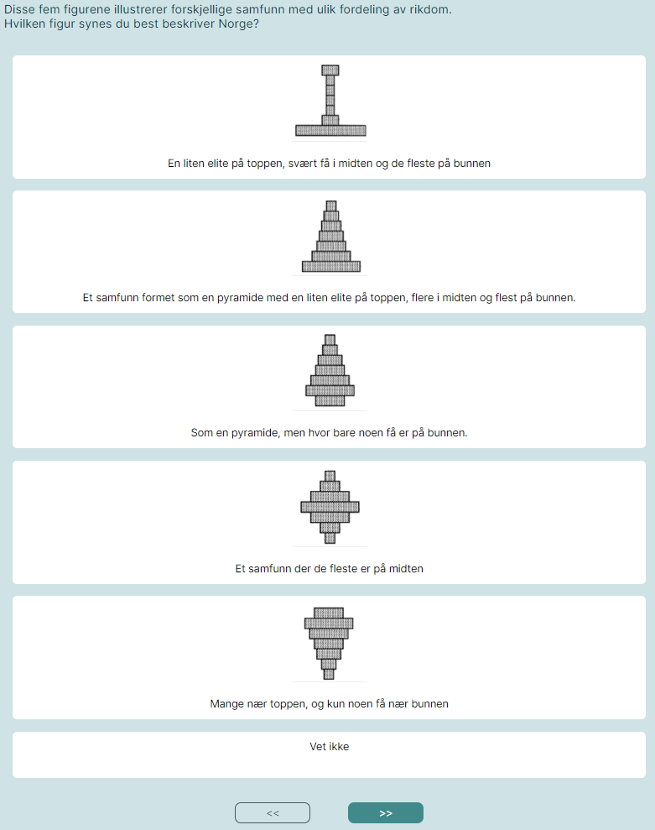

Figure 2.1: How the question about perception of economic inequality appeared in the survey.

Related to the questions under (3.), in both surveys, respondents are asked about which party they voted for in the previous election (i.e. 2023) and trust in various public and political institutions, though the list of institutions varied between surveys.

In the pilot survey, respondents are asked about the following topics related to transport policies (3.):

* How road pricing (implemented as a distance-based fee), would affect both themselves and low-income residents, indicating whether each group would be better or worse off
* General attitudes towards air pollution, road pricing, public revenues, taxation, and road tolls

In the main survey, respondents are more specifically asked about attitudes towards transport policies (3.):

* Whether they think air pollution is a serious environmental and health problem
* Whether they think road pricing will reduce greenhouse gas emissions, congestion, air pollution and personal car use
* Which groups will gain or lose from road pricing
* General attitudes towards (i) current road tolls and (ii) the proposed road pricing scheme
* Three final questions about attitudes towards public revenues, taxation and privacy

## Sociodemographic characteristics

In the questionnaire, respondents were asked to report the following characteristics (in addition to where they live):

* Year of birth
* Gender
* Education level
* Gross personal income
* The number of adults in the household (main survey)
* The number of people in the household (pilot survey)
* The number of children under 15 in the household
* Main occupation (working, studying etc.)

# Data collection

The pilot survey was launched in September 2023, while the main survey was run in March 2024. The recruitment method varied, as explained below. In both surveys, respondent were incentivized in terms of a lottery where they could win a gift card of NOK 5000.

## Pilot survey in Norway

To recruit respondents for the pilot survey, a sponsored Facebook post[4] was created, see Figure 3.1. This means that potential respondents could have gotten information about the survey either because they were targeted by the sponsored post or because someone in their network shared it or interacted with it. Hence, we did not control who received information about the survey. Those who received the information are unlikely to be representative of the general population, neither are those who chose to answer the survey.

The post and corresponding survey were launched on September 27, 2023 and people could answer until the 4th of October. To expand the reach of the survey, researchers at TØI asked several organizations to share the Facebook post on their Facebook pages. The only organization that confirmed that it had shared the post was Syklistforeningen (the Cyclists’ Association). The pilot survey received 1,741 responses.

The Facebook post text stated:

*“What do you think about replacing current road tolls with other forms of taxes? Researchers at TØI wish to study people’s attitudes toward tax schemes that can replace road tolls. We want your feedback!”*

In addition to survey responses, the Facebook post received considerable attention on social media. About 1,500 users reacted to the post with an emoji, of which about 2/3 posted an angry face. About 1,200 users commented on the post. Many of the comments also expressed negative attitudes towards road taxes. This could have implications for the representativeness of the net sample, and possible also the data quality.

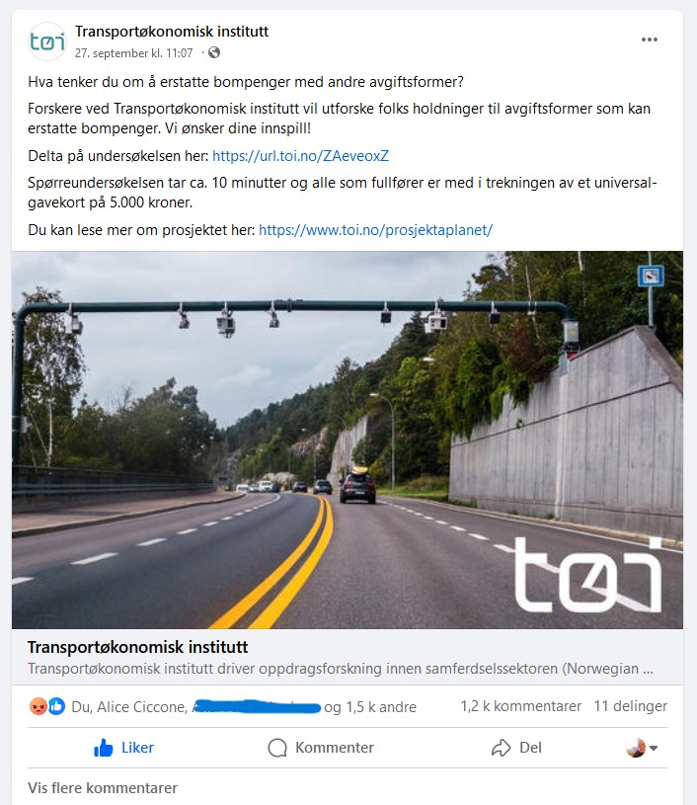

Figure 3.1: The Facebook post with the link to the survey (text in Norwegian).

## Main survey in Norway

To recruit respondents for the main survey, The Norwegian Tax Administration drew a representative random sample of roughly 50,000 people from the population register. These were contacted by e-mail using contact info from the Directorate of Digitalization (*Kontaktregisteret).* The survey was launched on Friday, March 8, 2024, and the sample was invited in several waves until the 12th of March. Those who had not answered the survey received a reminder the 15th of March and had the possibility to answer the survey until the 21st of March. We received 3,910 responses, which equals a response rate of xx percent.

The e-mail invitation stated:

*“The Institute of Transport Economics (TØI) invites you to take part in a survey about how people in Norway travel, and what they think about future transport solutions. It takes approx. 10 minutes to answer.*

*The survey is an important part of a research project funded by the Research Council. The results will provide the authorities with new knowledge that may have an impact on future transport and tax policy. By sharing your opinions, you contribute to research that can be used to create a more efficient, fair and sustainable transport system.”*

The motivation text is written such as to motivate respondents to participate but is much more neutral than the Facebook post used in the pilot. However, there is a slight risk that the last sentence could appeal more to respondents with certain values or affect how respondents answer in the survey.

## Data cleaning and filtering

The data cleaning process included removing respondents in the survey who indicated they had no regular trip of at least ten minutes (regardless of travel mode). When respondents were later asked about the length of their daily trip, they were also allowed to select an option indicating their trip was less than ten minutes long. Despite the slight inconsistency, these respondents were not filtered out, even if they should have been screened in the previous question. The sample was also filtered to exclude participants with very short response times of less than six minutes, roughly corresponding to responses falling below the 2nd percentile of response times. As a result, 22 responses from the pilot survey and 71 responses from the main survey were excluded. The final sample included 3,839 respondents for the main survey in Norway and 1,719 respondents for the pilot survey in Norway.

## Basic sample characteristics

Table 4.1 provides the sociodemographic statistics for the two surveys in Norway compared with the national average, based on official statistics from Statistics Norway (SSB).[5] It is interesting to compare the pilot survey and the main survey to the national average and between each other, considering their distinct recruitment methods.

Table 4.1: Sociodemographic statistics: shares and averages for Norwegian pilot and main surveys.

|  |  |  |  |
| --- | --- | --- | --- |
| Variable | Pilot survey mean or share (N = 1,719) | Main survey mean or share (N = 3,839) | National average |
| Age (years) | 54 | 48 | 49 |
| Female share | 12% | 45% | 50% |
| Number of adults per household, including respondent | 2.01 | 2.01 | 2.11 |
| **Number of children per household** |  |  |  |
| No children | 69.5% | 64.5% | 56.5% |
| One child | 13.6% | 14.8% | 15.2% |
| Two children | 13.0% | 15.3% | 19.2% |
| Three or more children | 3.9% | 5.4% | 9.1% |
| **Highest completed education** |  |  |  |
| Basic school level | 3.0% | 2.8% | 23.7% |
| Upper secondary education | 22.6% | 24.5% | 39.5% |
| College/university (4 years or less) | 36.0% | 38.1% | 25.3% |
| College/university (5 years or more) | 35.4% | 32.1% | 11.6% |
| Don't want to state | 3.1% | 2.3% | Not Applicable |
| **Employment Status** |  |  |  |
| Employed | 75.5% | 73.6% | 62.4% |
| Student | 1.3% | 8.0% | 6.0% |
| Retired | 14.9% | 9.0% | 17.9% |
| Unemployed | 0.5% | 1.9% | 0.8% |
| Other | 5.4% | 5.6% | 12.9%* |
| Don’t want to state | 2.4% | 1.9% | Not Applicable |
| **Income** |  |  |  |
| Annual Gross Income | NOK 792 558 | NOK 702 065 | NOK 561 700 |

*\*Including participants in labor marked measures and recipients of work assessment allowance/disability benefits*

*Source: Statistics Norway (SSB)*

The sociodemographic statistics indicate that both pilot and main surveys have been answered by more men, people that have fewer children and higher education and income. They also have a higher share of employed respondents at the expense of retired people and the “Other” category.[6] Nevertheless, the pilot survey has a much higher rate (14.9%) of retired people compared to the main survey (9.0%), although lower than the national average (17.9%).

One particularly notable difference is the much lower female share in the pilot compared both to the main survey and to the national average, with a female share of 12% compared to the national average of 50%. In addition, the average age of the respondents in the pilot survey is higher than the national average. Conversely, respondents of the main survey better match the national average for the female share, 45% compared to 50%. The main survey respondents are also slightly younger than the national average.

Figure 4.1 shows the home counties distribution for the pilot survey respondents, for which Oslo and Viken are slightly overrepresented compared to the national average. Similarly, Figure 4.2 shows the distributions of the home counties of the main survey respondents and the national average are within 2%-points, except for Oslo which has a share 5%-points greater than the national average. Both pilot and main survey respondents live in more urban areas compared to the national average.

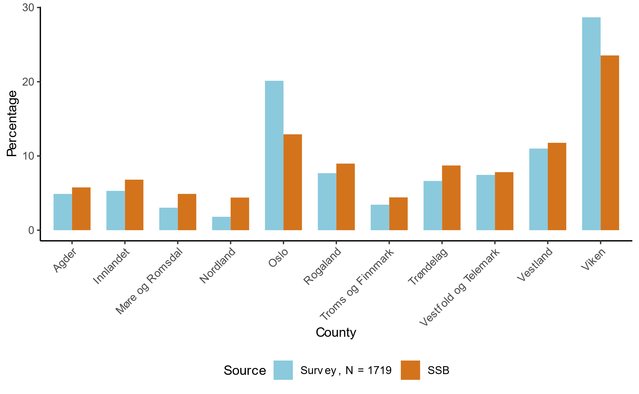

Figure 4.1: Share of home counties for pilot survey (2023 counties), compared to Statistics Norway (SSB).

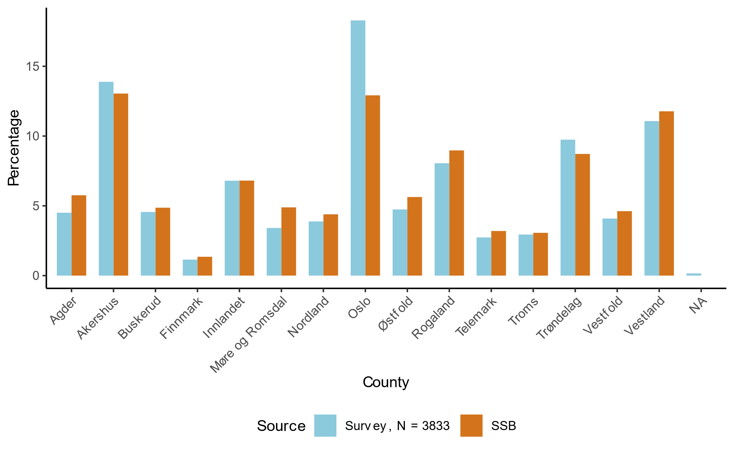

Figure 4.2: Share of home counties for main survey (2024 counties), with comparison to Statistics Norway (SSB).

Figure 4.3 provides details on the income distribution of the pilot and main survey respondents, illustrating that the sample is skewed towards higher income categories. According to Statistics Norway (SSB), average gross personal income was 561,700 in 2022.

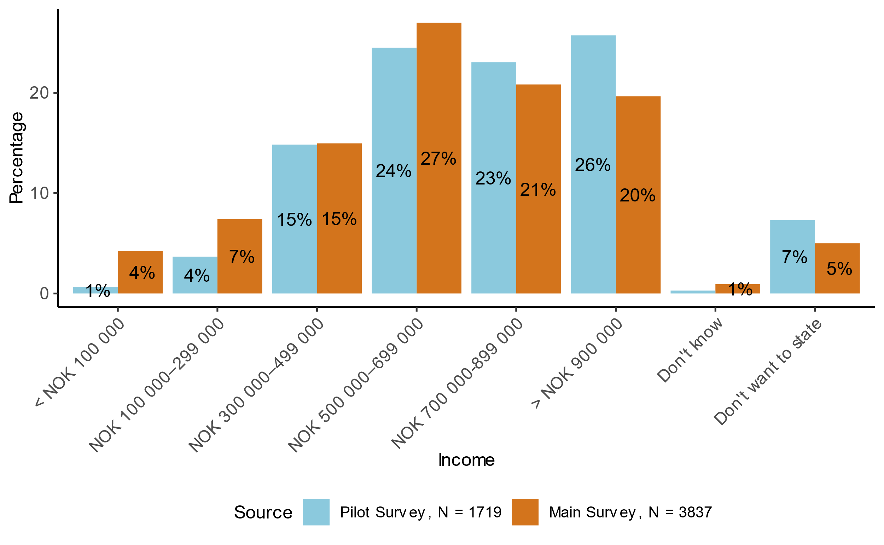

Figure 4.3: Share of annual income categories for the pilot and main surveys.

To sum up, the main survey better matches the national averages and thus is more representative for the country of Norway. Both surveys over-represented people with high income and education and residents of Oslo and the surrounding region, but the share of high-income earners is more extreme in the pilot survey. The pilot survey also has a vast majority of male respondents.

As pointed out above, the recruitment method used in the pilot survey is unlikely to lead to a representative net sample. The net sample of the pilot survey also appears to be less representative in terms of observable characteristics. When presenting the results in the next chapter, we therefore focus on the sample from the main survey. For some selected findings, we compare the two net samples. We also compare with statistics from other sources when such are available.

# Results

In this chapter, we describe our data and present selected results in terms of geography and travel behavior (4.1), road tolls paid on the selected trip (4.2), general political attitudes (4.3) and opinions on road pricing and other transport policies (4.3). For the reasons discussed in the previous chapter, we focus on the results from the main survey. For some selected findings, we compare the results of the main survey and pilot survey. We also compare with statistics from other sources when such are available.

## Geography and travel behavior

### Car and bike ownership and access

Table 4.2 shows the summary statistics for car and bike ownership and access for the Norwegian surveys.

Table 4.2: Summary statistics for car and bike ownership and access in the Norwegian surveys.

|  |  |  |  |
| --- | --- | --- | --- |
| Variable | Pilot survey share  (N = 1,719) | Main survey share  (N = 3,839) | National average |
| **Car ownership** |  |  |  |
| Owns a car | 91.6% | 74.9% |  |
| Has access to car | 6.6% | 14.1% |  |
| Does not have access to a car | 1.8% | 10.9% | 16%1 |
| **Household car ownership/access\*** |  |  |  |
| Owns or has access to a car | 72.2% | 59.1% | 68.3%2 |
| **Bike ownership** |  |  |  |
| Owns a bike | 74.2% | 71.7% |  |
| Has access to a bike | 4.6% | 7.3% |  |
| Does not have access to a bike | 21.2% | 20.9% | 20%1 |

*\* Here, respondents who belong to a single-adult household are weighted twice as much as those belonging to a two-adult household, such that the number represents the average across households.*

*1 Source: The national travel survey 2023. 2 Source:* *Fevang, E., Figenbaum, E., Fridstrøm, L., Halse, A. H., Hauge, K. E., Johansen, B. G., & Raaum, O. (2021). Who goes electric? The anatomy of electric car ownership in Norway.* Transportation Research Part D: Transport and Environment, 92*, 102727.*

Most of the pilot survey respondents (91.6%) own a car, compared to 74.9% of the main survey respondents. The main survey sample has lower household car ownership and access compared to the national average, while the pilot survey sample is higher and closer to the national average.

Respondents were asked about their plans to purchase a car within the next 12 months. The question allowed respondents to select multiple options from the following choices: "Yes, petrol car", "Yes, diesel car", "Yes, hybrid or plug-in hybrid car", "Yes, electric car", or exclusively: “No”.

Most responders (about 70%) in the main survey are not planning to buy a car..[7] Among those who plan to purchase a car, 41% plan to buy an electric car (plug-in hybrids not included). Given that purchasing a car could mean purchasing either a new car or a used car, this is a reasonable share.[8] We do not know whether the respondents plan to buy a new or used car. See Figure 0.1 and Figure 0.2 in the Appendix for more details on which cars respondents plan to buy.

### Trip origins and destinations

According to the spatial data provided by the respondents, there were 295 unique municipality trip origins and 283 unique municipality destinations for the main survey. A location was considered Urban if the provided coordinate was located in one of the following municipalities: Sarpsborg, Fredrikstad, Bærum, Lillestrøm, Nordre Follo, Lørenskog, Oslo, Drammen, Porsgrunn, Skien, Kristiansand, Stavanger, Sandnes, Bergen, and Trondheim. All other locations were considered Rural. This distinction is based on the list of the largest urban settlements published by Statistics Norway.[9] This rough classification is motivated by the road pricing scheme presented in the survey, which has different prices for urban and rural areas. We only include the largest urban areas and not all cities or urban settlements in our Urban category in order to be consistent with the definition used in the government investigation on road tax reform (Skatteetaten & Statens vegvesen, 2022)[10] For simplicity, we do not distinguish between different neighborhoods within municipalities.

The three most common municipalities for origins and destinations of trips were Oslo, Bergen, and Trondheim. Figure 4.4 shows maps of the origins and destinations for each trip, for the main survey.[11] We can observe coverage extending across the country. Similar findings apply to the pilot survey, as seen in Appendix Figure 0.3.

|  |  |
| --- | --- |
| A: Origins | B: Destinations |
|  |  |
| Figure 4.4: Shaded (choropleth) maps of the origins and destinations of trips for the main survey. Urban municipalities are outlined in bold. | |

Figure 4.5 presents the mapping of origin and destination types for each respondent for the main survey. The figures show that most trips are “Urban to Urban” or “Rural to Rural” for each survey. As expected, more trips are “Rural to Urban” than the other way around. These trip characteristics are observed in the pilot survey as well, see Figure 0.4 in the.

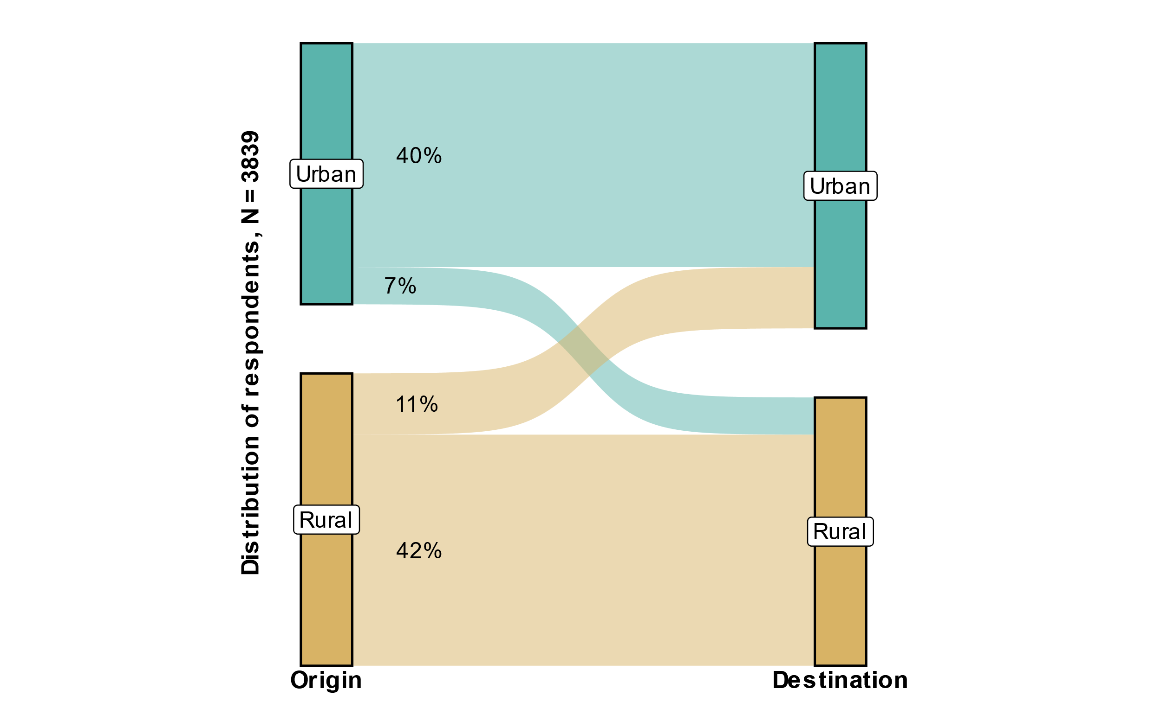

Figure 4.5: Mapping of individual’s origin and destination types for the main survey.

### Trip characteristics and mode choice

Figure 4.6 provides the share of trip purposes for all trips for the pilot survey and main survey. In both surveys, “Travel to workplace” is the most common trip purpose. The share of school trips is very small in the pilot survey, especially compared to the main survey. This is not surprising, given the higher average age and lower share of students in this sample.

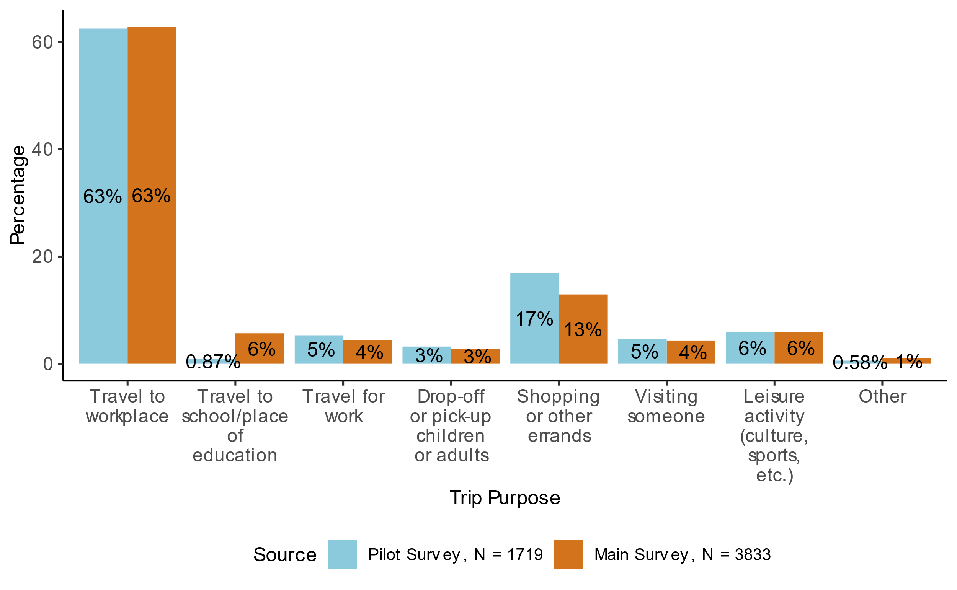

Figure 4.6: Share of trip purpose for all trips in the pilot and main surveys.

Figure 4.7 illustrate the share of travel modes for all trips in the pilot and main surveys. In both surveys, more than half of the trips use the 'Private car (driver)' mode. The second most common mode is “Bike” at 10% in the pilot survey and “Bus” at 13% in the main survey.

Figure 4.8 shows the distribution of travel modes by gender for the main survey. As expected, there are some gender differences, with a higher share of car drivers among men. Since men are highly overrepresented in the pilot survey, this means that the modal split will be more similar if we account for this. Still, there is a lower share of car drivers in the main survey for both genders than in the pilot survey.

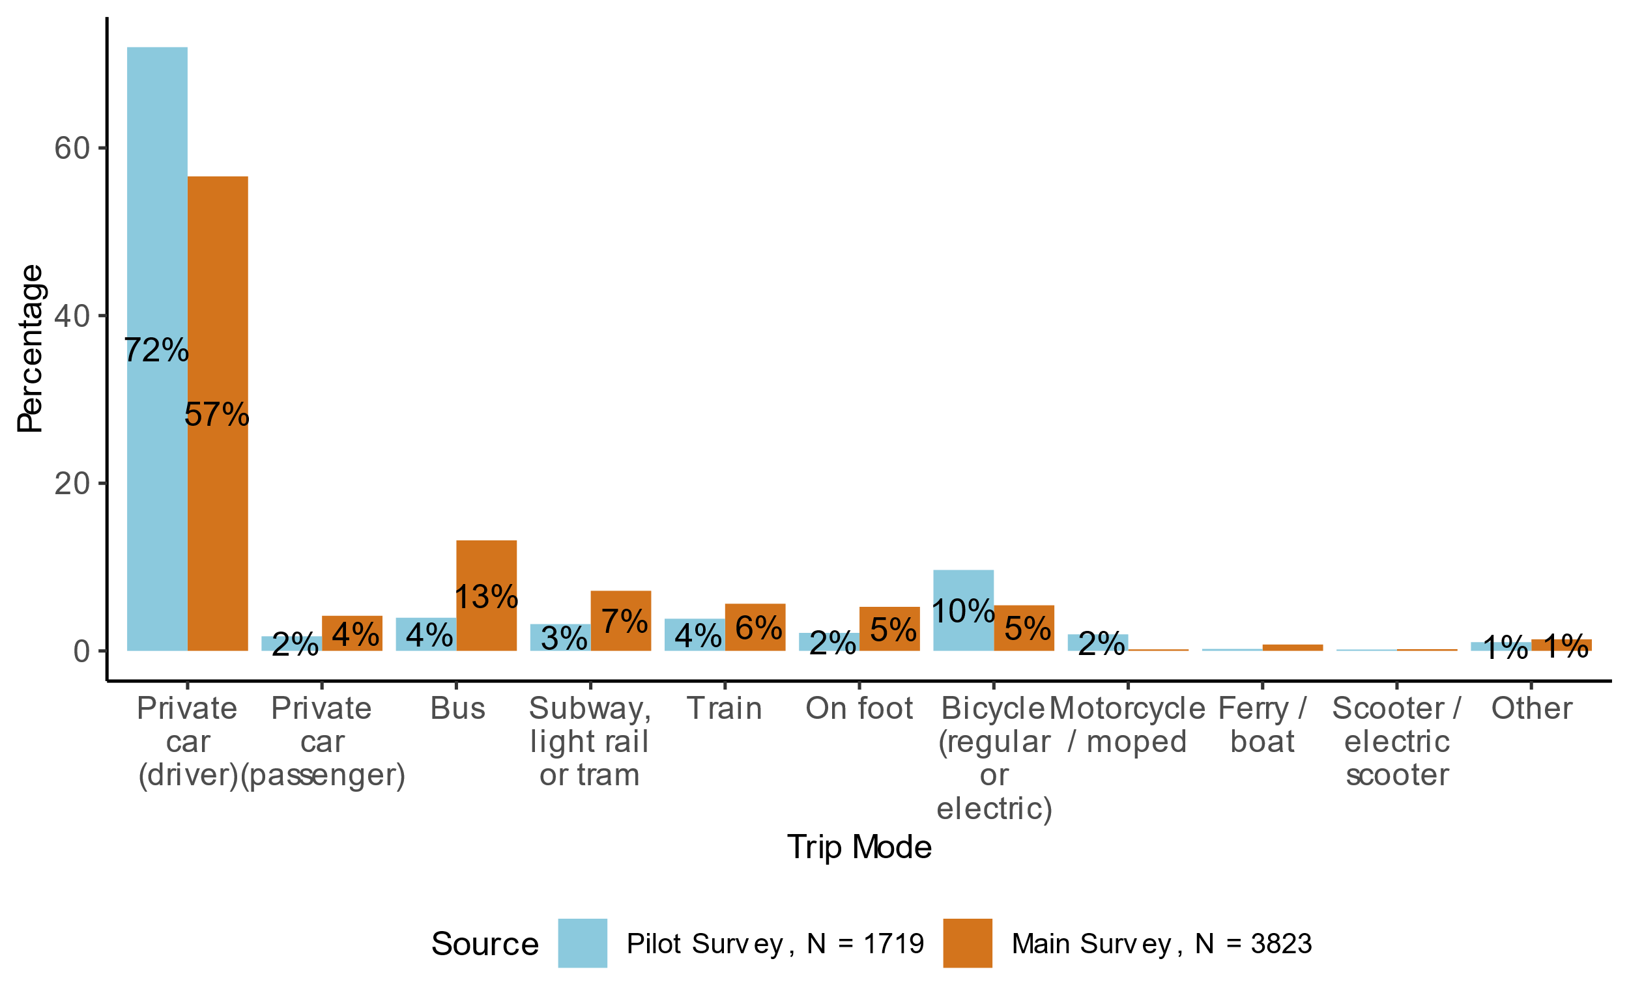

Figure 4.7: Share of travel mode for all trips in the pilot and main surveys.

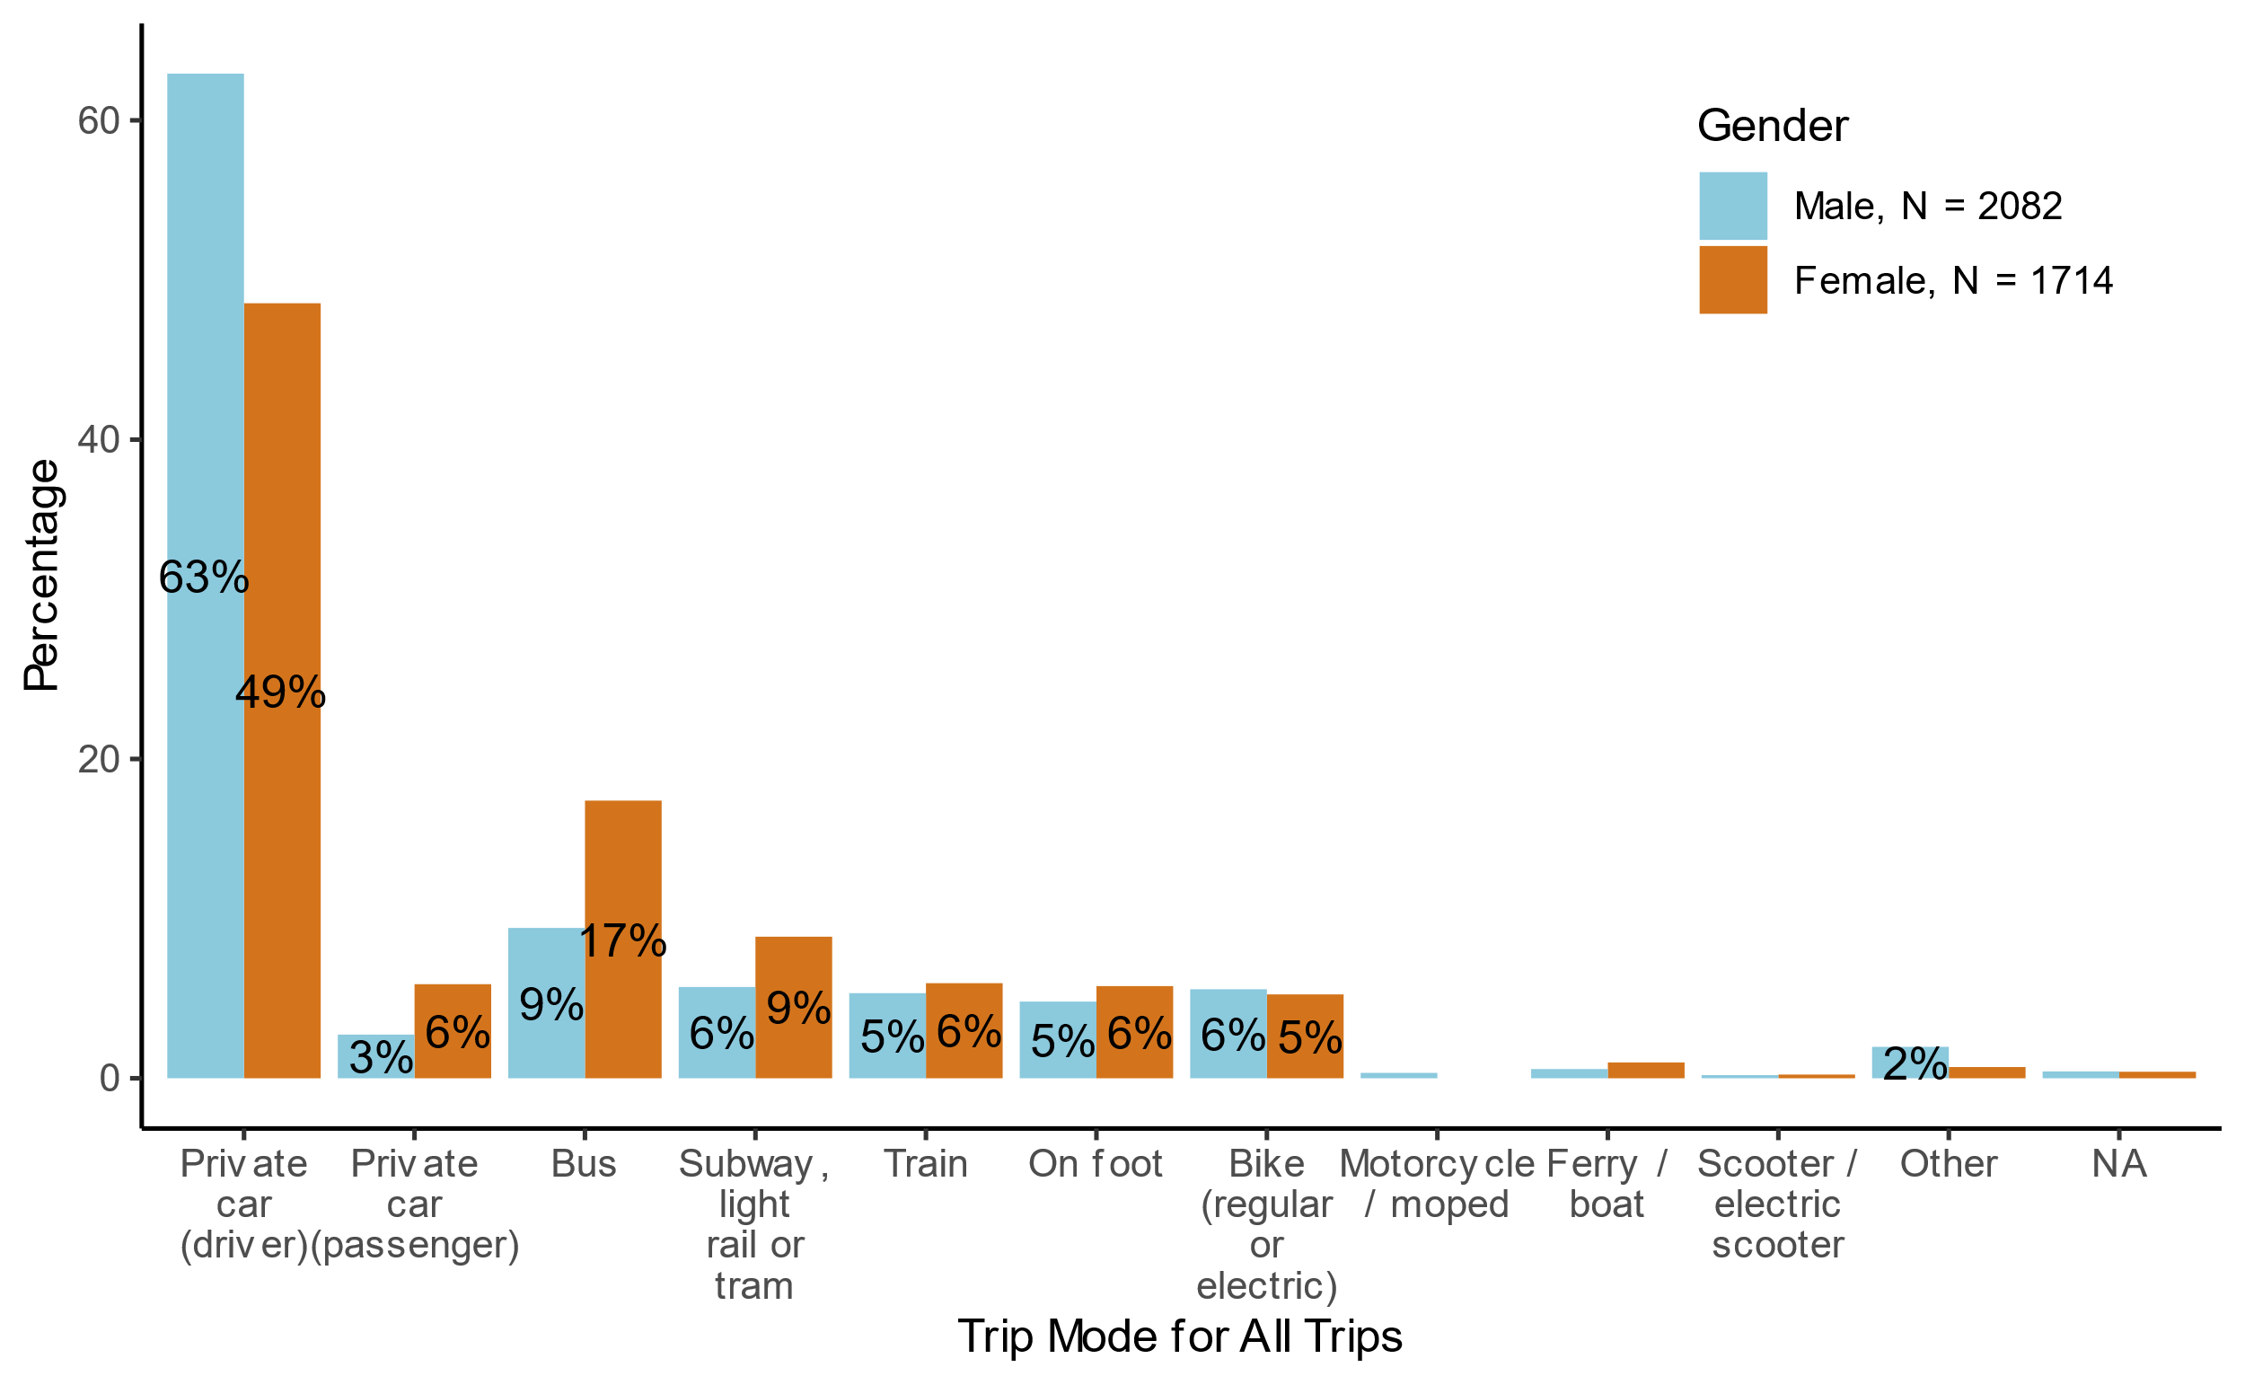

Figure 4.9: Share of travel mode for all trips by gender, in the main survey.

Figure 4.10 compares the share of travel modes for work trips between the pilot survey and main survey to the National Travel Survey (2023). Public transport includes bus, subway, light rail or tram, and ferry/boat. In the pilot survey, private car (driver) and bike modes are overrepresented, while walking is underrepresented. Furthermore, in the main survey, most of the modes are within 2%-points of each other, except for public transport which is overrepresented in the main survey, and the walking mode which is underrepresented. This could be related to the fact that respondents were not asked to report all trips – only one typical trip, and that this trip was required to last at least 10 minutes.

There are some notable differences between the two samples. Those who drive and cycle to work, are overrepresented in the pilot survey, but not in the main survey. The overrepresentation of cyclists could be partly due to the fact that the Facebook post was shared by the cyclist association.

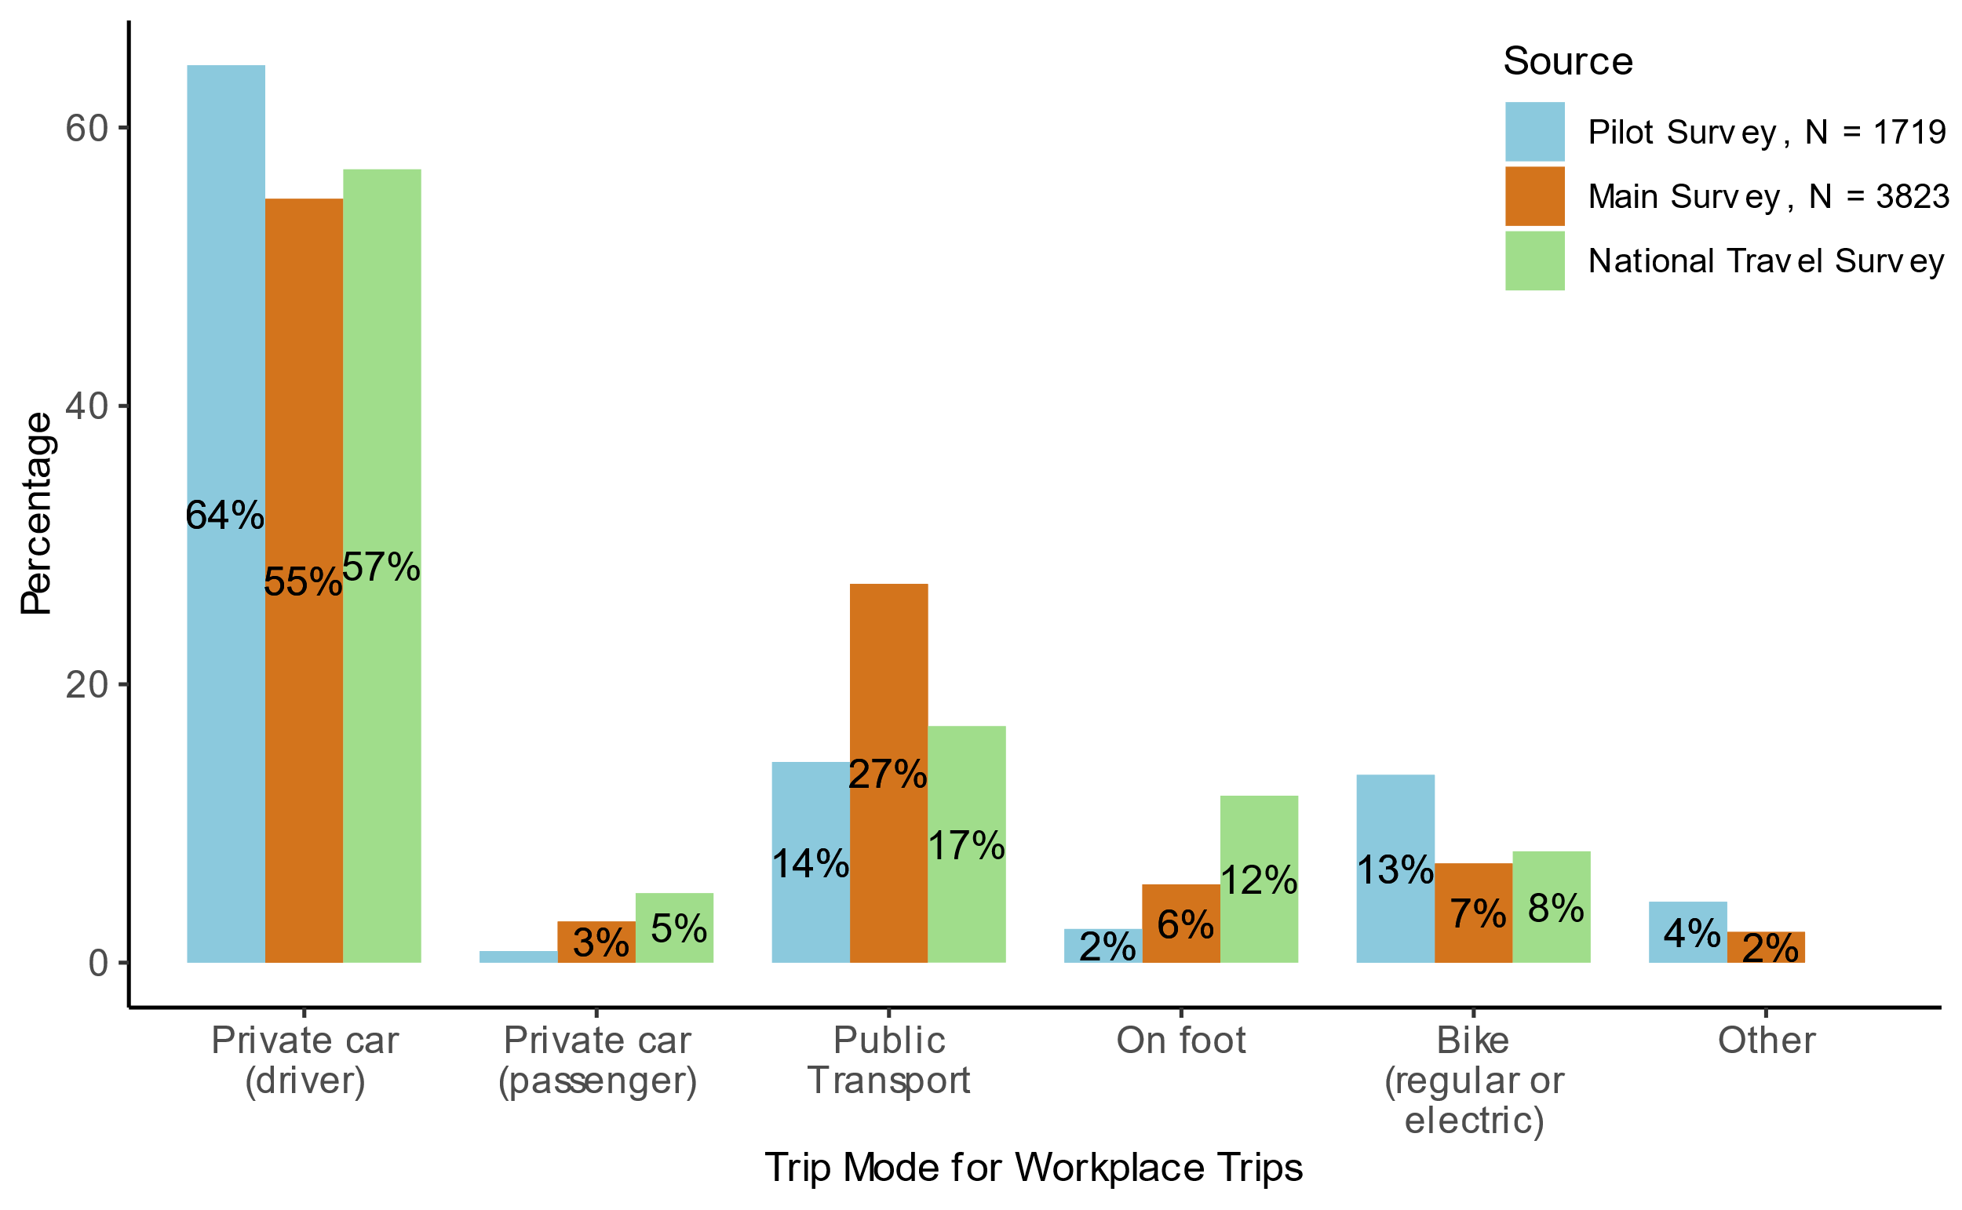

Figure 4.10: Share of travel modes for workplace trips in the pilot survey, main survey, and the National Travel Survey (2023).

Figure 4.11 illustrates respondents’ usual trip mode and corresponding alternative mode, as well as their rating of the alternative relative to their usual mode trips for the main survey. Here, the car category includes private cars (as driver or passenger) and motorcycles/mopeds. Light transport includes walking, bicycles, e-scooters, and other modes.

The most common alternative mode among car users is public transport. However, many car users substitute with a different car-based mode. This includes car drivers, whose alternative mode is being a car passenger. Among public transport users, there is a close to even split between those who substitute with a car, a different public transport mode and light transport.

Those who substitute with public transport tend to rate the alternative as worse than their usual mode, which may be due to longer travel times with public transport. See Figure 0.5 in the Appendix for an equivalent diagram for the pilot survey.

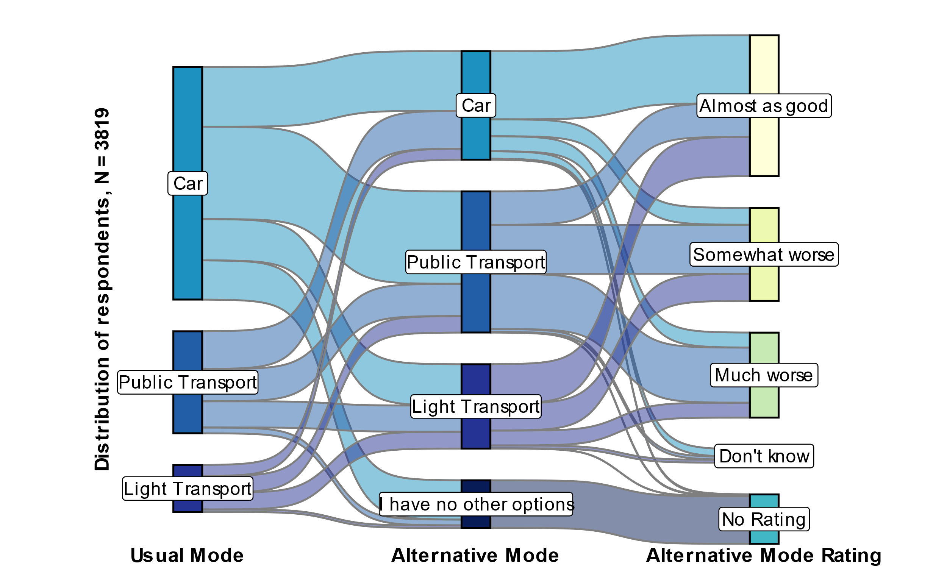

Figure 4.11: Mapping of main survey individuals’ alternative trip mode, and alternative mode rating relative to their usual mode for all trips. The car category includes private cars and motorcycles/mopeds. Public transport includes bus, subway, light rail or tram, and ferry/boat. Light transport includes walking, bicycles, e-scooters, and other modes.

Table 4.3 provides the percentages for each category. In the main survey, 13% of respondents lack an alternative transportation option. Of the car mode users with an alternative, 63% consider the alternative option “somewhat worse” or “much worse” than their usual mode.

Table 4.3. Percentage of respondents’ usual trip mode, alternative trip mode, and alternative mode rating for the pilot and main surveys.

|  |  |  |  |
| --- | --- | --- | --- |
| **Category** | **Subcategory** | **Percentage** | |
| **Pilot Survey** | **Main Survey** |
| Usual Mode | Car | 76% | 61% |
| Public Transport | 11% | 27% |
| Light Transport | 13% | 12% |
| Alternative Mode | Car | 31% | 28% |
| Public Transport | 35% | 37% |
| Light Transport | 16% | 22% |
| I have no other options | 18% | 13% |
| Rating | Almost as good | 28% | 37% |
| Somewhat worse | 23% | 24% |
| Much worse | 29% | 22% |
| Don’t know | 2% | 4% |
| No Rating | 18% | 13% |

See Figure 0.6, Figure 0.7, Figure 0.9, and Figure 0.10, in the Appendix for detailed results on total trip cost, duration, time of day, and traffic conditions for the pilot survey. In addition, see Figure 0.8 in the Appendix for results on trip length for the main survey.

Figure 4.12 shows the distribution of the time of day that the trip is typically taken in the main survey. Respondents were not asked to report the exact departure or arrival time, only what time of day the trip took place and whether it was during rush hour.[12] It makes sense that morning trips are most prevalent considering that we explicitly asked them to think of adaily trip starting from home and the most frequent type of trip was to the workplace.

Figure 4.13 depicts the share of observed traffic conditions (degree of congestion) during the trip in the main survey. For car travelers, this will be the traffic conditions that they experience themselves, while for other travelers, it could also be the conditions that they observe in the car lane of the road. Roughly half of the trips encounter little to no queuing and less than 10% of trips encounter lots of queueing. The shares are similar in the pilot survey. (See Figure 0.10 in the Appendix).

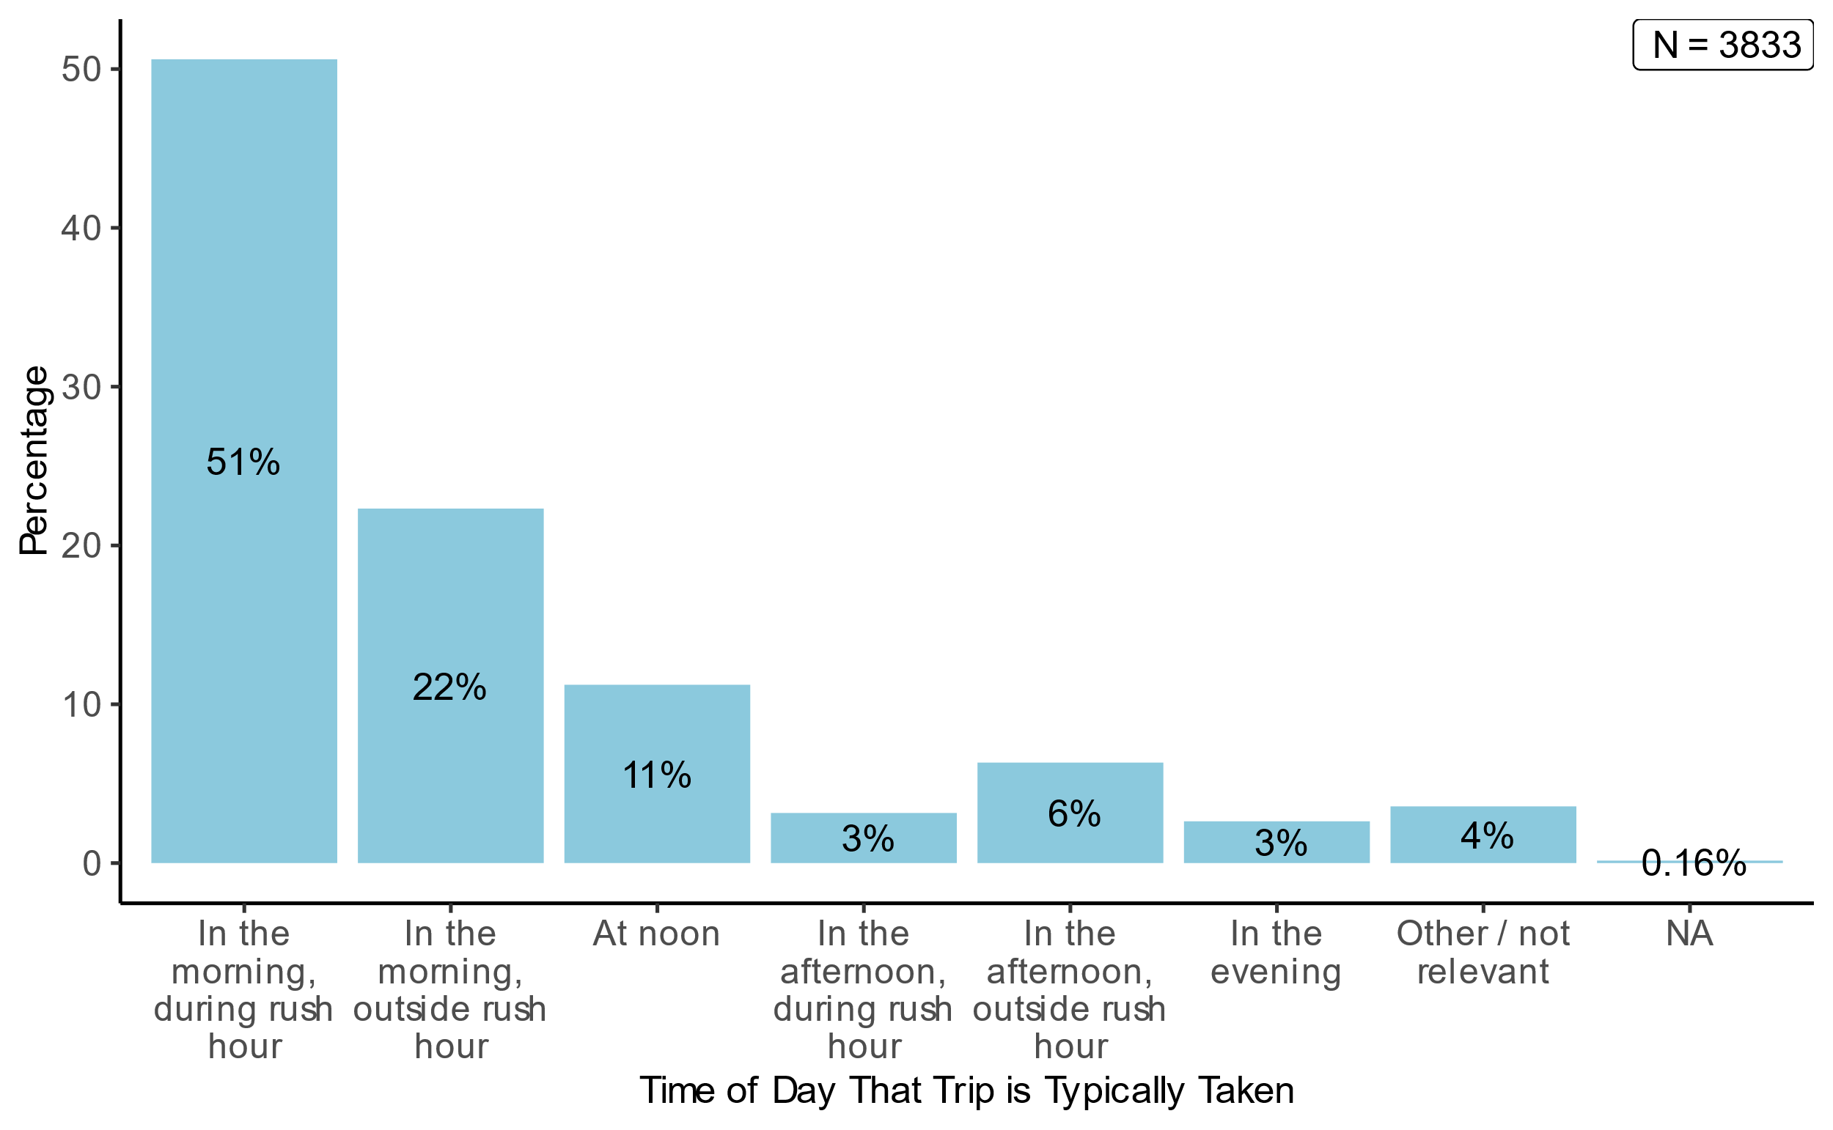

Figure 4.12: Distribution of the time of day that the trip is typically taken for all trips in the main survey. Percent

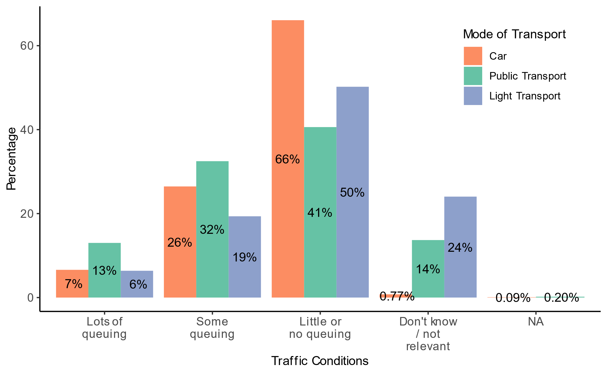

Figure 4.13: Share of observed traffic conditions during the trip for all trips in the main survey. Percent

## Road tolls

As explained in Chapter 2, respondents’ road tolls were calculated based on the reported origin and the destination using the road toll calculator from Fremtind Service. In the main survey, people who responded that they used a private car during their trip were also asked follow-up questions about whether they paid road tolls and if so, how much. Of the 2,324 respondents who used a private car, 966 (42%) indicated they paid road tolls during their trip. Figure 4.14 shows the distribution of how much respondents think they pay in tolls for the trip and the calculated tolls for the trip based on the trip coordinates. The calculated road tolls in the main survey follow a similar distribution to those in the pilot survey, with the largest proportion being no tolls, followed by tolls between NOK 21-40. The main survey respondents reported fewer tolls between NOK 1-10 and more tolls between NOK 21-40, compared to the toll calculator.

To better understand the geographic distribution of toll payers, we examined the share of pilot and main survey respondents who pay road tolls, categorized by county. See Figure 0.13 and Figure 0.14 in the Appendix. For both surveys, the county of Oslo contains the highest share of those who pay tolls. In the main survey, the counties with the greatest difference between the reported and calculated percentages are Østfold, Oslo, and Rogaland. Although the compared percentages are not equal for each county, this may be due to the respondents using an alternative route than the one used by the toll calculator, rather than inaccurate reporting. However, the share of reported tolls is surprisingly much larger than the calculated tolls for Østfold (about 50 versus 15 percent). This may be due to the toll cordon that opened around the city of Sarpsborg on March 20, 2024. While only 7% answered the survey after March 20, it is possible people thought that the toll cordon opened earlier and reported tolls accordingly.

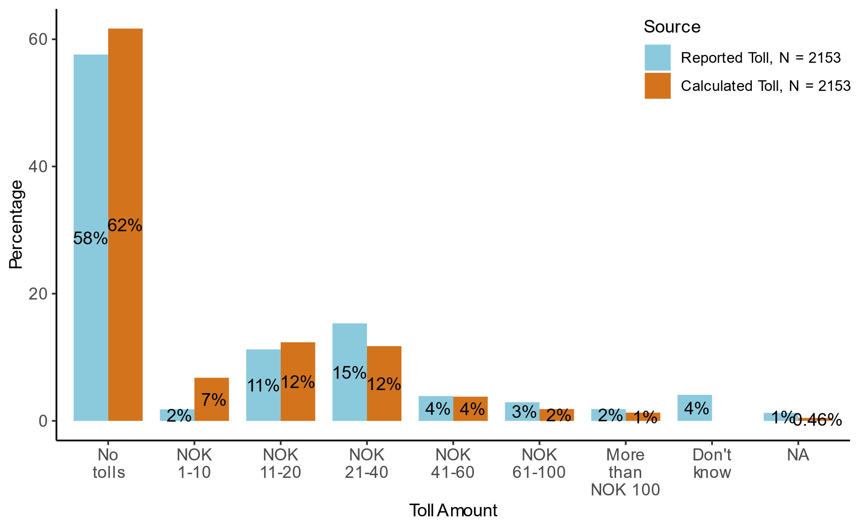

Figure 4.14: Share of main survey respondents’ self-reported toll costs compared to calculated toll costs.

There is considerable variation between the reported and calculated tolls. Figure 4.15 describes the consistency between self-reported toll costs and calculated toll costs. We define self-reported and calculated toll costs as consistent if calculated toll costs are within the interval that the respondent reported (e.g., NOK 21-40), and inconsistent otherwise. When considering all tolls, about two thirds of the respondents reported paying a toll consistent with the toll calculator, while 21% reported paying more than the toll calculator.

Note that the level of consistency is ‘inflated’ by the number of respondents who correctly report zero tolls. Many of these could be traveling in areas where there are no toll gates at all, and therefore have little difficulty reporting correctly, After filtering out those with calculated tolls equal to zero, the share of those reporting more than the toll calculator increases to 37%.[13] See Figure 0.15 in the Appendix for a detailed sankey diagram comparing calculated and reported tolls.



Figure 4.15: Share of consistency in main survey self-reported toll costs compared to calculated toll costs.

## General political attitudes

### Party preferences

To capture party affiliation, respondents were asked what they voted in the most recent election, which is the local election in 2023.[14] Figure 4.16 shows there are respondents from all the major political parties for the pilot survey and the main survey, as well as a joint category for other parties.[15] In the pilot survey, party affiliations deviates from the official election results for 2023. The largest differences are observed in the underrepresentation of the Labour Party and the overrepresentation of the Industry and Business Party. In contrast, for the main survey, nearly all the shares are within 3%-points of the shares in the official election results. In both the pilot and main surveys, non-voters are highly underrepresented. In the pilot survey, 45 respondents (2.6%) indicated they did not vote in the last election, while in the main survey, 238 respondents (6.2%) reported the same. In contrast, the Norwegian Directorate of Elections reported that 37.7% of eligible persons did not vote in the 2023 election. In the figures, we do not include the non-voters in order to get more comparable numbers for relative party support among those that vote. 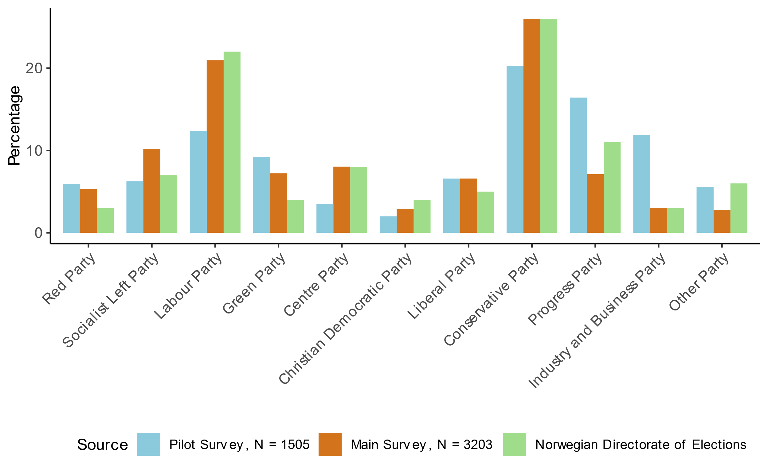

Figure 4.16: Party affiliations for the pilot and main surveys compared to the Norwegian Directorate of Elections.

Figure 4.17 shows the distribution of party affiliations by gender for the main survey.

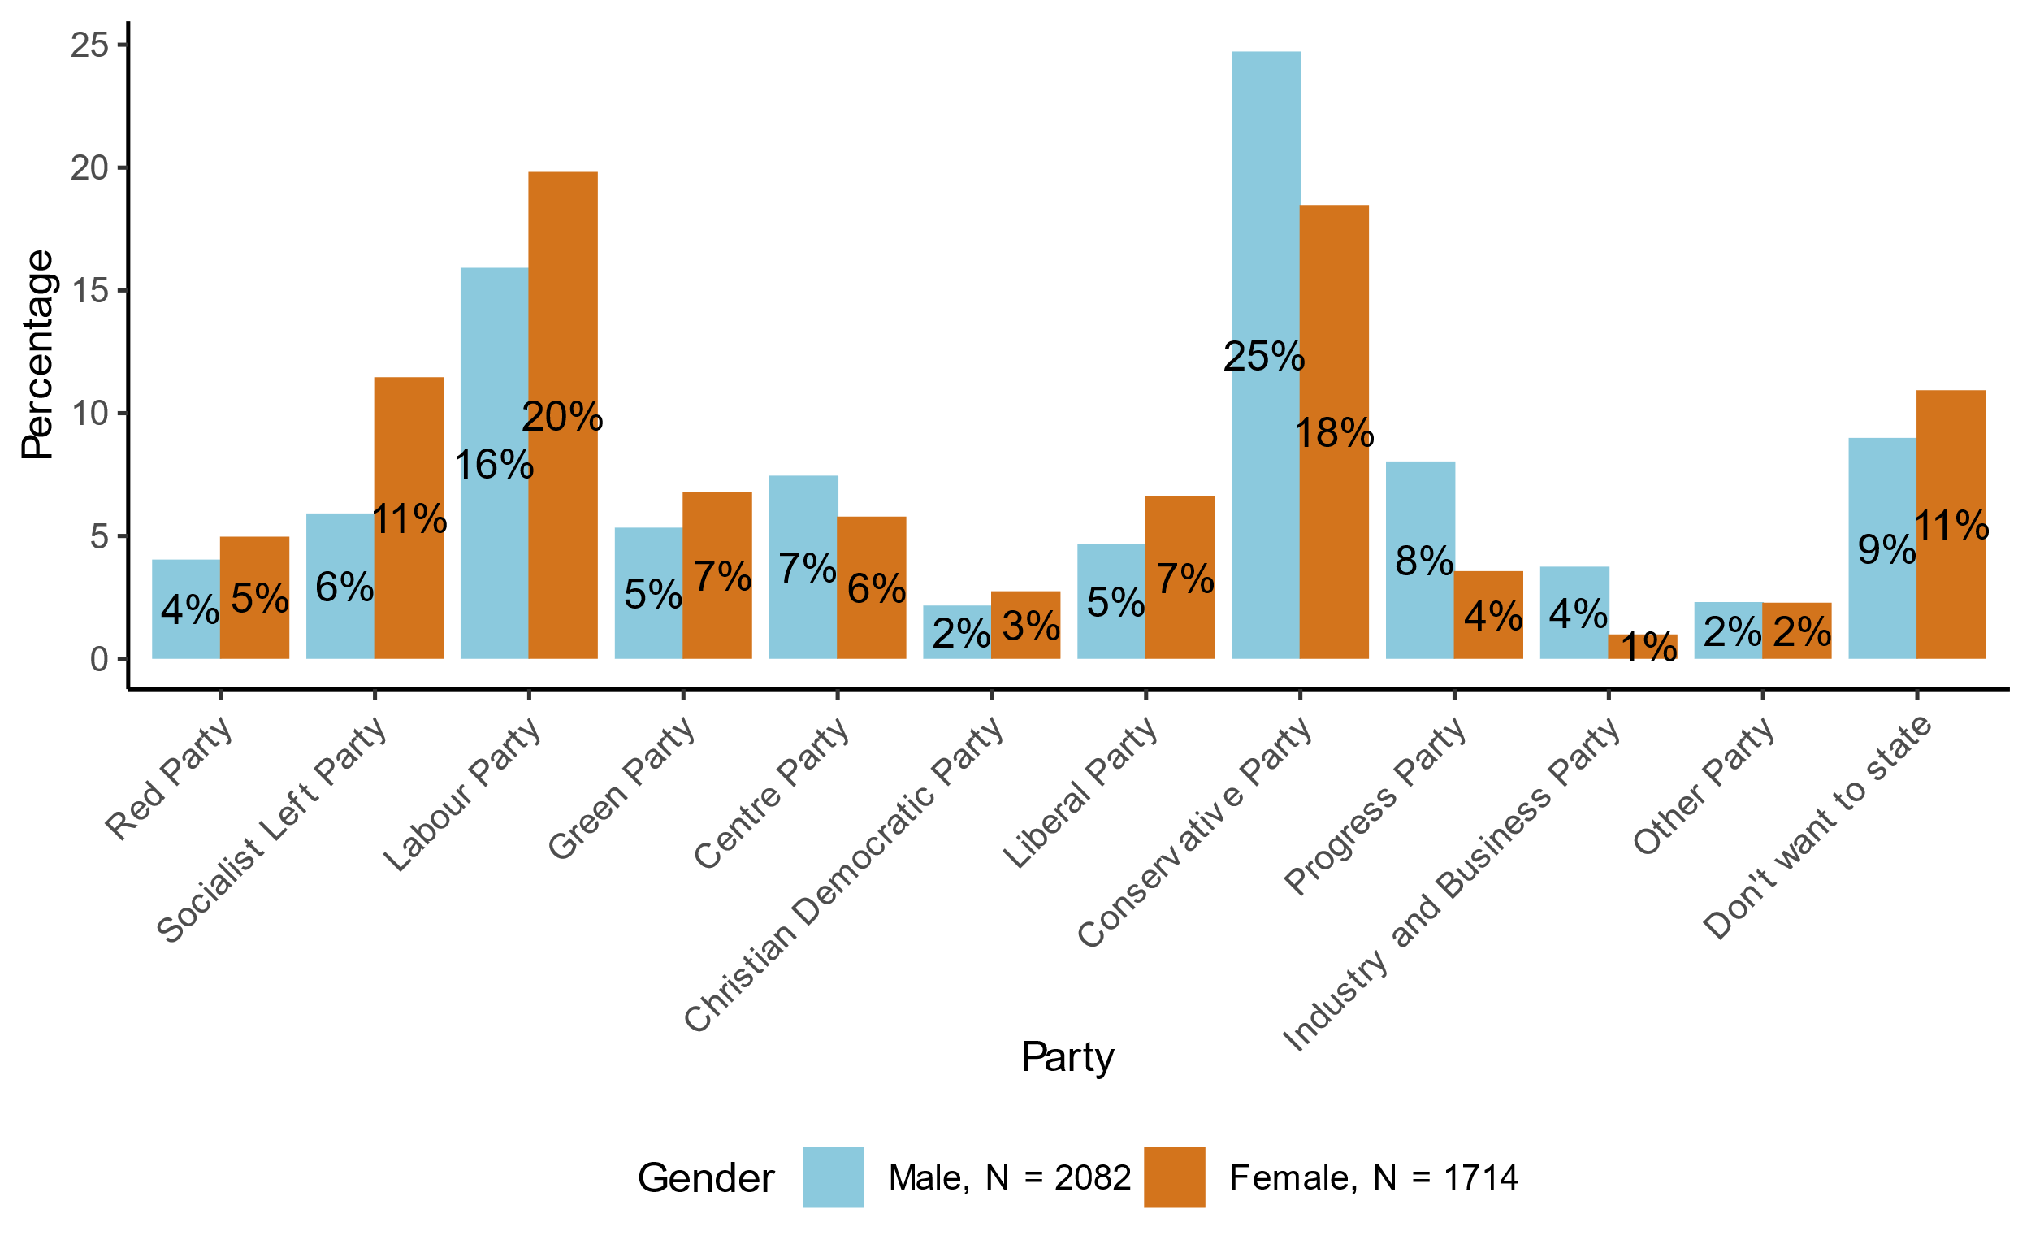

Figure 4.18: Share of party affiliations by gender, in the main survey.

In some of the following analysis, we will use four main categories for party preferences, based on this question:

1. Moderate: Labor Party, Center Party, Christian Democratic Party, Conservative Party
2. Environmental: Socialist Left Party, Green Party, Liberal Party
3. Populist: Progress Party, Industry and Business Party
4. Other: Red Party, other parties, non-voters

This categorization is used because we expect that it could be relevant for explaining attitudes towards transport and environmental policies, but possibly also other political views. We expect those who vote for environmental parties to be more in favor of road pricing and other environmental taxes, and the opposite for those who vote for populist parties. We expect those who vote for moderate parties to be somewhere in between. Note that the moderate and environmental blocs include both left-wing and right-wing parties, while the populist bloc is more right-wing.[16]

### Perception of inequality

Figure 4.19 and Figure 4.20 illustrate the responses to questions about economic inequality as shown in Figure 2.1 in Section 2.4. Here, respondents were asked to choose the stylized distribution that they thought best represented the current economic distribution in society and the distribution that they would like society to have.

Figure 4.19 compares perceived inequality structures for current conditions and ideal conditions based on the main survey. In the main survey, 44% of respondents believe that inequality conditions (“top and bottom”, “pyramid”, “pyramid, fewer at the bottom”) currently describe Norway, while only 14% think these same conditions are how the country should be ideally. Figure 0.16 shows an equivalent plot for the pilot survey in the Appendix. The results are similar in the pilot survey.

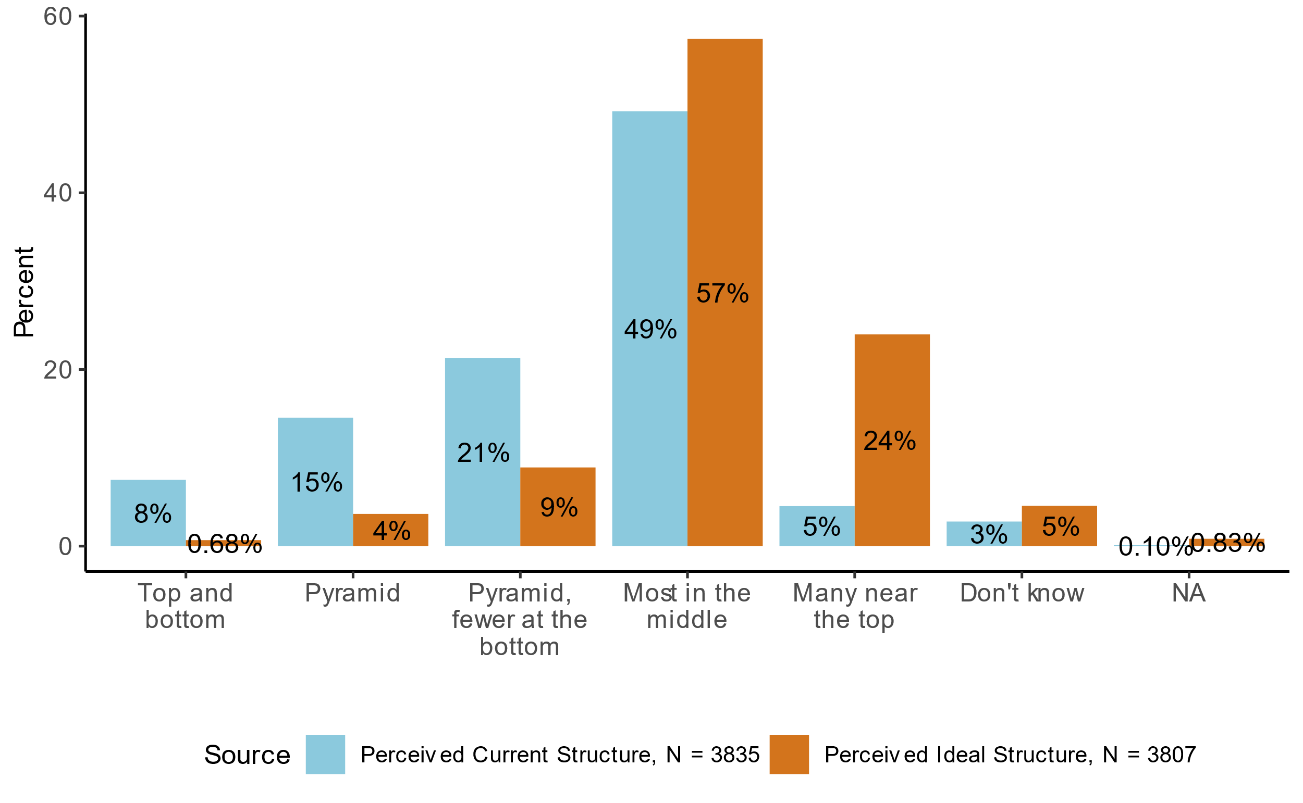

Figure 4.19: Comparison of perceived current and ideal inequality structures, for the main survey.

In terms of party affiliation, Figure 4.20 shows that main survey respondents in the moderate and environmental party blocs think society is relatively equal, with most people in the middle or a pyramid with fewer people at the bottom. However, those who vote for populist parties and the “other” group are much more likely to think that society is very unequal.[17] When asked how they think society should be, Figure 4.20 shows that the relative differences between party blocs are much smaller. The majority of respondents in all groups think that most people should be in the middle or near the top. The corresponding figure for the pilot survey is included in the Appendix, see Figure 0.17.

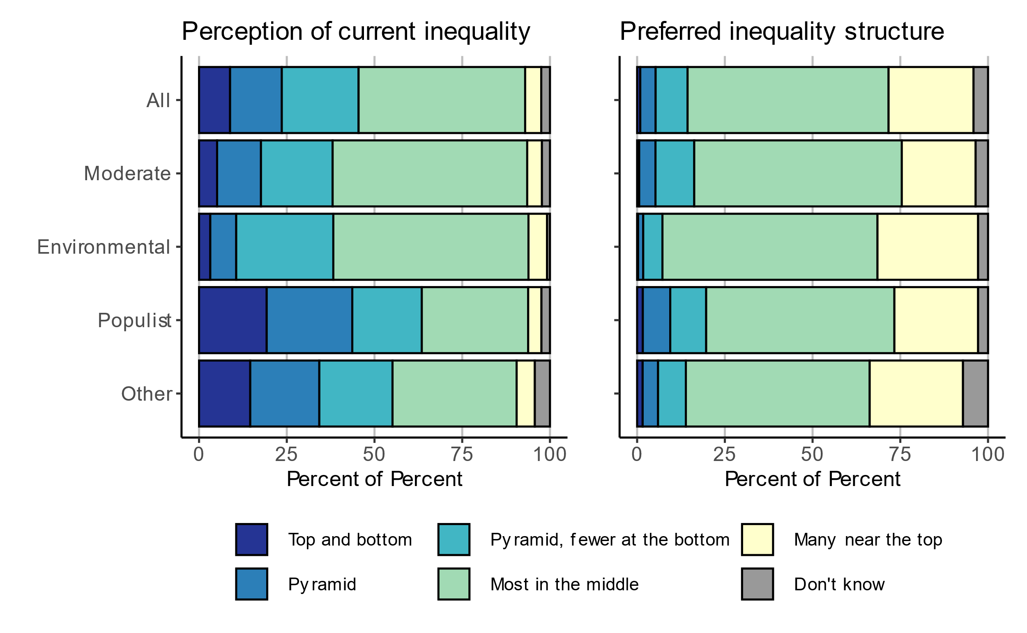

Figure 4.20: Perception of current inequality and preferred inequality structure, by political party, for the main survey.

### Political views and trust in institutions

Figure 4.21 presents the average trust in various institutions for the pilot survey and main survey. The figure shows that respondents from the pilot survey and the main survey tend to have relatively lower trust in politicians compared to other institutions. Respondents’ trust levels for authorities, Norwegian Parliament and the municipal council are similar, with generally higher trust in authorities. Overall, the main survey respondents are slightly more trusting than the pilot survey respondents as the average trust is higher for each institution, except for the municipal council. Figure 4.22 provides a more detailed break-down of trust in various institutions for the main survey. An equivalent figure (Figure 0.18) for the pilot survey is provided in the Appendix, although additional institutions are included for the pilot.

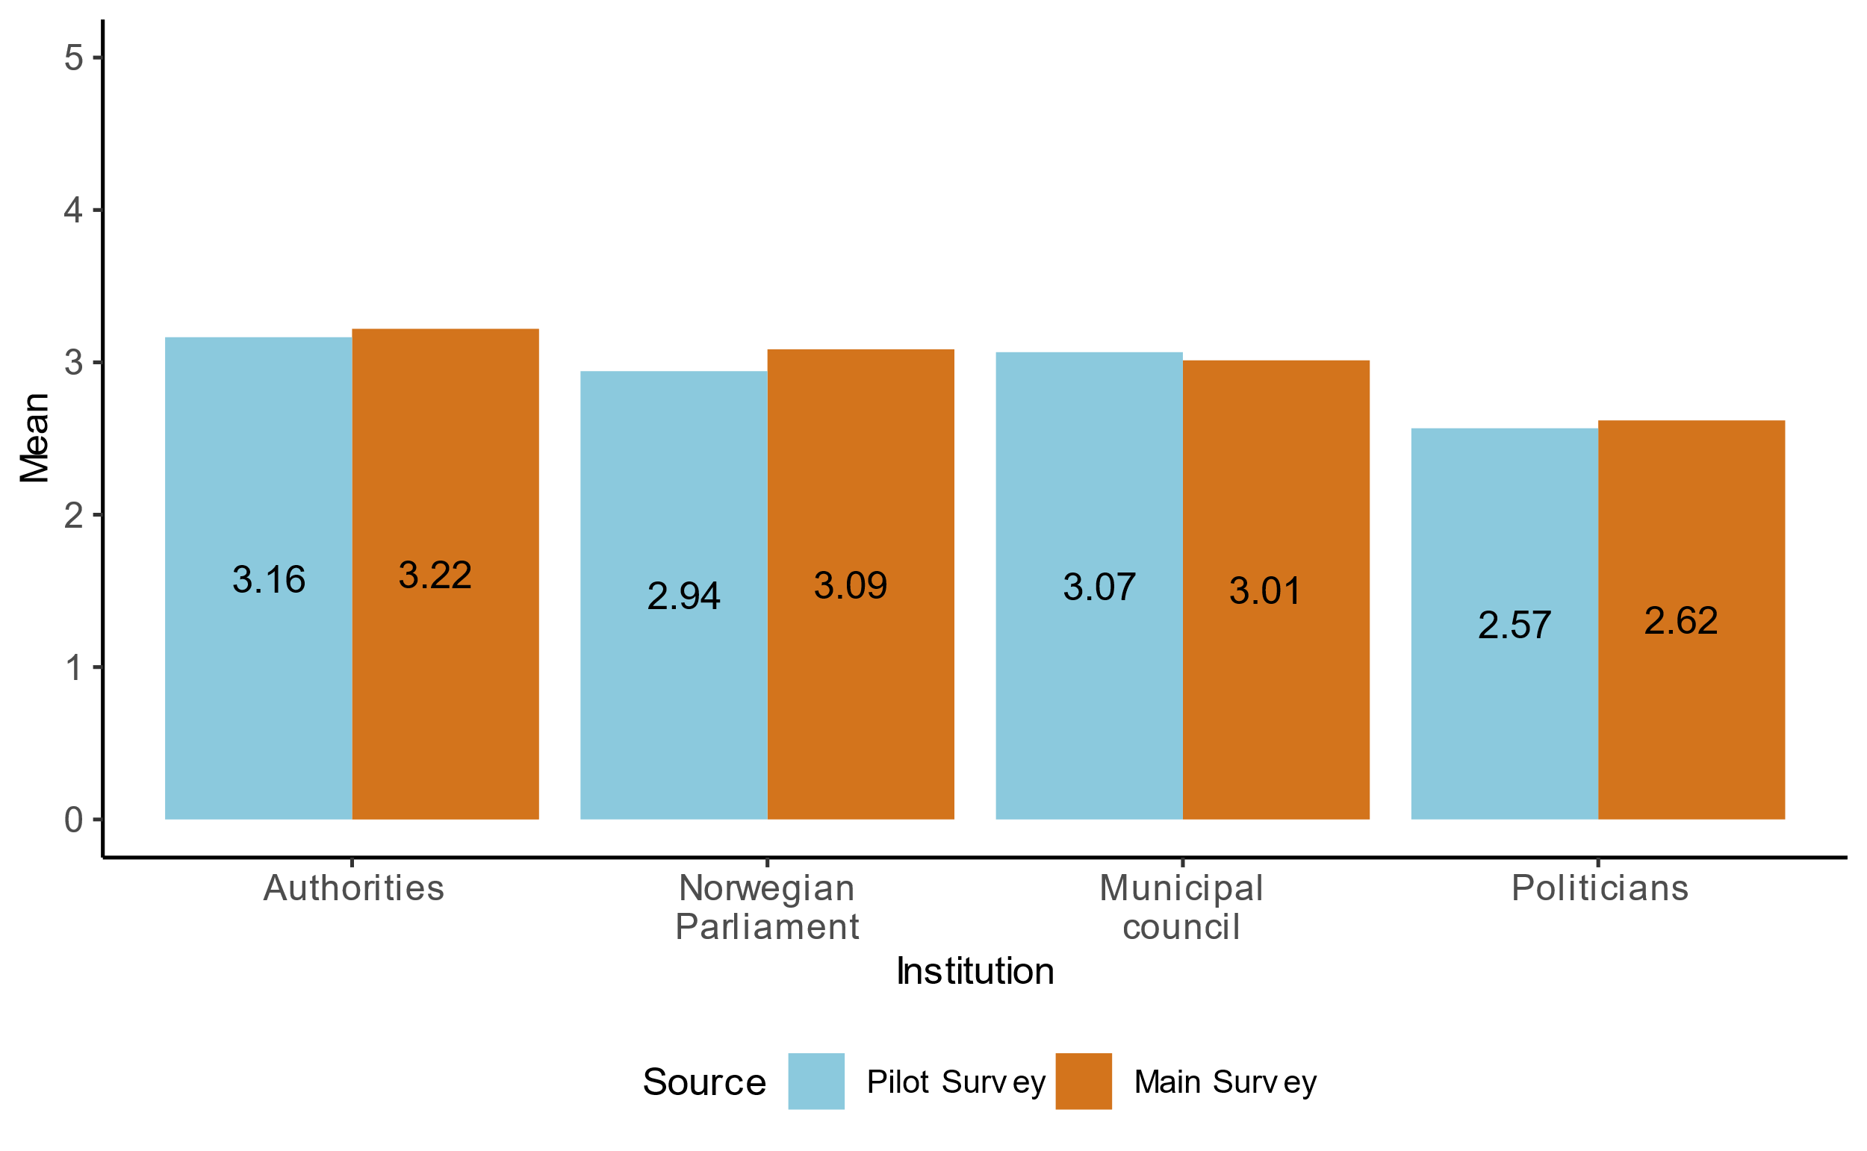

Figure 4.21: Average trust in institutions (5 = “Full trust”, 1 = “No trust”) for the pilot survey and main survey.



Figure 4.22: Trust in institutions for the main survey.

## Opinions on road pricing and transport policies

As discussed in Section 2.4, attitudinal questions are presented differently in the pilot survey compared to the main survey. The main survey contains more attitudinal questions than the pilot survey, and the wording of the political statements has been improved. See Figure 0.19 though Figure 0.21 in the Appendix for the results on the policy related questions posed in the pilot survey.

Figure 4.23 presents the level of agreement regarding the anticipated effects of replacing current tolls and fuel taxes with road pricing for the main survey.

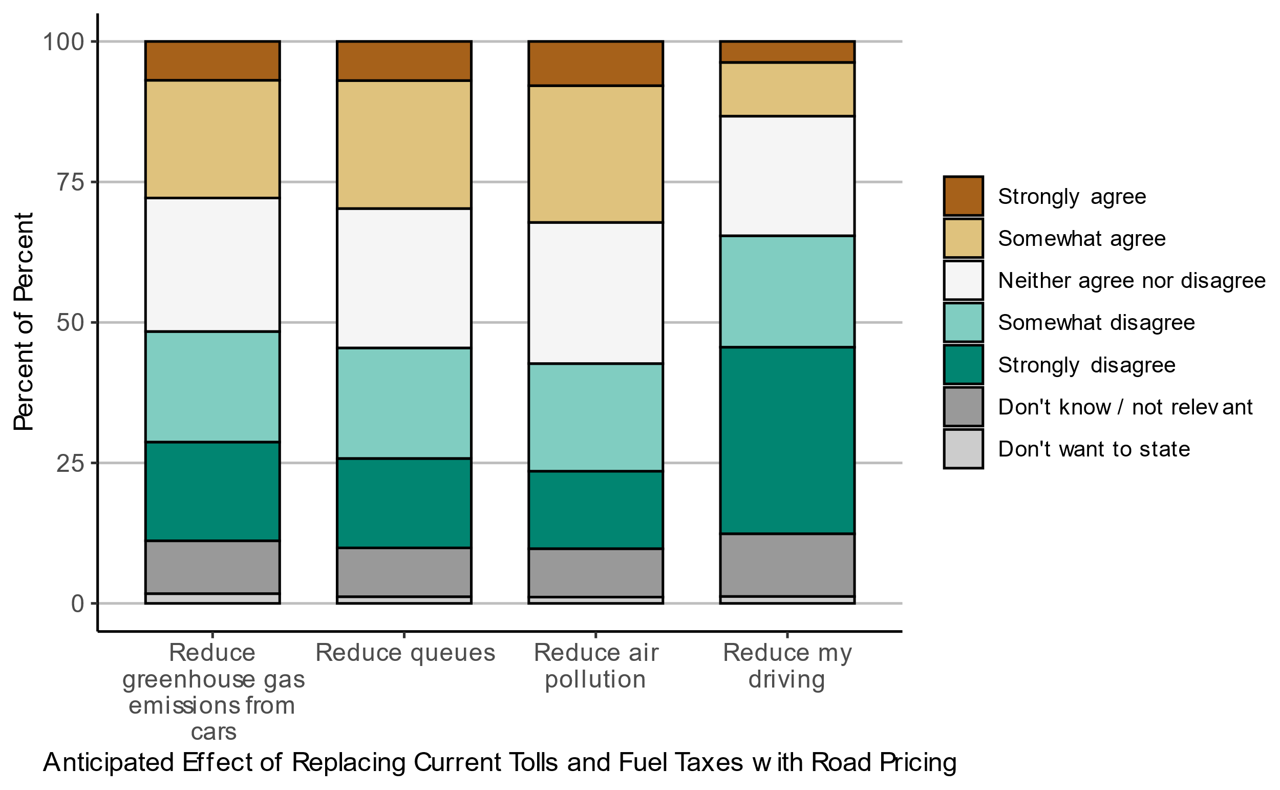

Figure 4.23: Level of agreement regarding anticipated effects of replacing current tolls and fuel taxes with road pricing, for the main survey.

Figure 4.24 shows the level of agreement regarding various statements based on the main survey. Most respondents agree that the government needs revenue to finance public services. At the same time, a narrow majority thinks the tax level is too high. Most respondents also agree that air pollution from car traffic is a serious environmental problem that impacts public health. Opinions on whether road pricing will lead to worse privacy are more mixed, and a large share is uncertain about this.

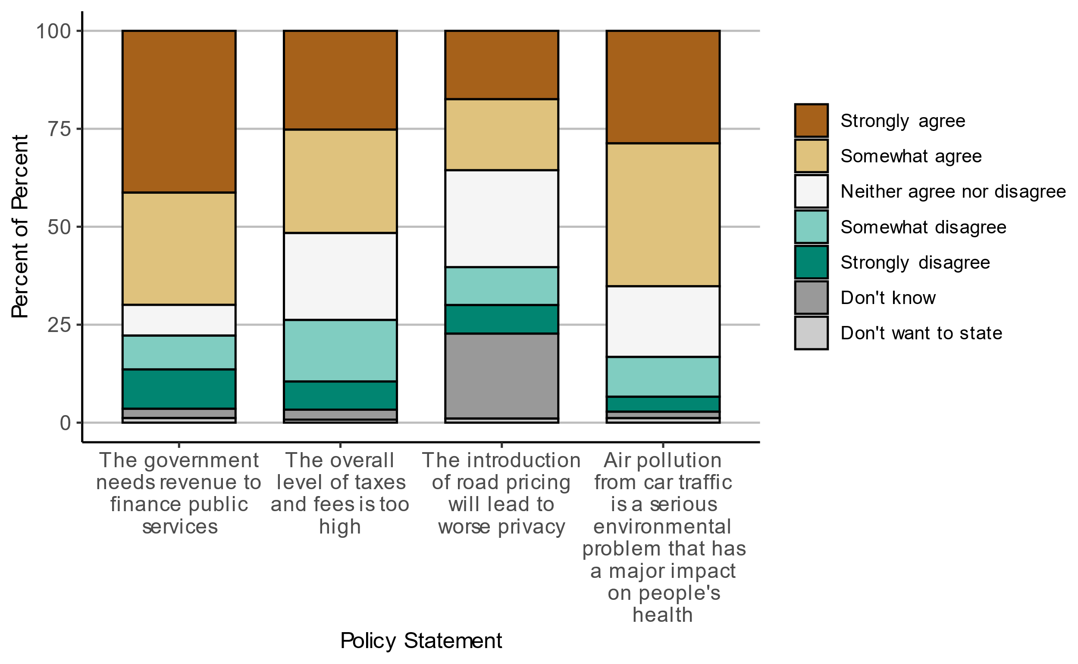

Figure 4.24: Level of agreement regarding various environmental and transport policy statements, for the main survey.

Figure 4.25 presents attitudes towards which groups will win or lose from road pricing for the main survey. Most respondents believe those with low incomes would lose as a result of road pricing. The responses regarding those with middle incomes and regarding themselves were quite similar, with the majority being “lose some” or “neither win nor lose”. Lastly, respondents indicated that those with high incomes would “win a lot” more often than the other groups. See Figure 0.22 in the Appendix for a similar figure based on the pilot survey.

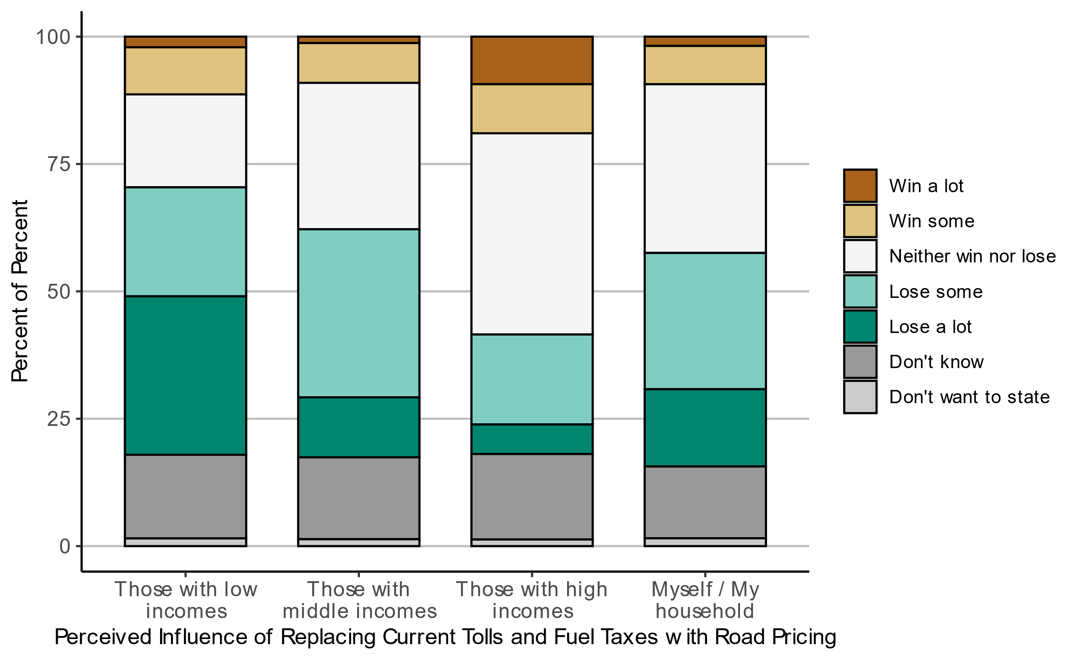

Figure 4.25: Attitudes towards which groups will win or lose from replacing current tolls and fuel taxes with road pricing, for the main survey.

Figure 4.26 shows that the main survey respondents who vote for moderate and populist parties think that revenues from road pricing should be spent on road investments. Those who vote for environmental parties think that revenue should be spent on investments in public transport, walking and cycling. See Figure 0.23 in the Appendix for an equivalent figure for the pilot survey.

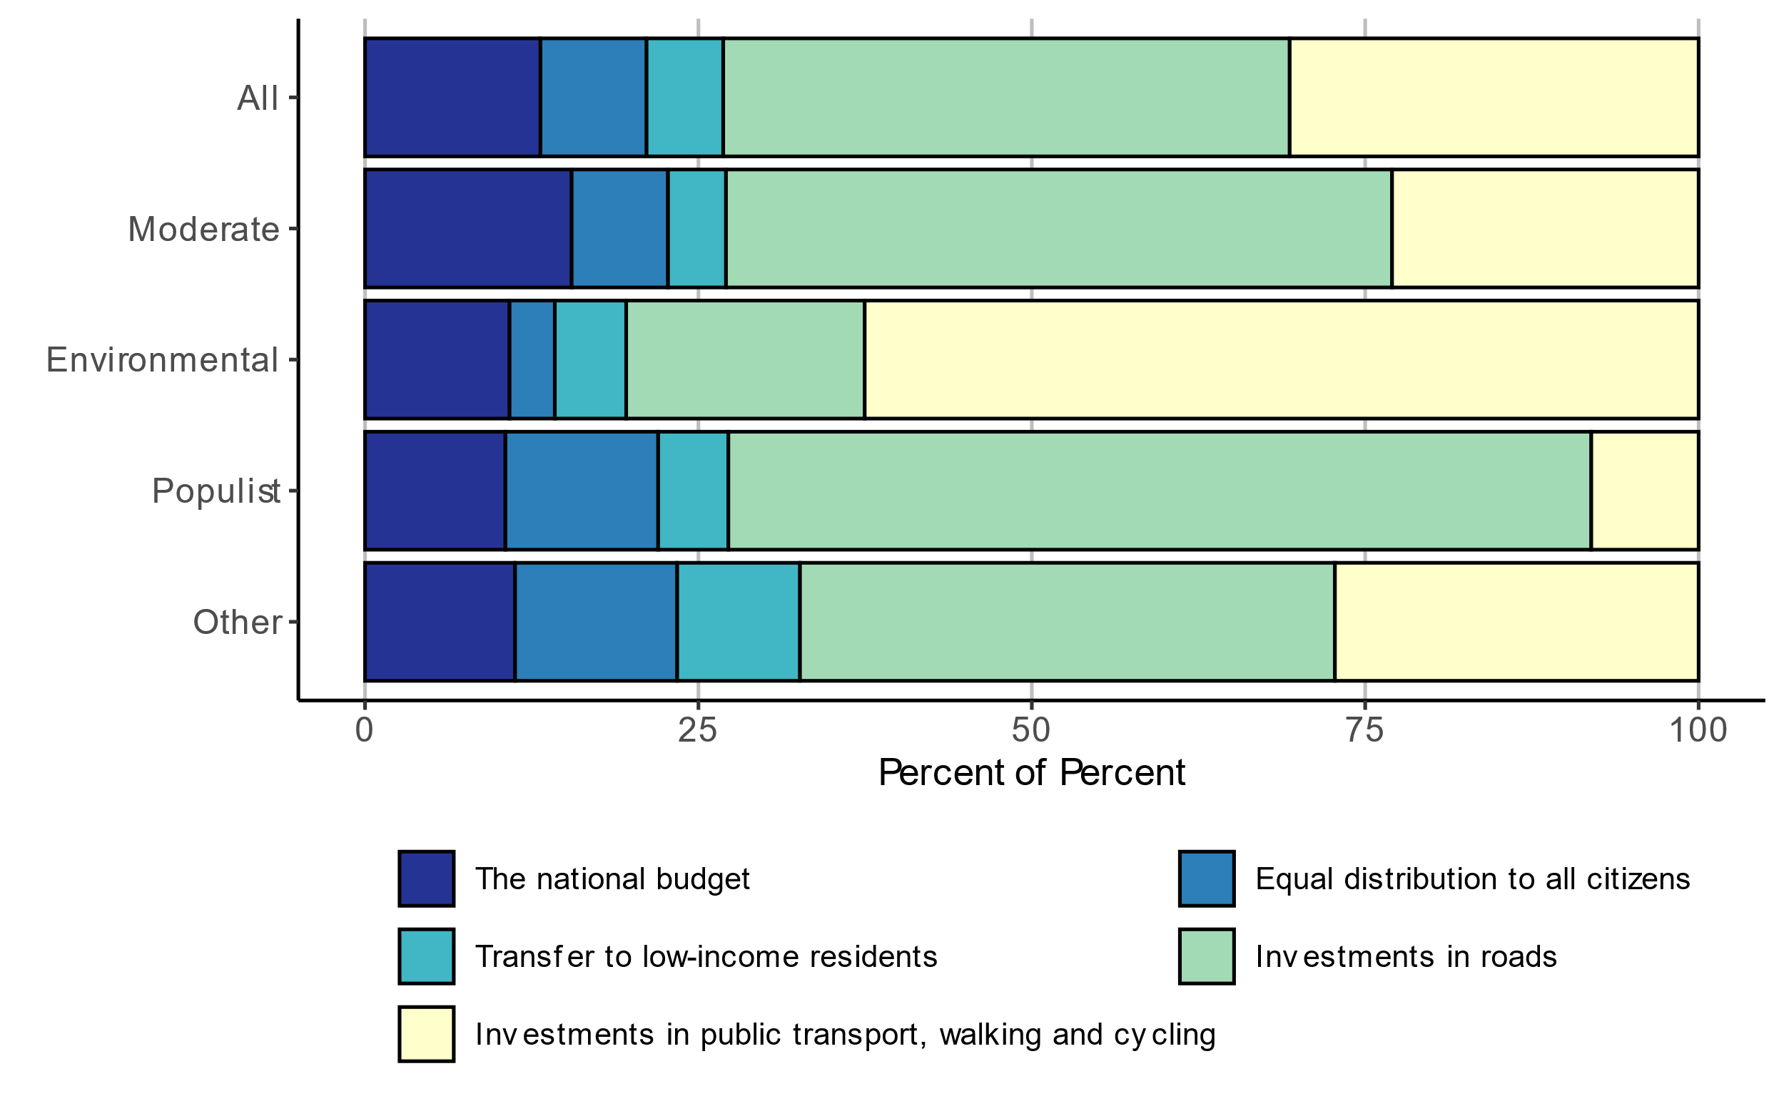

Figure 4.26: Preferences for how revenues from road pricing should be spent, for the main survey.

Figure 4.27 illustrates the main survey respondents’ views on the road pricing proposal and the current toll system. Respondents report stronger feelings (i.e. very positive or very negative) towards the road pricing proposal, and report more neutral feelings toward the current toll system.[18]

Figure 4.28 shows attitudes towards proposed road pricing and the current toll system by travel mode choice, for the main survey. Respondents who use a car are more negative towards road pricing and road tolls. Figure 4.29 describes attitudes towards the proposed road pricing and the current toll system by gender. The share of “very negative” attitudes towards road pricing and road tolls is higher for men. On the other hand, women are less certain about their attitudes as evidenced by the larger share of “don’t know” responses. Figure 4.30 shows attitudes towards the proposed road pricing and road tolls based on education. There are sizable differences in attitudes between education levels. Specifically, respondents with a basic school level are far more negative towards both concepts. This is important considering the basic school level is underrepresented in our sample (3% versus the national average of 23.7%, as shown in Table 4.1. Figure 4.31 presents attitudes towards the proposed road pricing and the current toll system by party bloc. Those in the environmental party bloc are more positive towards road pricing than the current toll system. Nearly 75% of respondents in the populist party bloc are negative towards both concepts.

Figure 4.32 shows the respondents’ attitudes towards the proposed road pricing by reported road toll expense. Respondents who report paying NOK 1-10 or NOK 41-60 in tolls are the most negative towards road pricing, with over 50% of the groups selecting “somewhat” or “very” negative. Figure 4.33 shows the respondents’ attitudes towards the current toll system by reported road toll. Interestingly, several groups have no respondents with very positive attitudes towards the current toll system, in contrast to the proposed road pricing which have some. Respondents who pay NOK 41-60 or more than NOK 100 in tolls are the most negative towards the current toll system. See Figure 0.24 and Figure 0.25 in the Appendix for attitudes by income categories, the attitudes are similar between categories.



Figure 4.27: Views on the road pricing proposal and the current toll system, for the main survey.

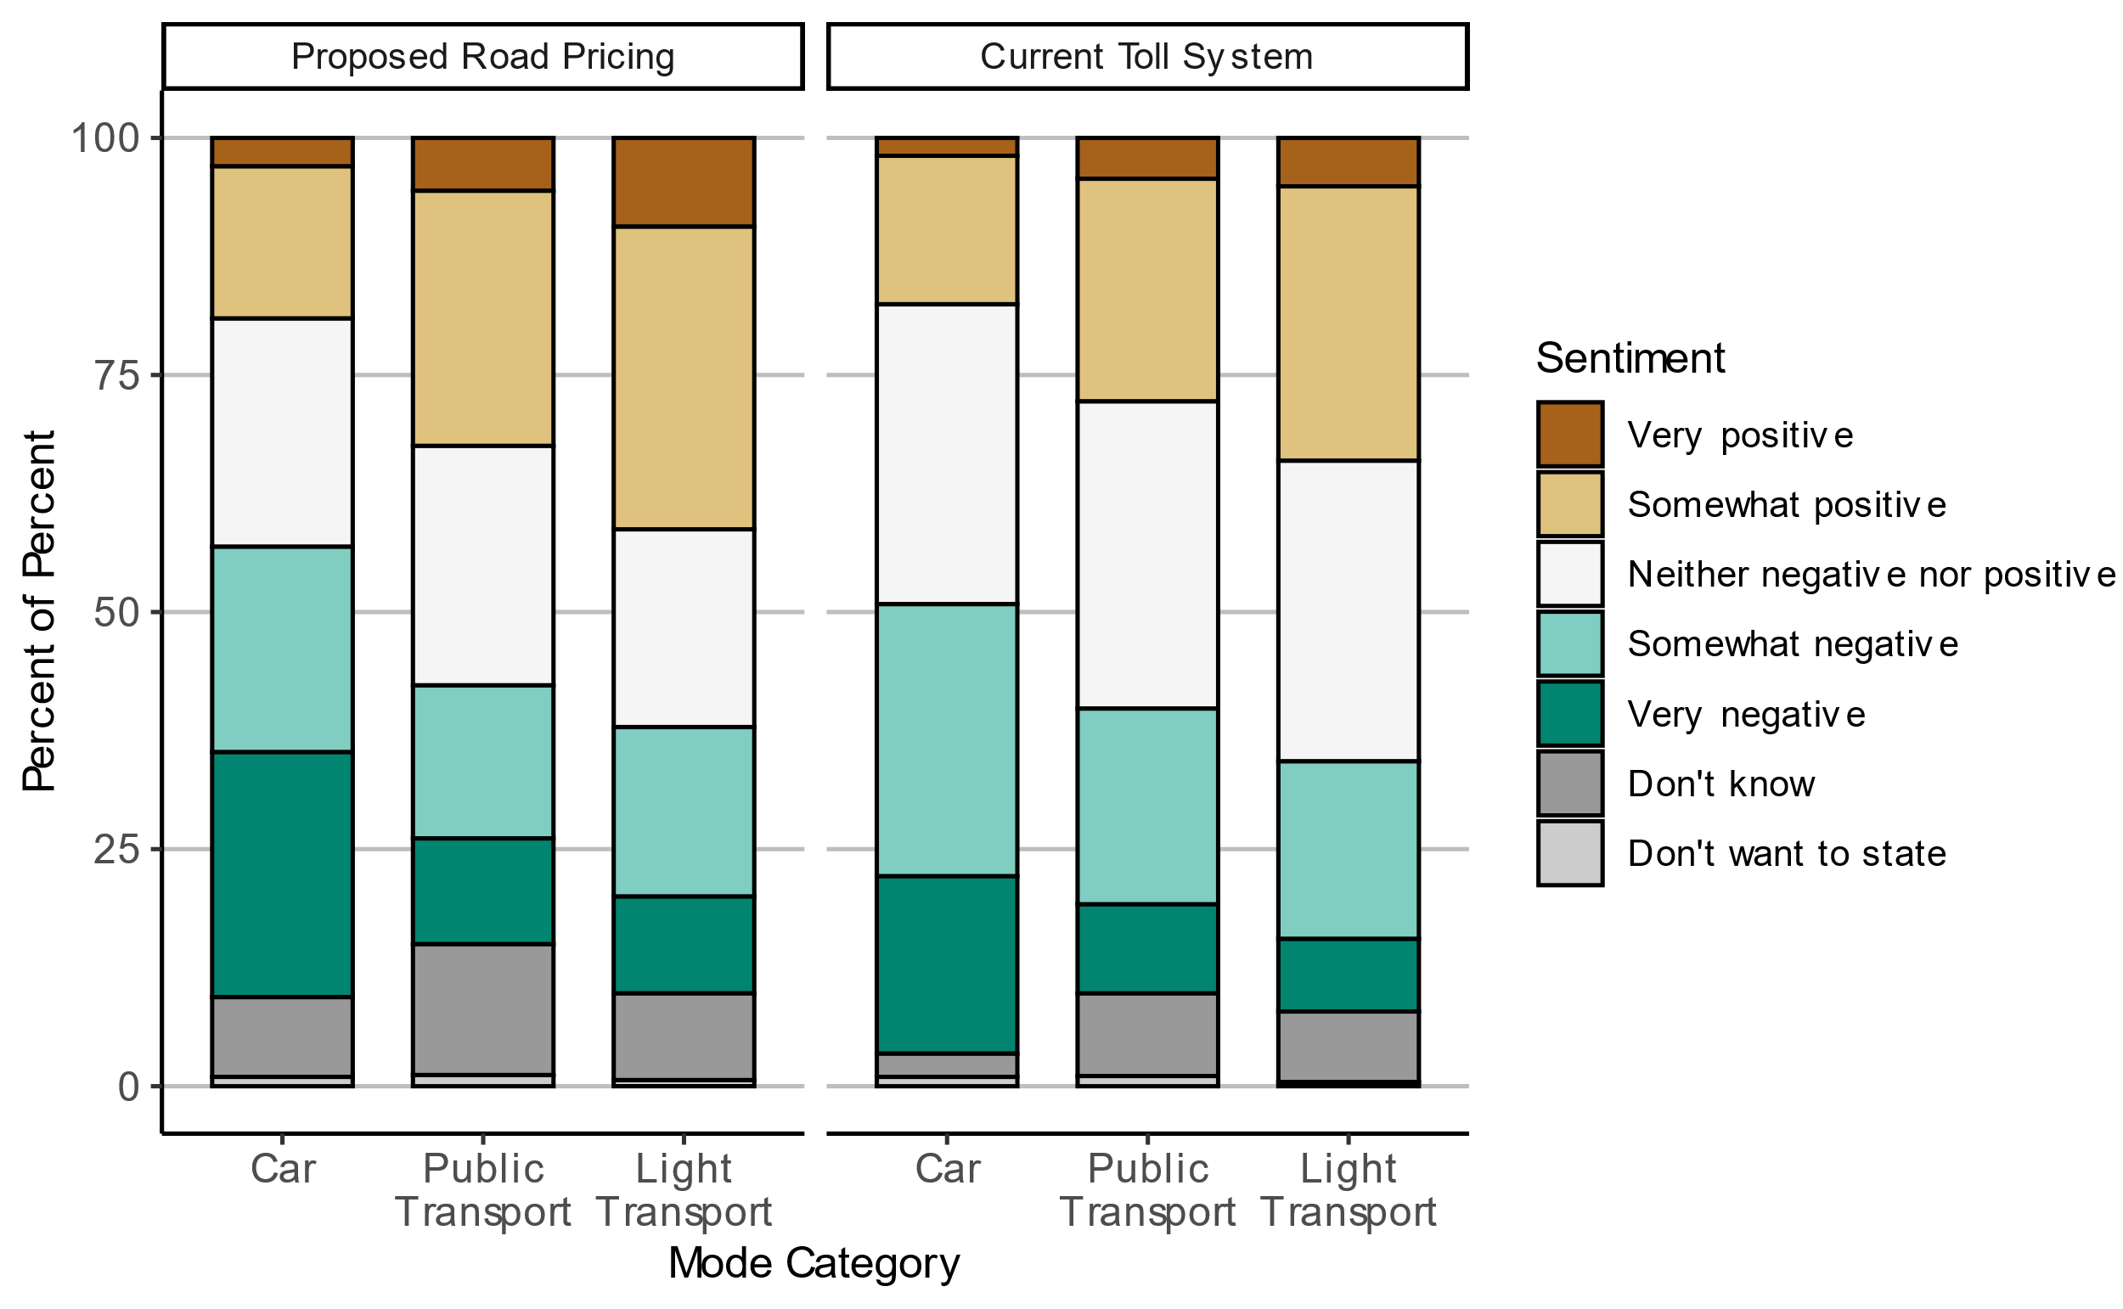

Figure 4.28: Attitudes towards proposed road pricing and current toll system by mode choice-, for the main survey.

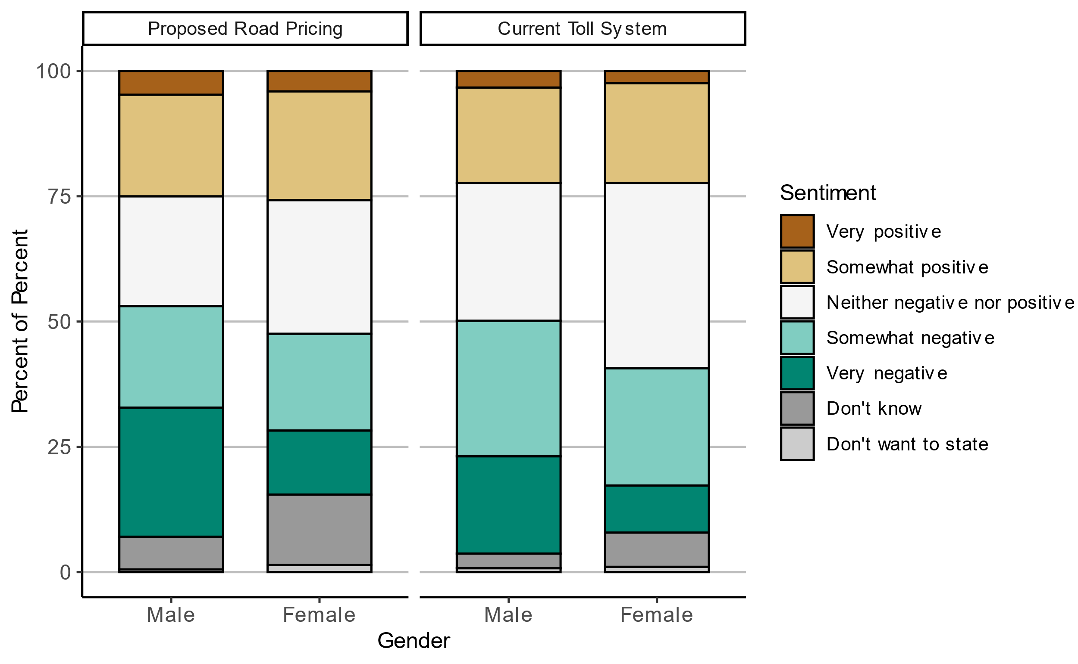

Figure 4.29: Attitudes towards proposed road pricing and current toll system by gender, for the main survey (Males N = 2082, Females N = 1714).

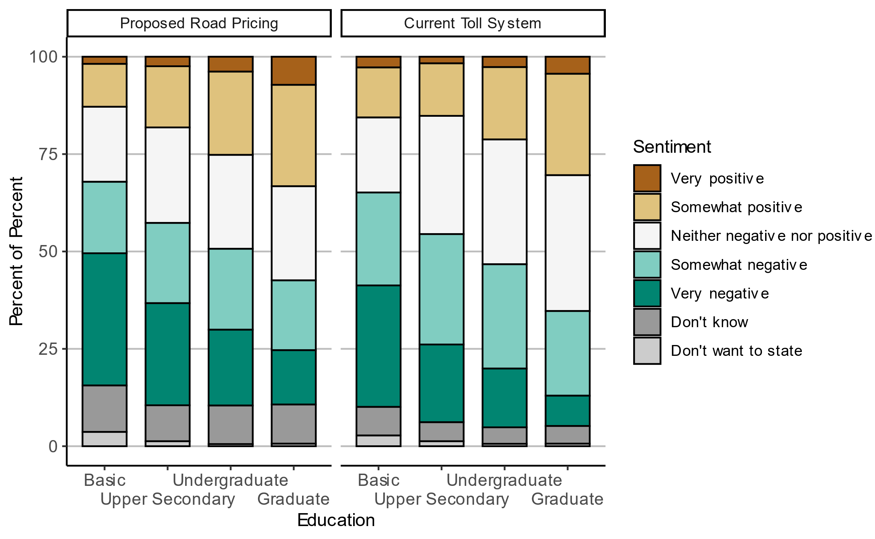

Figure 4.30: Attitudes towards proposed road pricing and current toll system by education, for the main survey.

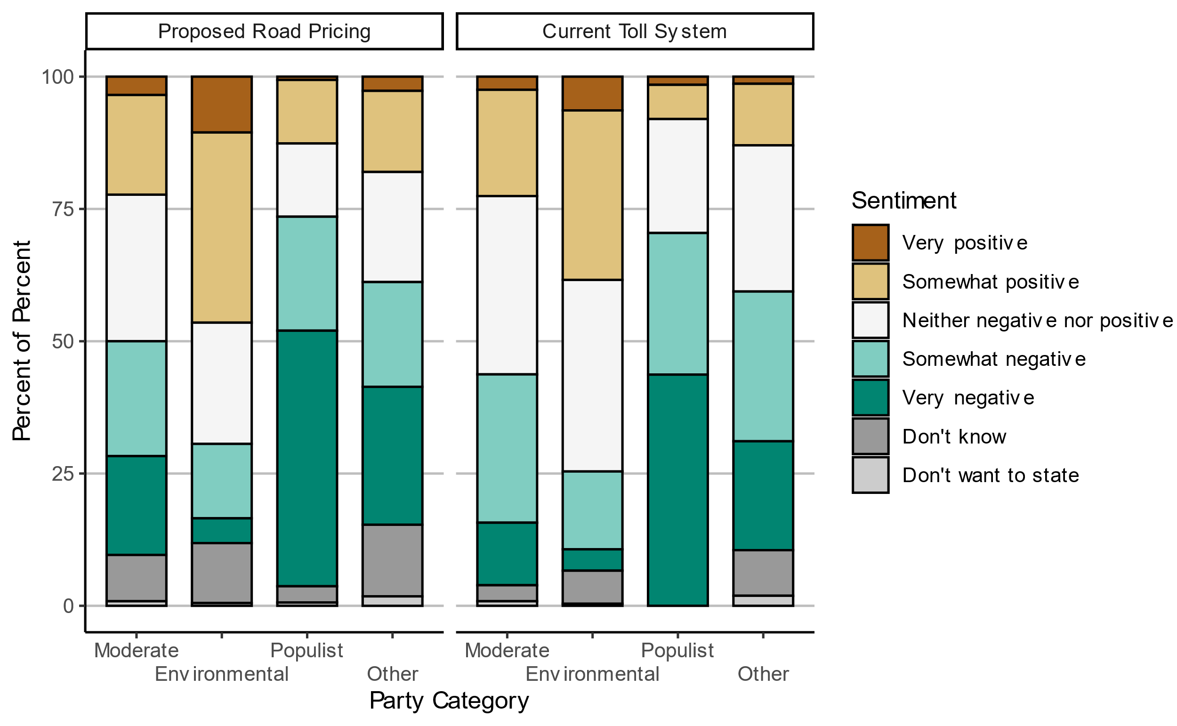

Figure 4.31: Attitudes towards proposed road pricing and current toll system by party bloc, for the main survey.

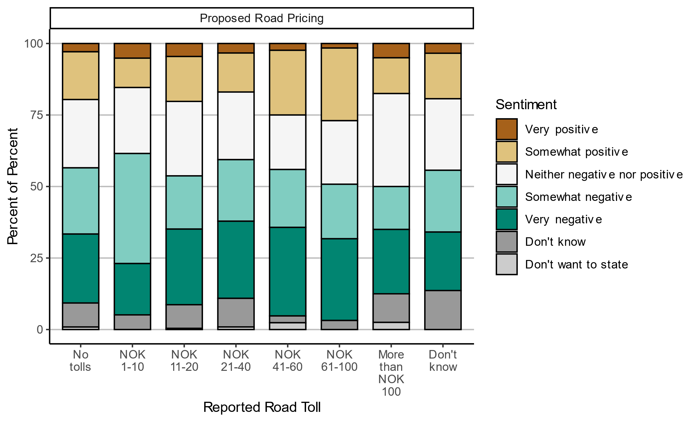

Figure 4.32: Attitudes towards proposed road pricing by reported road toll, for the main survey.

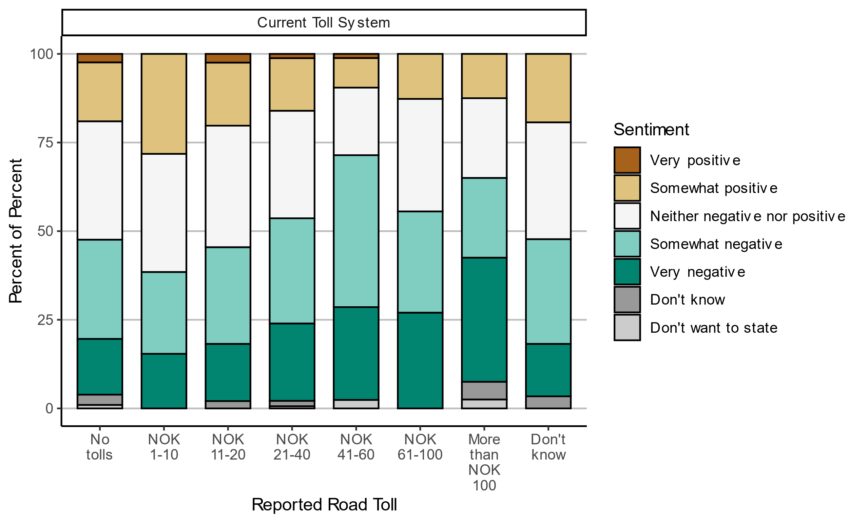

Figure 4.33: Attitudes towards current toll system by reported road toll, for the main survey.

# Summary and discussion

## Summary of results

In this report, we have documented the survey design and data collection, shown selected results and evaluated the representativeness of the data. In this section we briefly summarize and discuss the findings.

As expected, the main sample, which was recruited using the population register, is more representative than the pilot sample, where respondents were recruited through social media. Interestingly, the samples are similar in a few aspects: for instance, those who have high income and education and vote in elections are overrepresented in both samples, but they are quite different with respect to travel behavior and party support. Compared to the National Travel Survey, the main sample is somewhat overrepresented by public transport travelers, while the pilot survey is overrepresented by private car driving and biking.

Among those who reported voting in the last election, the main sample has a slight over-representation of voters for left-wing and/or environmental parties. The pilot sample is instead more “polarized” as it has an over-representation of voters who support an environmental party and voters who support a party labeled as populist (The Progress Party and the Industry and Business Party). The differences may be partly driven by the fact that there is a large over-representation of men in the pilot survey, but there are also considerable differences in party support between the two samples within each gender.

Regarding travel behavior and access to transport modes, the results are largely as expected. The majority of respondents owns or has access to a car. Work trips are mostly done by car, consistent with the National Travel Survey. While survey responses are concentrated in urban areas, there are enough trips occurring in rural areas to constitute a significant proportion of the total trips (around 60% of trips begin or end in a rural area). Roughly half of the respondents in both surveys that travel by car pay tolls on their trip. In addition, according to the road toll calculator, road tolls occur most frequently in more urbanized counties such as Oslo. When asked what the pay in road tolls, most respodents report toll costs consistent with the road toll calculator, but not all. On average, respondents tend to report that they pay somewhat more in tolls than the road toll calculator estimates that they do.

Regarding general political views and attitudes, our results show that about half of respondents think that Norway is a society where most people are in the middle of the distribution. When asked about how society should be, the vast majority want a society where most people are in the middle or near the top. Those who vote for populist parties tend to think that society is more unequal. Concerning trust in institutions, the main survey respondents are more trusting than the pilot survey respondents as the average trust is higher for each institution. Both survey samples tend to have relatively lower trust in politicians and higher trust in other authorities and institutions.

Finally, considering attitudes towards transport policies, our results suggest that opinions on road tolls and road tax reform are quite divided. Many respondents are negative towards both current road tolls and universal road pricing and do not expect the policy to reduce traffic congestion problems, air pollution and greenhouse gas emissions. However, there is also a large group of respondents who are neither positive nor negative, or do not know what their opinion is. Moreover, respondents are slightly more positive towards road pricing than current road tolls. Many respondents would like the revenues from road pricing to be earmarked to either road investments or investments in public transportation, walking and cycling infrastructure, as often found in previous literature.

Attitudes towards road tolls and road pricing vary considerably by gender, education, travel mode and political party. Those with higher education, public transport users and light transport users are more positive towards both policies. Those who vote for the populist party bloc indicate relatively more negative attitudes towards both road pricing and the toll system, compared to the other party blocs.

## Discussion

In this section, we discuss the implications of our results concerning the prospects of road tax reform in Norway. We also point out some limitations of our study.

The recruitment methods of the pilot survey and main survey were quite different. Since the pilot survey was recruited via Facebook, it was possible for survey respondents to share the survey with their social network, which was not the case for the main survey. We also note that the bicycle mode share for workplace trips for the pilot survey is higher than the national average, which is likely due to the fact that Syklistforeningen (Cyclists’ Association) agreed to share the Facebook post which would attract more frequent cyclists. These features imply that we cannot regard the pilot survey as representative, which is also reflected in the sociodemographic characteristics of the net sample.

The net sample of the main survey is also not perfectly in terms of observable characteristics. As is common with electronically administered surveys, the survey samples underrepresent lower-income and less-educated people, thus there are limits on the generalizability of the results. Our results show that those with low education are also more negative towards road tolls and road pricing, the same goes for those who drive a car on their daily trip or vote for populist parties. Given that these groups are somewhat underrepresented in our sample, opposition towards these policies in the population is likely to be somewhat stronger in the general population. Although the pilot survey cannot be regarded as representative, we note that the net sample from the pilot has a higher share of car drivers and voters of populist parties.

The results show that many respondents do not expect road pricing to have positive effects, and that it will have undesirable distributional effects. This is in line with previous literature (e.g. Douenne & Fabre, 2022). Notably, the majority of respondents disagree with the concept that road pricing will reduce their own driving more than they disagree with the other anticipated effects. This could be regarded as reasonable, since an increase in road taxes, if not extremely high, will only affect those who have a close substitute to making the trip by car. Trips who are already made by other modes and trips for which there are no good alternatives, will not be affected. However, it could also be that respondents underestimate their own opportunities for substitution – particularly in the longer run. Also, road pricing will not result in higher travel costs by car for all respondents, some will pay less.

Our results show that slightly more respondents are positive towards universal road pricing than towards current road tolls. One should note that in these questions, respondents are asked to express their opinion on each policy in isolation, they are not explicitly asked to choose between the two. (In the choice experiment, on the other hand, respondents are forced to choose between introducing road pricing and keeping the current system. The results from this experiment will be reported at a later stage.) Hence, we should be careful drawing conclusions about the prospects of road tax reform in Norway based on these results.

The fact that current road tolls are quite unpopular is interesting, given that about half of car drivers do not pay road tolls on their reported trip today. However, those who do not pay tolls may pay tolls on other trips, or may be afraid that they will do so in the future. Interestingly, not all drivers seem to be aware of what they pay in road tolls, which could have implications both for travel behavior and public support (Finkelstein, 2009).

In our results, attitudes towards both road pricing and road tolls vary considerably by gender, education, travel mode and political party. Among car drivers, there is no clear tendency that those who pay high road tolls today are more in favor of replacing road tolls with road pricing. However, these findings are just bivariate correlations, not causal relationships. In future work, one should look more closely into causal explanations of support for, or opposition against road pricing, and what this implies for the prospects of a road tax reform receiving the support necessary for implementation.

## Further Research

There are many opportunities for subsequent research on this topic, both using the data described in this report and other data and methods. In this report, we have not utilized the data from the choice experiment. The choice experiment data provides a more direct test of support for road tax reform, since respondents are explicitly asked to choose between universal road pricing and current policies. It also allows us to test for the effect of key characteristics of the policy (pricing scheme and use of revenues), as well as additional information about the effects of the policy.

Our results suggest that opinions on road pricing and other transport policies are quite divided, with some respondents expressing strong support and some strong opposition. There is probably a large heterogeneity also in the preferences for the design of the road pricing scheme (prices and use of revenues), and possibly in the effect of additional information. One method which could be suitable for capturing this kind of heterogeneity is latent class modelling, which allows for a limited number of distinct classes with different preferences.[19] With this method, one could also investigate which factors predict membership of a given class, for instance gender, current car use and party support. Advanced machine learning methods could also prove useful in this respect.

In our survey, respondents state their opinion on a policy that has not been introduced, and that they do not have any experience with. Even if our data allows us to test for the effect of additional information, we can only evaluate the effect within the context of a one-shot survey. Conducting field experiments with repeated surveys would allow us to study experiences with pricing incentives or the effect of information about prices. The drawback of field experiments, on the other hand, is that they are often of a limited scale and participants do not experience the full consequences of the policy. Ideally, one would like to run a full-scale pilot of road pricing in one or several cities, which would make it possible to both experience and evaluate the effect on traffic and congestion, and on public opinion.

# References

Baranzini, A., Carattini, S., & Tesauro, L. (2021). Designing effective and acceptable road pricing schemes: evidence from the Geneva congestion charge. *Environmental and Resource Economics,* 79(3), 417-482.

Börjesson, M., Asplund, D., & Hamilton, C. (2023). Optimal kilometre tax for electric vehicles. *Transport Policy*.

Börjesson, M., Eliasson, J., Hugosson, M. B., & Brundell-Freij, K. (2012). The Stockholm congestion charges—5 years on. Effects, acceptability and lessons learnt. *Transport Policy*, 20, 1-12.

De Borger, B., & Proost, S. (2012). A political economy model of road pricing. *Journal of Urban Economics,* 71(1), 79-92.

Douenne, T., & Fabre, A. (2022). Yellow vests, pessimistic beliefs, and carbon tax aversion. *American Economic Journal: Economic Policy,* 14(1), 81-110.

Finkelstein, A. (2009). E-ztax: Tax salience and tax rates. *The Quarterly Journal of Economics,* 124(3), 969-1010.

ITF (2023), *Decarbonisation and the Pricing of Road Transport: Summary and Conclusions.* ITF Roundtable Reports, No. 191, OECD Publishing, Paris.

Skatteetaten & Statens vegvesen (2022). *KVU Veibruksavgift og bompenger. Konseptvalgutredning Trinn 1 – versjon 1.0.* 15.november 2022

Sælen, H., & Kallbekken, S. (2011). A choice experiment on fuel taxation and earmarking in Norway. *Ecological Economics,* 70(11), 2181-2190.

Tatham, M., & Peters, Y. (2022). Fueling opposition? Yellow vests, urban elites, and fuel taxation. *Journal of European Public Policy,* 1-25.

Aasen, M., & Sælen, H. (2022). Right-wing populism and climate policies: Explaining opposition to road tolls in Norway. *Transportation Research Part D: Transport and Environment, 105*, 103222.

Appendix

1. Questionnaire

|  |  |  |
| --- | --- | --- |
| |  |  | | --- | --- | | **samtykke_detalj** | **Do you want to participate in a research project?**  **A-PLANET is a research project that deals with the choices we make when we travel, what explains these choices and possible measures to make the transport system better. The researchers will investigate how people feel about various interventions through surveys and experiments.**  **Who is responsible for the research project?**  **The Institute of Transport Economics (TØI) is responsible for the project.**  **Why are you being asked to participate?**  **This survey is sent to persons who are randomly drawn from the National Registry. Your contact information (e-mail) will be treated confidentially by TØI after your consent.**  **What does it mean for you to participate?**  **If you would like to participate, please complete this questionnaire, which will take approximately 10 minutes. If you complete the questionnaire, you will be entered into a draw for gift cards worth NOK 5000. To enter the draw, you must provide your contact information. The questionnaire includes questions about where you live, your travel habits, opinions about the political situation in Norway and you will be asked to choose between alternative hypothetical transportation measures.**  **Participation is voluntary.**  **Participation in the project is voluntary. If you choose to participate, you may withdraw your consent at any time without giving any reason. All your personal data will then be deleted. There will be no negative consequences for you if you do not want to participate or later choose to withdraw.**  **Your privacy – how we store and use your information**  **We will only use your information for the purposes we have explained in this letter. We treat the information confidentially and in accordance with the privacy regulations. As long as you can be connected directly to the survey, only selected project staff at TØI will have access to the data. The technical registration of the survey responses is undertaken by Walr (https://walr.com/). TØI is the data controller, and the relationship is regulated by contract. Reports and publications from this study will only include information at the group level, i.e. individuals cannot be identified.**  **What happens to your personal data when the research project ends?**  **All information is anonymised so that individual participants cannot be identified. An anonymised data set is stored for further research, while other information is deleted after the end of the project (scheduled for 2025).**  **What gives us the right to process personal data about you?**  **We process information about you based on your consent. On behalf of TØI, Sikt – the knowledge sector's service provider has assessed that the processing of personal data in this project complies with the privacy regulations**  **Your rights**  **As long as you can be identified in the data material, you have the right to:**  **- access to what information we process about you, and to receive a copy of the information**  **- to have information about you corrected that is incorrect or misleading**  **- to have personal data about you deleted;**  **- to lodge a complaint with the Norwegian Data Protection Authority about the processing of your personal data**  **If you have questions about the study, or want to know more about or make use of your rights, read more on the project website https://www.toi.no/aplanet/ or contact project manager Alice Ciccone (aci@toi.no) or the data protection officer's contact person at TØI: Silvia Olsen at silvia.olsen@toi.no**  **If you have any questions related to the assessment made by the privacy services from Sikt, you can contact us by email to personverntjenester@sikt.no or by phone 73 98 40 40.** | |
| |  |  |  | | --- | --- | --- | | w **Answer control:** * | | | | That's okay, start the survey | |  | | --- | | ¡ | | 1 | | No, I don't want to participate anyway | |  | | --- | | ¡ | | 2 | |

|  |  |  |
| --- | --- | --- |
| |  |  | | --- | --- | | **county** | **Where do you live?** | |
| |  |  |  |  | | --- | --- | --- | --- | | College | |  | | --- | | ¡ | | 1 | | Akershus | |  | | --- | | ¡ | | 2 | | Buskerud | |  | | --- | | ¡ | | 3 | | Finnmark | |  | | --- | | ¡ | | 4 | | Inland | |  | | --- | | ¡ | | 5 | | Møre og Romsdal | |  | | --- | | ¡ | | 6 | | Nordland | |  | | --- | | ¡ | | 7 | | Oslo | |  | | --- | | ¡ | | 8 | | Rogaland | |  | | --- | | ¡ | | 9 | | Telemark | |  | | --- | | ¡ | | 10 | | Troms | |  | | --- | | ¡ | | 11 | | Trøndelag | |  | | --- | | ¡ | | 12 | | Vestfold | |  | | --- | | ¡ | | 13 | | Western Norway | |  | | --- | | ¡ | | 14 | | See also | |  | | --- | | ¡ | | 15 | |

|  |  |  |
| --- | --- | --- |
| |  |  | | --- | --- | | **residence** | **{{\county.a}}**  **Where do you live?**  **You can search for your address in the field or tap the map to zoom in, position, or move your cursor** | |
| |  |  |  | | --- | --- | --- | | Coordinate | Open | 1 | |

|  |  |  |
| --- | --- | --- |
| |  |  | | --- | --- | | **access** | **Do you own or have access to...** | |
| |  |  |  |  |  | | --- | --- | --- | --- | --- | |  | I own | I don't own, but I have access | I don't have access to |  | |  | 1 | 2 | 3 |  | | car? | |  | | --- | | ¡ | | |  | | --- | | ¡ | | |  | | --- | | ¡ | | 1 | | bicycle (electric or regular)? | |  | | --- | | ¡ | | |  | | --- | | ¡ | | |  | | --- | | ¡ | | 2 | |

|  |  |  |
| --- | --- | --- |
| |  |  | | --- | --- | | **bil_plan** | **Are you planning to buy a car in the next 12 months?**  **You can select several options** | |
| |  |  |  |  | | --- | --- | --- | --- | | Yes, petrol car | |  | | --- | | o | | 1 | | Yes, diesel car | |  | | --- | | o | | 2 | | Yes, hybrid or plug-in hybrid | |  | | --- | | o | | 3 | | Yes, electric car | |  | | --- | | o | | 4 | | w **Exclusive:** yes  No | |  | | --- | | ¡ | | 5 | |

|  |  |  |
| --- | --- | --- |
| |  |  | | --- | --- | | **reise_form** | **Think of a journey you make daily or regularly from your home to another place. For example, it could be a trip to work, school or somewhere else you go regularly. Choose a journey that lasts at least 10 minutes (one way).**  **What is the destination of this trip?** | |
| |  |  |  |  | | --- | --- | --- | --- | | Travel to workplace | |  | | --- | | ¡ | | 1 | | Travel to school/educational institution | |  | | --- | | ¡ | | 2 | | Travel for work/due to work | |  | | --- | | ¡ | | 3 | | Bring/pick up children or adults | |  | | --- | | ¡ | | 4 | | Purchases or other errands | |  | | --- | | ¡ | | 5 | | Visit someone | |  | | --- | | ¡ | | 6 | | Recreational activity (culture, sports, etc.) | |  | | --- | | ¡ | | 7 | | Other: | Open | 8 | | I have no regular travel (of at least 10 min) outside my home | |  | | --- | | ¡ | | 9 | |

|  |  |  |
| --- | --- | --- |
| |  |  | | --- | --- | | **reise_mal** | **{{\county.a}}**  **Where is the destination for this journey?**  **You can search for your address in the field or tap the map to zoom in, position, or move your cursor** | |
| |  |  |  | | --- | --- | --- | | Coordinate | Open | 1 | |

|  |  |  |
| --- | --- | --- |
| |  |  | | --- | --- | | **reise_ofte** | **How often do you make this journey?** | |
| |  |  |  |  | | --- | --- | --- | --- | | 6 or more times per week | |  | | --- | | ¡ | | 1 | | 4-5 times per week | |  | | --- | | ¡ | | 2 | | 2-3 times a week | |  | | --- | | ¡ | | 3 | | 1 time per week | |  | | --- | | ¡ | | 4 | | Rarer | |  | | --- | | ¡ | | 5 | |

|  |  |  |
| --- | --- | --- |
| |  |  | | --- | --- | | **reise_tidspkt** | **Think about the journey from home to the destination you have entered.**  **What time of day do you usually travel?** | |
| |  |  |  |  | | --- | --- | --- | --- | | In the morning, during rush hour | |  | | --- | | ¡ | | 1 | | In the morning, outside rush hour | |  | | --- | | ¡ | | 2 | | At noon | |  | | --- | | ¡ | | 3 | | In the afternoon, during rush hour | |  | | --- | | ¡ | | 4 | | In the afternoon, outside rush hour | |  | | --- | | ¡ | | 5 | | In the evening | |  | | --- | | ¡ | | 6 | | Other / Not Applicable | |  | | --- | | ¡ | | 7 | |

|  |  |  |
| --- | --- | --- |
| |  |  | | --- | --- | | **reise_trmid** | **How do you usually travel on this journey?**  **If you use multiple means of transport, choose the one that takes you the farthest. If your mode of travel varies, state how you usually travel at this time of year.** | |
| |  |  |  |  | | --- | --- | --- | --- | | Private car (driver) | |  | | --- | | ¡ | | 1 | | Private car (passenger) | |  | | --- | | ¡ | | 2 | | Bus | |  | | --- | | ¡ | | 3 | | Underground, light rail or tram | |  | | --- | | ¡ | | 4 | | Train | |  | | --- | | ¡ | | 5 | | On foot | |  | | --- | | ¡ | | 6 | | Bicycle (regular or electric) | |  | | --- | | ¡ | | 7 | | Motorcycle/moped | |  | | --- | | ¡ | | 8 | | Ferry/boat | |  | | --- | | ¡ | | 9 | | Scooter / e-scooter | |  | | --- | | ¡ | | 10 | | Other means of travel: | Open | 11 | |

|  |  |  |
| --- | --- | --- |
| |  |  | | --- | --- | | **bil_type** | **What type of car do you usually use on this journey?** | |
| |  |  |  | | --- | --- | --- | | w **Filter:** \reise_trmid.a=1; 2 | | | | Petrol car | |  | | --- | | ¡ | | 1 | | Diesel car | |  | | --- | | ¡ | | 2 | | Hybrid car or plug-in hybrid | |  | | --- | | ¡ | | 3 | | Electric car | |  | | --- | | ¡ | | 4 | | w **Exclusive:** yes  None of these | |  | | --- | | ¡ | | 5 | |

|  |  |  |
| --- | --- | --- |
| |  |  | | --- | --- | | **reise_ko** | **What are the traffic conditions on the road usually like on your journey?** | |
| |  |  |  |  | | --- | --- | --- | --- | | A lot of queuing | |  | | --- | | ¡ | | 1 | | Some queuing | |  | | --- | | ¡ | | 2 | | Little or no queue | |  | | --- | | ¡ | | 3 | | Don't know/Not relevant | |  | | --- | | ¡ | | 4 | |

|  |  |  |
| --- | --- | --- |
| |  |  | | --- | --- | | **reise_varigh** | **How long does the journey usually take (one way)?** | |
| |  |  |  |  | | --- | --- | --- | --- | | 0-9 minutes | |  | | --- | | ¡ | | 1 | | 10-19 minutes | |  | | --- | | ¡ | | 2 | | 20-39 minutes | |  | | --- | | ¡ | | 3 | | 40-59 minutes | |  | | --- | | ¡ | | 4 | | 1-2 hours | |  | | --- | | ¡ | | 5 | | More than 2 hours | |  | | --- | | ¡ | | 6 | |

|  |  |  |
| --- | --- | --- |
| |  |  | | --- | --- | | **reise_bomp** | **Think about the journey from home to the destination you have entered.**  **Do you pay tolls on this journey?** | |
| |  |  |  | | --- | --- | --- | | w **Filter:** \reise_trmid.a=1; 2 | | | | Yes | |  | | --- | | ¡ | | 1 | | No | |  | | --- | | ¡ | | 2 | | Don't know | |  | | --- | | ¡ | | 3 | |

|  |  |  |
| --- | --- | --- |
| |  |  | | --- | --- | | **reise_kostn** | **How much do you pay in tolls on this journey?** | |
| |  |  |  | | --- | --- | --- | | w **Filter:** \reise_bomp.a=1 | | | | 1-10 NOK | |  | | --- | | ¡ | | 1 | | NOK 11-20 | |  | | --- | | ¡ | | 2 | | NOK 21-40 | |  | | --- | | ¡ | | 3 | | NOK 41-60 | |  | | --- | | ¡ | | 4 | | NOK 61-100 | |  | | --- | | ¡ | | 5 | | More than NOK 100 | |  | | --- | | ¡ | | 6 | | Don't know | |  | | --- | | ¡ | | 7 | | There are no tolls on this journey | |  | | --- | | ¡ | | 8 | |

|  |  |  |
| --- | --- | --- |
| |  |  | | --- | --- | | **reise_trmid_alt** | **Think about the journey from home to the destination you have entered.**  **If you had to travel in a different way than you normally do, what would be the best option out of those available to you?** | |
| |  |  |  |  | | --- | --- | --- | --- | | Private car (driver) | |  | | --- | | ¡ | | 1 | | Private car (passenger) | |  | | --- | | ¡ | | 2 | | Bus | |  | | --- | | ¡ | | 3 | | Metro, light rail or tram | |  | | --- | | ¡ | | 4 | | Train | |  | | --- | | ¡ | | 5 | | On foot | |  | | --- | | ¡ | | 6 | | Bicycle (regular or electric) | |  | | --- | | ¡ | | 7 | | Motorcycle/moped | |  | | --- | | ¡ | | 8 | | I have no other options | |  | | --- | | ¡ | | 9 | | Other means of travel: | Open | 10 | |

|  |  |  |
| --- | --- | --- |
| |  |  | | --- | --- | | **reise_trmid_alt_1** | **How would you rate the alternative mode of travel ({{\reise_trmid_alt.a}})?**  **How would you rate the alternative mode of travel?** | |
| |  |  |  | | --- | --- | --- | | w **Filter:** !\reise_trmid_alt.a=9 | | | | Almost as good as my usual mode of travel | |  | | --- | | ¡ | | 1 | | Something worse than my usual mode of travel | |  | | --- | | ¡ | | 2 | | Much worse than my usual mode of travel | |  | | --- | | ¡ | | 3 | | Don't know | |  | | --- | | ¡ | | 4 | |

|  |  |  |
| --- | --- | --- |
| |  |  | | --- | --- | | **reise_trmid_alt_2** | **You have stated that you have no alternatives. Can you elaborate on this?** | |
| |  |  |  | | --- | --- | --- | | w **Filter:** \reise_trmid_alt.a=9 | | | |  | Open | 1 | |

|  |  |  |
| --- | --- | --- |
| |  |  | | --- | --- | | **fordeling_beskr** | **These five figures illustrate different societies with unequal distribution of wealth.**  **Which figure do you think best describes Norway?** | |
| |  |  |  |  | | --- | --- | --- | --- | | A small elite at the top, very few in the middle and most at the bottom | |  | | --- | | ¡ | | 1 | | A society shaped like a pyramid with a small elite at the top, several in the middle and most at the bottom. | |  | | --- | | ¡ | | 2 | | Like a pyramid, but where only a few are at the bottom. | |  | | --- | | ¡ | | 3 | | A society where most people are in the middle | |  | | --- | | ¡ | | 4 | | Many near the top, and only a few near the bottom | |  | | --- | | ¡ | | 5 | | Don't know | |  | | --- | | ¡ | | 6 | |

|  |  |  |
| --- | --- | --- |
| |  |  | | --- | --- | | **fordeling_ideell** | **How do you think Norway should be?** | |
| |  |  |  |  | | --- | --- | --- | --- | | A small elite at the top, very few in the middle and most at the bottom | |  | | --- | | ¡ | | 1 | | A society shaped like a pyramid with a small elite at the top, several in the middle and most at the bottom. | |  | | --- | | ¡ | | 2 | | Like a pyramid, but where only a few are at the bottom. | |  | | --- | | ¡ | | 3 | | A society where most people are in the middle | |  | | --- | | ¡ | | 4 | | Many individuals near the top, and only a few near the bottom | |  | | --- | | ¡ | | 5 | | Don't know | |  | | --- | | ¡ | | 6 | |

|  |  |  |
| --- | --- | --- |
| |  |  | | --- | --- | | **fordeling_rettf** | **How fair do you think the distribution of wealth is in Norway?** | |
| |  |  |  |  | | --- | --- | --- | --- | | Very fair | |  | | --- | | ¡ | | 1 | | Pretty fair | |  | | --- | | ¡ | | 2 | | Pretty unfair | |  | | --- | | ¡ | | 3 | | Very unfair | |  | | --- | | ¡ | | 4 | | Don't know | |  | | --- | | ¡ | | 5 | |

|  |  |
| --- | --- |
| |  | | --- | | **Information** | |
| |  | | --- | | The results of this study will provide new knowledge that may have implications for future tax policy.  Imagine that the government introduces a new taxation system for drivers, which we will henceforth call road pricing. We focus here on the tax for passenger cars.  Road pricing is a fee per kilometre driven that depends on when, where and what kind of car one drives. The fee is higher in places where traffic contributes more to problems such as congestion and pollution, such as in urban areas during rush hour.  Road pricing will replace the current tolls and taxes on fuel.  Your privacy will be safeguarded so that no information about where and when you drive will be shared, only how much you will pay. | |

|  |  |
| --- | --- |
| |  | | --- | | **Information** | |
| |  | | --- | | The fee has three different rates for driving in:  urban areas during rush hour, urban areas outside rush hour, outside the city, all day.  By urban areas we mean both large cities and the centers of smaller cities. Drivers of electric cars and other zero-emission vehicles pay a different price, between 25 and 100 percent of the usual price. 100 percent means that it is the same price for electric cars as for other cars. Hybrid cars have the same price as diesel and gasoline cars.  Example:  Suppose the following rates apply:  If you drive 10 kilometres with a diesel or petrol car during rush hour, and half of this journey is within an urban area, you will in this case pay NOK 4/km x 5 km + 20 øre/km x 5 km = NOK 21.  If, on the other hand, you drive an electric car, you pay NOK 10 and 50 øre. | |

|  |  |  |
| --- | --- | --- |
| |  |  | | --- | --- | | **veipris_tst** | **Suppose the following rates apply:**  **Imagine driving 10 kilometres with a diesel car during rush hour in an urban area.**  **How much will this trip cost you?** | |
| |  |  |  |  | | --- | --- | --- | --- | | NOK 4 | |  | | --- | | ¡ | | 1 | | NOK 20 | |  | | --- | | ¡ | | 2 | | NOK 30 | |  | | --- | | ¡ | | 3 | | NOK 40 | |  | | --- | | ¡ | | 4 | |

|  |  |  |
| --- | --- | --- |
| |  |  | | --- | --- | | **veipris_tst2** | **It was wrong, you can try again:**  **Suppose the following prices apply**  **Imagine driving 10 kilometres with a diesel car during rush hour in an urban area.**  **How much will this trip cost you?** | |
| |  |  |  | | --- | --- | --- | | w **Filter:** \veipris_tst.a=1; 2; 3 | | | | NOK 4 | |  | | --- | | ¡ | | 1 | | NOK 20 | |  | | --- | | ¡ | | 2 | | NOK 30 | |  | | --- | | ¡ | | 3 | | NOK 40 | |  | | --- | | ¡ | | 4 | |

|  |  |  |
| --- | --- | --- |
| |  |  | | --- | --- | | **veipris_svar** | **The correct answer is 40 kroner!**  **If you drive 10 kilometres with a diesel car during rush hour in an urban area, you pay NOK 4/km x 10 km = NOK 40.** | |
| |  |  |  |  | | --- | --- | --- | --- | | Continue | |  | | --- | | ¡ | | 1 | |

|  |  |  |
| --- | --- | --- |
| |  |  | | --- | --- | | **inntekt_bruk** | **Today, the revenues from tolls are used to finance roads and other transport purposes. The revenue from road pricing can be used in one of the following ways:**  **The central government budget: The Government and the Storting decide how the revenues are to be spent in line with their priorities.**  **Equal transfer: The income is paid back to the citizens, evenly distributed.**  **Transfer to low-income residents: Income is redistributed to low-income residents.**  **Investments in roads: The revenues are used for improvements in the road network.**  **Investments in public transport, walking and cycling: The proceeds are used for improvements in public transport, walking and cycling infrastructure.**  **Which use of the proceeds do you prefer?** | |
| |  |  |  |  | | --- | --- | --- | --- | | The national budget | |  | | --- | | ¡ | | 1 | | Equal transmission | |  | | --- | | ¡ | | 2 | | Transfer to low-income residents | |  | | --- | | ¡ | | 3 | | Investments in roads | |  | | --- | | ¡ | | 4 | | Investments in public transport, walking and cycling | |  | | --- | | ¡ | | 5 | |

|  |  |  |
| --- | --- | --- |
| |  |  | | --- | --- | | **treatment_gr** | **Group division respondents** | |
| |  |  |  | | --- | --- | --- | | w **Answer control:** 1 when \random.a.1=0:249 2 when \random.a.1=250:499 3 when \random.a.1=500:749 4 when \random.a.1=750:1000  w **Set answer:** sys_range c | | | | Control | |  | | --- | | ¡ | | 1 | | Treatment1 congestion and pollution | |  | | --- | | ¡ | | 2 | | Treatment2 public services | |  | | --- | | ¡ | | 3 | | Treatment3 benefits road pricing | |  | | --- | | ¡ | | 4 | |

|  |  |
| --- | --- |
| |  | | --- | | **Information** | |
| |  | | --- | | w **Filter:** \treatment_gr.a=2; 3; 4  According to the European Environment Agency (EEA), air pollution is the environmental problem in Europe that causes the greatest harm to people's health. Pollution is one of the most common causes of cancer and other deadly diseases.  The rationale for road pricing is that driving in urban areas contributes more to congestion and pollution than driving outside urban areas. Therefore, it should cost more to drive in urban areas, especially during rush hour. Electric cars pollute less than diesel and petrol cars, but contribute just as much to congestion and wear and tear on the roads.  The introduction of road pricing will make it more expensive to drive in urban areas, resulting in less traffic, congestion and air pollution. This has been seen in practice in several cities that have adopted similar measures. For example, traffic was reduced by between 20 and 30 percent in London, Milan and Stockholm after the introduction of a congestion charge.  Revenues from direct and indirect taxes can be used to finance public services. This also applies to the income from road pricing.  If the revenues from road pricing are transferred to the national budget, the politicians in the Storting will spend this money on what they believe is most important.  For example, it will be possible to improve public infrastructure or public services such as education, care for children, the elderly and health. The money can also be used for transport purposes such as roads or public transport if politicians prioritise this.  If the introduction of road pricing results in higher revenues for the state, it will also make it possible to lower other taxes and fees.  Today, many people have to pay tolls on daily journeys. You have previously described a journey with the purpose {{\reise_form.a}}. You said you're traveling with {{\reise_trmid.a}}, and that your journey is during rush hour.  Today, many people have to pay tolls on daily journeys. You have previously described a journey with the purpose {{\reise_form.a}}. You said you're traveling with {{\reise_trmid.a}}, and that your journey is outside rush hour.  You said the car is a {{\bil_type.a}}. If you travel with this car on this journey today, according to Fremtind's toll calculator, you will pay {{\api_kall.a.2}} kroner with a tag.  If you had travelled by car on this journey today, according to Fremtind's toll calculator, you would have paid {{\api_kall.a.2}} kroner with a tag.  If road pricing is introduced as we have described, you will not pay tolls.  An advantage of road pricing is that one pays based on how much one drives, it does not matter whether one passes a toll plaza or not. This means that everyone who drives a car is involved in sharing the bill and that the tax affects less randomly.  Therefore, road pricing is generally seen as fairer than tolls and fuel taxes. Everyone has to pay something, and one pays for what driving costs society. | |

|  |  |
| --- | --- |
| |  | | --- | | **Information** | |
| |  | | --- | | In the following questions, you will be asked to choose between different road pricing systems with different prices and use of revenue.  You can choose between two different road pricing options (A or B), where their characteristics vary.  You can also choose neither of the two options, that is, you prefer to keep the current fee system. | |

--- CHOICE EXPERIMENT ----

|  |  |  |
| --- | --- | --- |
| |  |  | | --- | --- | | **valg_hensyn** | **Did you take the following into account when choosing between the options?** | |
| |  |  |  |  | | --- | --- | --- | --- | |  | Yes | No |  | |  | 1 | 2 |  | | Price per kilometer in urban areas, rush hour | |  | | --- | | ¡ | | |  | | --- | | ¡ | | 1 | | Price per kilometre in urban areas, outside rush hour | |  | | --- | | ¡ | | |  | | --- | | ¡ | | 2 | | Price per kilometre outside built-up areas | |  | | --- | | ¡ | | |  | | --- | | ¡ | | 3 | | Price for electric car | |  | | --- | | ¡ | | |  | | --- | | ¡ | | 4 | | Use of revenue | |  | | --- | | ¡ | | |  | | --- | | ¡ | | 5 | |

|  |  |  |
| --- | --- | --- |
| |  |  | | --- | --- | | **trust** | **To what extent do you trust the following institutions?** | |
| |  |  |  |  |  |  |  |  |  | | --- | --- | --- | --- | --- | --- | --- | --- | --- | |  | No trust | Pretty low trust | Neither low nor high trust | Pretty high trust | Full confidence | Don't know | Don't want to state |  | |  | 1 | 2 | 3 | 4 | 5 | 6 | 7 |  | | Government in general | |  | | --- | | ¡ | | |  | | --- | | ¡ | | |  | | --- | | ¡ | | |  | | --- | | ¡ | | |  | | --- | | ¡ | | |  | | --- | | ¡ | | |  | | --- | | ¡ | | 1 | | Parliament | |  | | --- | | ¡ | | |  | | --- | | ¡ | | |  | | --- | | ¡ | | |  | | --- | | ¡ | | |  | | --- | | ¡ | | |  | | --- | | ¡ | | |  | | --- | | ¡ | | 2 | | Council | |  | | --- | | ¡ | | |  | | --- | | ¡ | | |  | | --- | | ¡ | | |  | | --- | | ¡ | | |  | | --- | | ¡ | | |  | | --- | | ¡ | | |  | | --- | | ¡ | | 3 | | Politicians | |  | | --- | | ¡ | | |  | | --- | | ¡ | | |  | | --- | | ¡ | | |  | | --- | | ¡ | | |  | | --- | | ¡ | | |  | | --- | | ¡ | | |  | | --- | | ¡ | | 4 | |

|  |  |  |
| --- | --- | --- |
| |  |  | | --- | --- | | **parti_valg** | **Which political party did you vote for in the last election?** | |
| |  |  |  |  | | --- | --- | --- | --- | | Labor | |  | | --- | | ¡ | | 1 | | Progress | |  | | --- | | ¡ | | 2 | | Right | |  | | --- | | ¡ | | 3 | | Christian People's Party | |  | | --- | | ¡ | | 4 | | Green Party (MDG) | |  | | --- | | ¡ | | 5 | | Red | |  | | --- | | ¡ | | 6 | | Center | |  | | --- | | ¡ | | 7 | | Socialist Left Party (SV) | |  | | --- | | ¡ | | 8 | | Left | |  | | --- | | ¡ | | 9 | | Industrial and Industrial Party | |  | | --- | | ¡ | | 10 | | Other party | |  | | --- | | ¡ | | 11 | | Did not vote in the last election | |  | | --- | | ¡ | | 12 | | Don't want to state | |  | | --- | | ¡ | | 13 | |

|  |  |  |
| --- | --- | --- |
| |  |  | | --- | --- | | **Assertion** | **Air pollution from car traffic is a serious environmental problem that has a major impact on people's health** | |
| |  |  |  |  | | --- | --- | --- | --- | | Totally agree | |  | | --- | | ¡ | | 1 | | Quite agree | |  | | --- | | ¡ | | 2 | | Neither nor | |  | | --- | | ¡ | | 3 | | Quite disagree | |  | | --- | | ¡ | | 4 | | Strongly disagree | |  | | --- | | ¡ | | 5 | | Don't know | |  | | --- | | ¡ | | 6 | | Don't want to state | |  | | --- | | ¡ | | 7 | |

|  |  |  |
| --- | --- | --- |
| |  |  | | --- | --- | | **effects** | **How do you agree or disagree with the following statements?**  **The introduction of road pricing to replace the current tolls and taxes on fuel will...** | |
| |  |  |  |  |  |  |  |  |  | | --- | --- | --- | --- | --- | --- | --- | --- | --- | | w **Answer control:** * | | | | | | | | | |  | Strongly disagree | Quite disagree | Neither nor | Quite agree | Totally agree | Don't know/ not relevant | Don't want to state |  | |  | 1 | 2 | 3 | 4 | 5 | 6 | 7 |  | | Reducing greenhouse gas emissions from cars | |  | | --- | | ¡ | | |  | | --- | | ¡ | | |  | | --- | | ¡ | | |  | | --- | | ¡ | | |  | | --- | | ¡ | | |  | | --- | | ¡ | | |  | | --- | | ¡ | | 1 | | Reduce queues | |  | | --- | | ¡ | | |  | | --- | | ¡ | | |  | | --- | | ¡ | | |  | | --- | | ¡ | | |  | | --- | | ¡ | | |  | | --- | | ¡ | | |  | | --- | | ¡ | | 2 | | Reduce air pollution | |  | | --- | | ¡ | | |  | | --- | | ¡ | | |  | | --- | | ¡ | | |  | | --- | | ¡ | | |  | | --- | | ¡ | | |  | | --- | | ¡ | | |  | | --- | | ¡ | | 3 | | Reducing My Driving | |  | | --- | | ¡ | | |  | | --- | | ¡ | | |  | | --- | | ¡ | | |  | | --- | | ¡ | | |  | | --- | | ¡ | | |  | | --- | | ¡ | | |  | | --- | | ¡ | | 4 | |

|  |  |  |
| --- | --- | --- |
| |  |  | | --- | --- | | **Affect** | **In your view, will the following groups gain or lose from the introduction of road pricing as a replacement for tolls and fuel taxes?** | |
| |  |  |  |  |  |  |  |  |  | | --- | --- | --- | --- | --- | --- | --- | --- | --- | | w **Answer control:** * | | | | | | | | | |  | Lose a lot | Tape something | Neither win nor lose | Win something | Winning a lot | Don't know | Don't want to state |  | |  | 1 | 2 | 3 | 4 | 5 | 6 | 7 |  | | Those with low incomes | |  | | --- | | ¡ | | |  | | --- | | ¡ | | |  | | --- | | ¡ | | |  | | --- | | ¡ | | |  | | --- | | ¡ | | |  | | --- | | ¡ | | |  | | --- | | ¡ | | 1 | | Those with middle incomes | |  | | --- | | ¡ | | |  | | --- | | ¡ | | |  | | --- | | ¡ | | |  | | --- | | ¡ | | |  | | --- | | ¡ | | |  | | --- | | ¡ | | |  | | --- | | ¡ | | 2 | | Those with high incomes | |  | | --- | | ¡ | | |  | | --- | | ¡ | | |  | | --- | | ¡ | | |  | | --- | | ¡ | | |  | | --- | | ¡ | | |  | | --- | | ¡ | | |  | | --- | | ¡ | | 3 | | I myself/my household | |  | | --- | | ¡ | | |  | | --- | | ¡ | | |  | | --- | | ¡ | | |  | | --- | | ¡ | | |  | | --- | | ¡ | | |  | | --- | | ¡ | | |  | | --- | | ¡ | | 4 | |

|  |  |  |
| --- | --- | --- |
| |  |  | | --- | --- | | **posnegToday's** | **How negative or positive do you think the current system of tolls is?** | |
| |  |  |  | | --- | --- | --- | | w **Answer control:** * | | | | Very negative | |  | | --- | | ¡ | | 1 | | Quite negative | |  | | --- | | ¡ | | 2 | | Neither negative nor positive | |  | | --- | | ¡ | | 3 | | Pretty positive | |  | | --- | | ¡ | | 4 | | Very positive | |  | | --- | | ¡ | | 5 | | Don't know | |  | | --- | | ¡ | | 6 | | Don't want to state | |  | | --- | | ¡ | | 7 | |

|  |  |  |
| --- | --- | --- |
| |  |  | | --- | --- | | **posneg_veipris** | **How negative or positive do you think the road pricing proposal is?** | |
| |  |  |  | | --- | --- | --- | | w **Answer control:** * | | | | Very negative | |  | | --- | | ¡ | | 1 | | Quite negative | |  | | --- | | ¡ | | 2 | | Neither negative nor positive | |  | | --- | | ¡ | | 3 | | Quite positive | |  | | --- | | ¡ | | 4 | | Very positive | |  | | --- | | ¡ | | 5 | | Don't know | |  | | --- | | ¡ | | 6 | | Don't want to state | |  | | --- | | ¡ | | 7 | |

|  |  |  |
| --- | --- | --- |
| |  |  | | --- | --- | | **effects2** | **How do you agree or disagree with the following statements?** | |
| |  |  |  |  |  |  |  |  |  | | --- | --- | --- | --- | --- | --- | --- | --- | --- | | w **Answer control:** * | | | | | | | | | |  | Strongly disagree | Quite disagree | Neither nor | Quite agree | Totally agree | Don't know | Don't want to state |  | |  | 1 | 2 | 3 | 4 | 5 | 6 | 7 |  | | The government needs revenues to finance public services | |  | | --- | | ¡ | | |  | | --- | | ¡ | | |  | | --- | | ¡ | | |  | | --- | | ¡ | | |  | | --- | | ¡ | | |  | | --- | | ¡ | | |  | | --- | | ¡ | | 1 | | The overall tax level is too high | |  | | --- | | ¡ | | |  | | --- | | ¡ | | |  | | --- | | ¡ | | |  | | --- | | ¡ | | |  | | --- | | ¡ | | |  | | --- | | ¡ | | |  | | --- | | ¡ | | 2 | | The introduction of road pricing will result in poorer privacy | |  | | --- | | ¡ | | |  | | --- | | ¡ | | |  | | --- | | ¡ | | |  | | --- | | ¡ | | |  | | --- | | ¡ | | |  | | --- | | ¡ | | |  | | --- | | ¡ | | 3 | |

|  |  |  |
| --- | --- | --- |
| |  |  | | --- | --- | | **Born** | **What year were you born?** | |
| |  |  |  | | --- | --- | --- | | w **Answer control:** (1900:2020) | | | | Year: | |  |  |  |  | | --- | --- | --- | --- | |  |  |  |  | | 1 | |

|  |  |  |
| --- | --- | --- |
| |  |  | | --- | --- | | **Gender** | **What do you identify as?** | |
| |  |  |  |  | | --- | --- | --- | --- | | Man | |  | | --- | | ¡ | | 1 | | Woman | |  | | --- | | ¡ | | 2 | | Other / do not want to state | |  | | --- | | ¡ | | 3 | |

|  |  |  |
| --- | --- | --- |
| |  |  | | --- | --- | | **education** | **What is your highest completed education?** | |
| |  |  |  |  | | --- | --- | --- | --- | | Primary school (incl. lower secondary school / high school) | |  | | --- | | ¡ | | 1 | | High school | |  | | --- | | ¡ | | 2 | | College/university, undergraduate degree (4 years or less) | |  | | --- | | ¡ | | 3 | | College/university, higher degree (5 years or more) | |  | | --- | | ¡ | | 4 | | Don't want to state | |  | | --- | | ¡ | | 5 | |

|  |  |  |
| --- | --- | --- |
| |  |  | | --- | --- | | **gross** | **Approximately what was your gross income last year?** | |
| |  |  |  |  | | --- | --- | --- | --- | | Less than NOK 100 000 | |  | | --- | | ¡ | | 1 | | NOK 100 000–299 000 | |  | | --- | | ¡ | | 2 | | NOK 300 000–499 000 | |  | | --- | | ¡ | | 3 | | NOK 500 000–699 000 | |  | | --- | | ¡ | | 4 | | NOK 700 000-899 000 | |  | | --- | | ¡ | | 5 | | More than NOK 900 000 | |  | | --- | | ¡ | | 6 | | Don't know | |  | | --- | | ¡ | | 7 | | Don't want to answer | |  | | --- | | ¡ | | 8 | |

|  |  |  |
| --- | --- | --- |
| |  |  | | --- | --- | | **household** | **How many adults live in your household, including yourself?** | |
| |  |  |  |  | | --- | --- | --- | --- | | 1 person (yourself) | |  | | --- | | ¡ | | 1 | | 2 persons | |  | | --- | | ¡ | | 2 | | 3 people or more | |  | | --- | | ¡ | | 3 | |

|  |  |  |
| --- | --- | --- |
| |  |  | | --- | --- | | **husstand_barn** | **How many children under the age of 15 live in your household?** | |
| |  |  |  | | --- | --- | --- | | w **Filter:** \household.a=2; 3 | | | | No children | |  | | --- | | ¡ | | 1 | | 1 child | |  | | --- | | ¡ | | 2 | | 2 children | |  | | --- | | ¡ | | 3 | | 3 children | |  | | --- | | ¡ | | 4 | | 4 or more children | |  | | --- | | ¡ | | 5 | |

|  |  |  |
| --- | --- | --- |
| |  |  | | --- | --- | | **Employment** | **What is your main occupation?**  **If you are both a student and a part-time employee, we want you to answer student** | |
| |  |  |  |  | | --- | --- | --- | --- | | Employed, full-time | |  | | --- | | ¡ | | 1 | | Economically active, part-time | |  | | --- | | ¡ | | 2 | | Student | |  | | --- | | ¡ | | 3 | | Old-age pensioner | |  | | --- | | ¡ | | 4 | | Unemployed | |  | | --- | | ¡ | | 5 | | Other | |  | | --- | | ¡ | | 6 | | Don't want to state | |  | | --- | | ¡ | | 7 | |

|  |  |
| --- | --- |
| |  | | --- | | **Information** | |
| |  | | --- | | Thank you for participating! | |

1. Official statistics

When comparing our data with official statistics, we have extracted data from the Statbank service of Statistics Norway (SSB). SSB Tables used:

* 07459: Population, by sex and one-year age groups (M) 1986 - 2024
* 09916: Gross income and wealth for residents 17 years and older, by different groups of gross wealth 2010 – 2022
* 08921: Educational attainment, by county, age and sex (C) 1980 – 2022
* 12423: Labour force status (incl. NEET) for residents 15 years and older 2008 – 2022
* 06081: Persons in private households, by type of household (M) (UD) 2005 – 2023
* 09747: Private households, persons in private households and persons per private houshold (M) (UD) 2005 – 2023
* 05212: Population in densely and sparsely populated areas, by sex (M) 1990 - 2023

1. Supplemental Figures

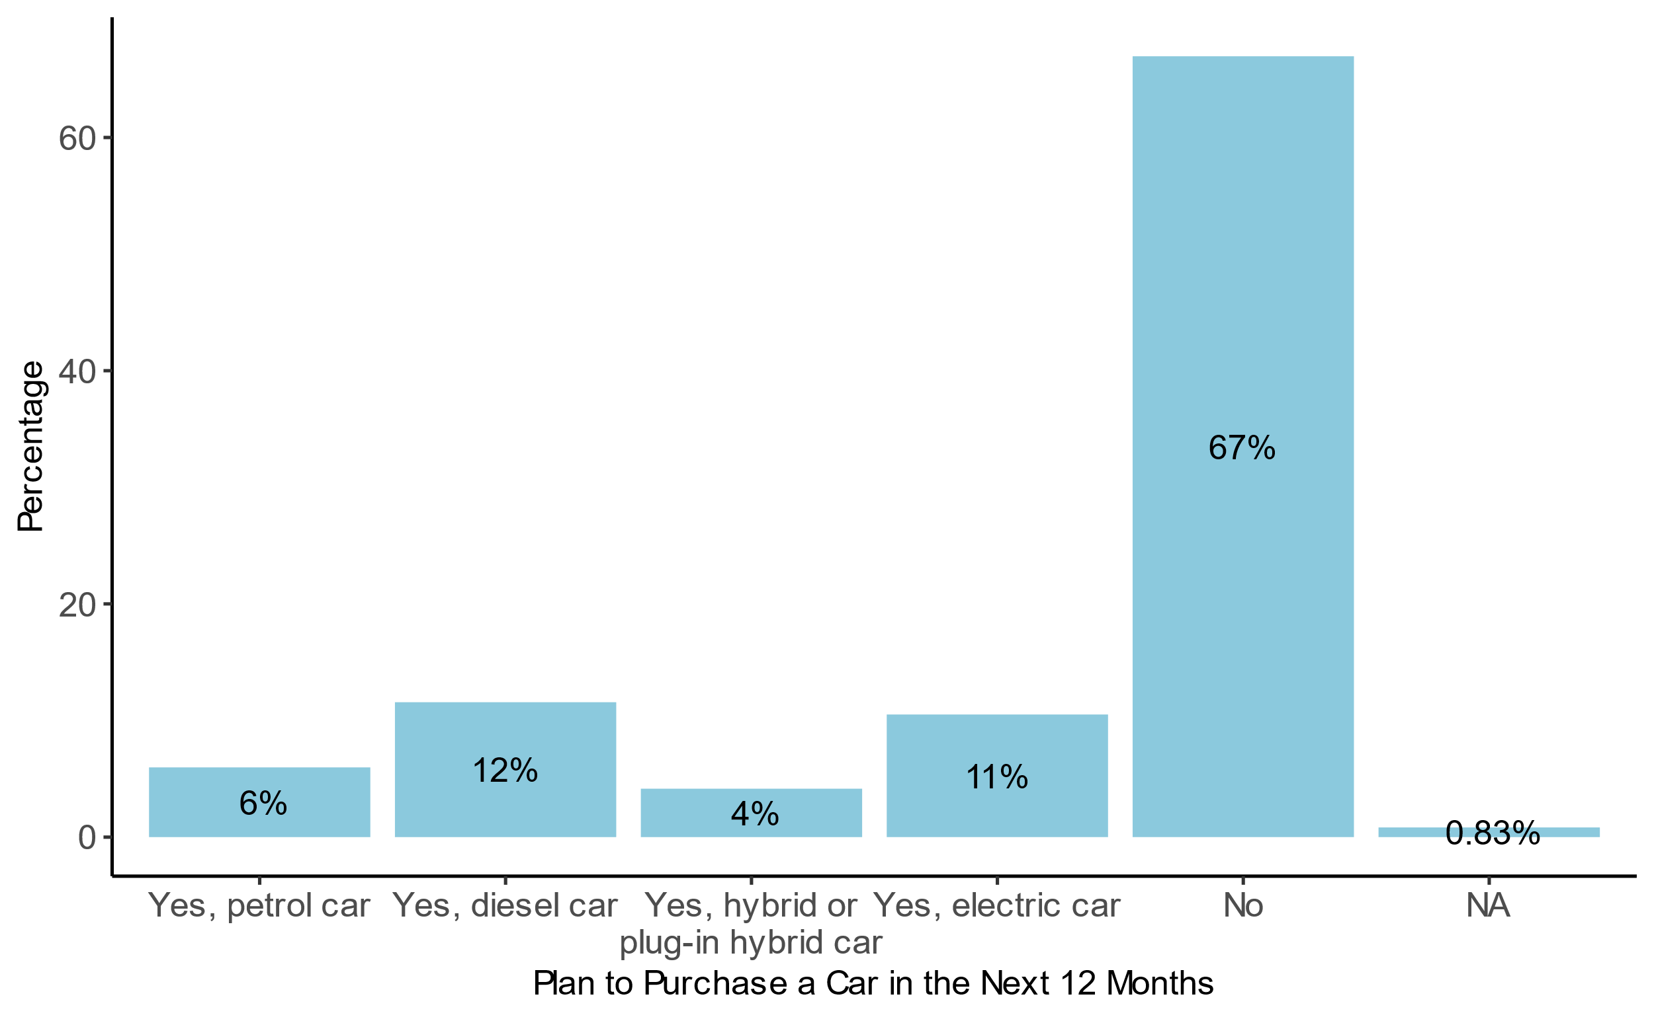

Figure 0.1. Pilot survey share of plans to purchase a car in the next 12 months.

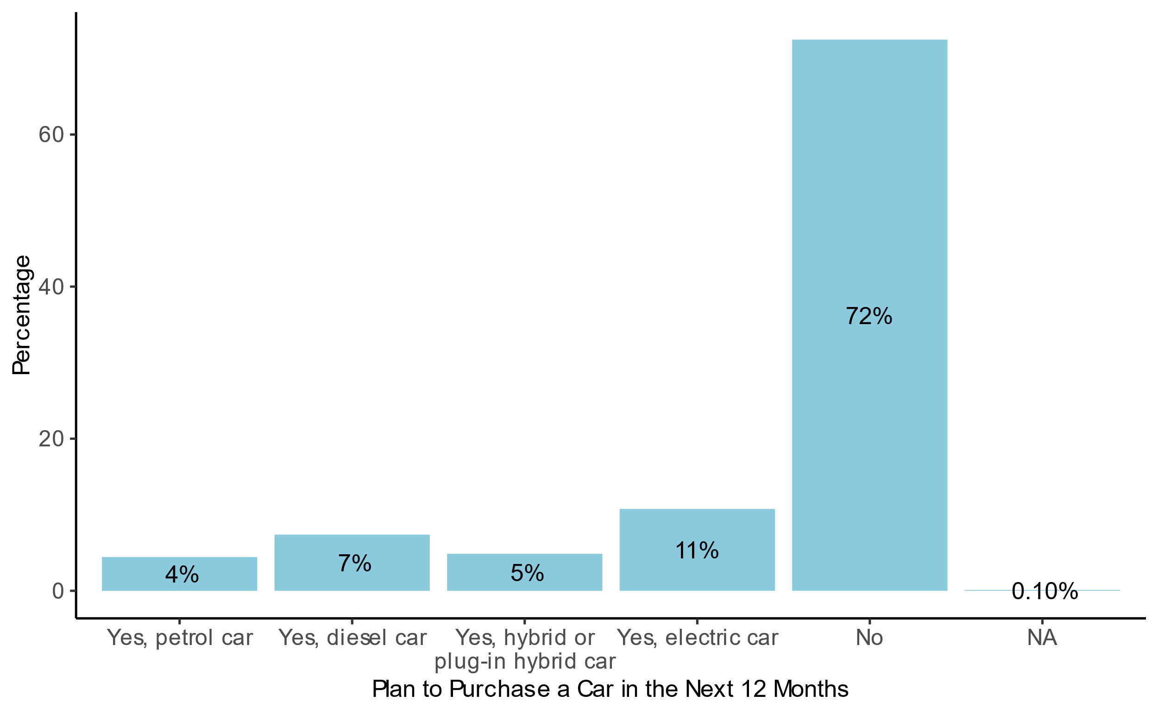

Figure 0.2. Main survey share of plans to purchase a car in the next 12 months.

|  |  |
| --- | --- |
| A: Origins | B: Destinations |
|  |  |
| Figure 0.3. Shaded (choropleth) maps of the origins and destinations of trips for the pilot survey. Urban municipalities are outlined in bold. | |

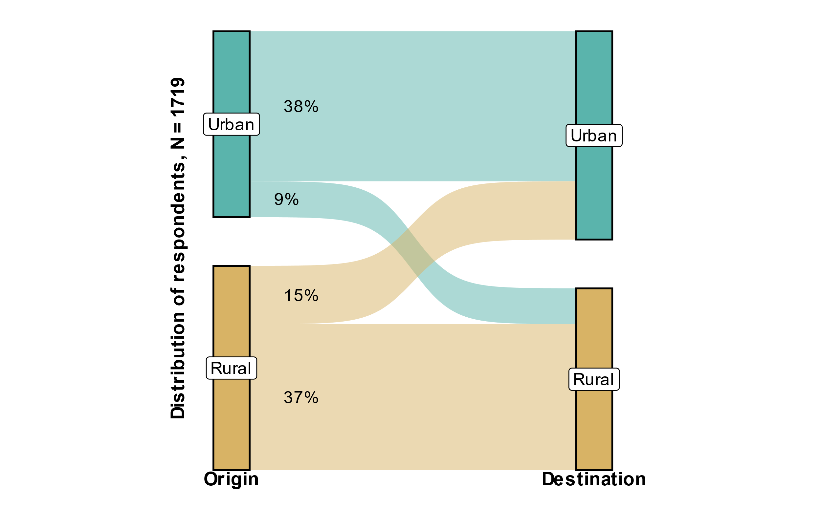

Figure 0.4. Mapping of individual’s origin and destination types for the pilot survey.

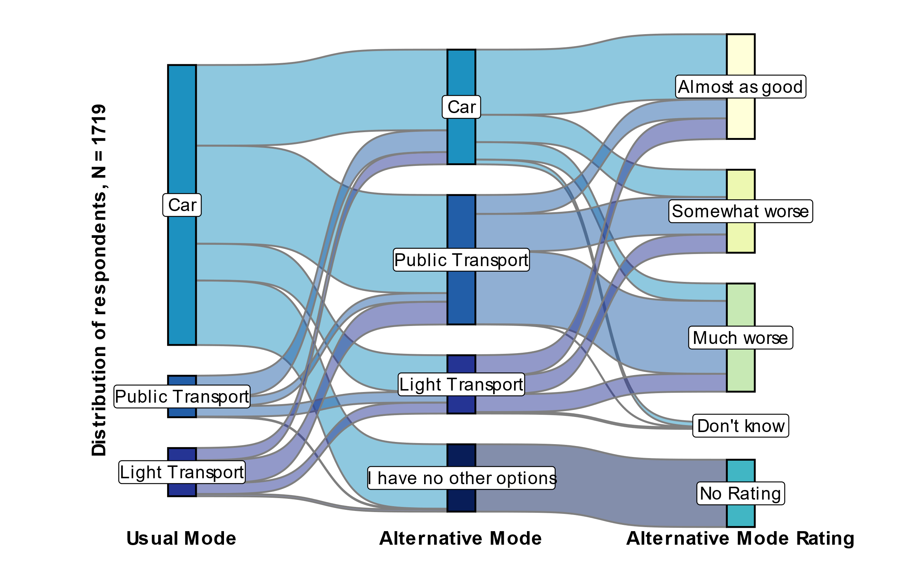

Figure 0.5. Mapping of pilot survey individuals’ usual trip mode, alternative trip mode, and alternative mode rating relative to their usual mode for all trips. The car category includes private cars and motorcycles/mopeds. Public transport includes bus, subway, light rail or tram, and ferry/boat. Light transport includes walking, bicycles, e-scooters, and other modes.

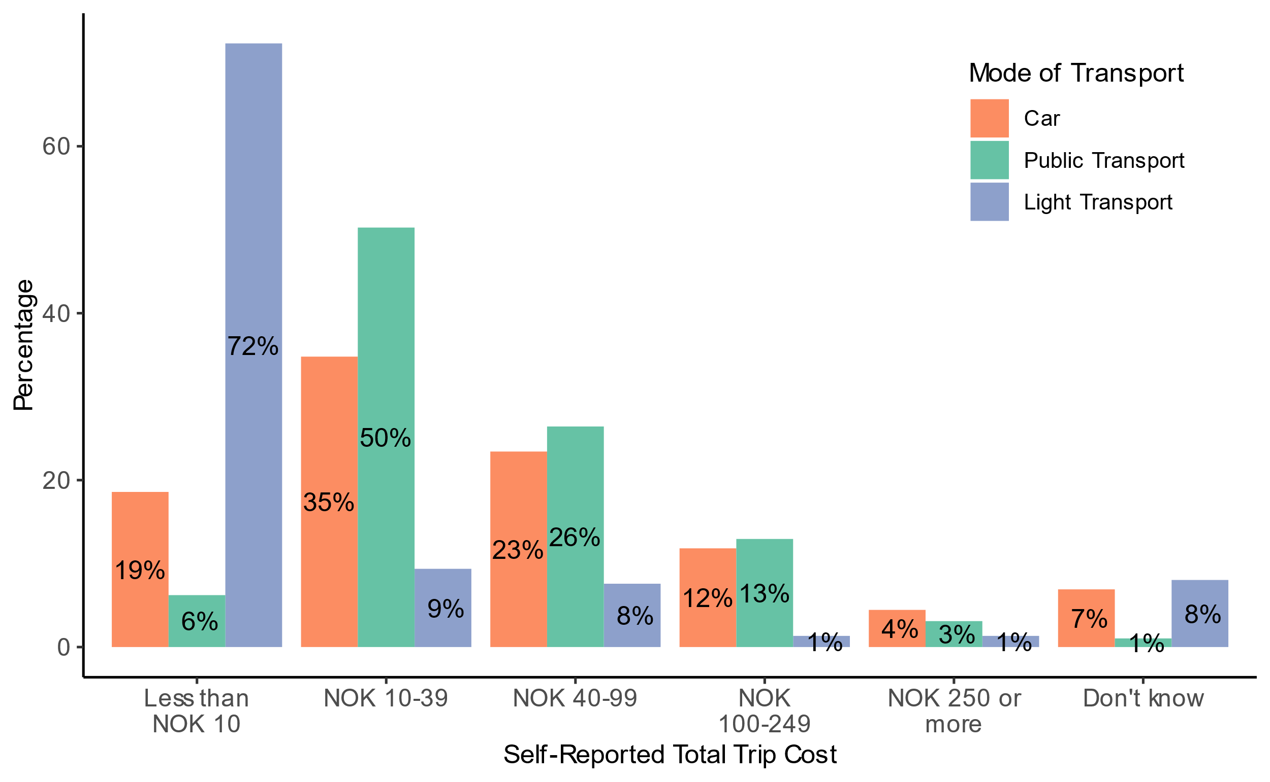

Figure 0.6. Share of pilot survey respondents’ self-reported total trip cost.

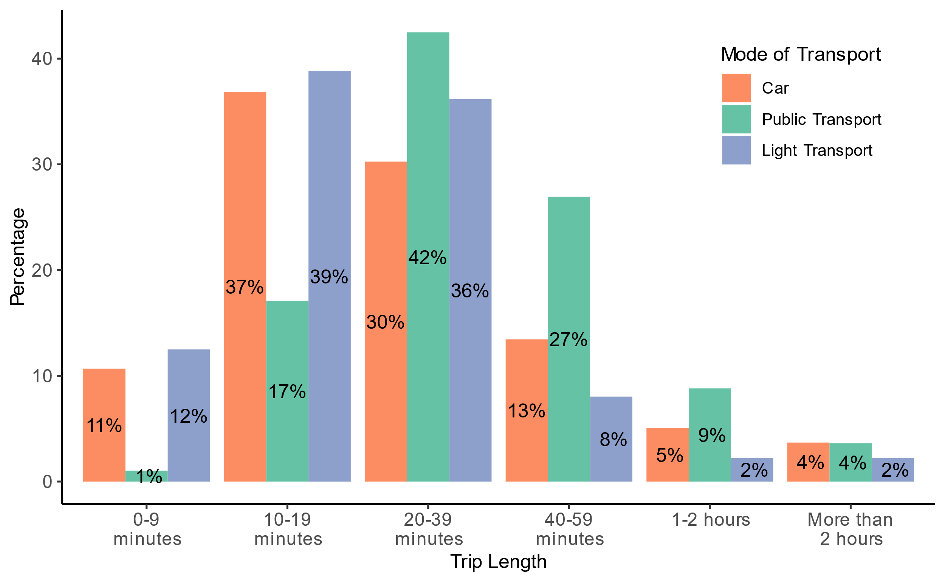

Figure 0.7. Share of trip length for all trips in the pilot survey.

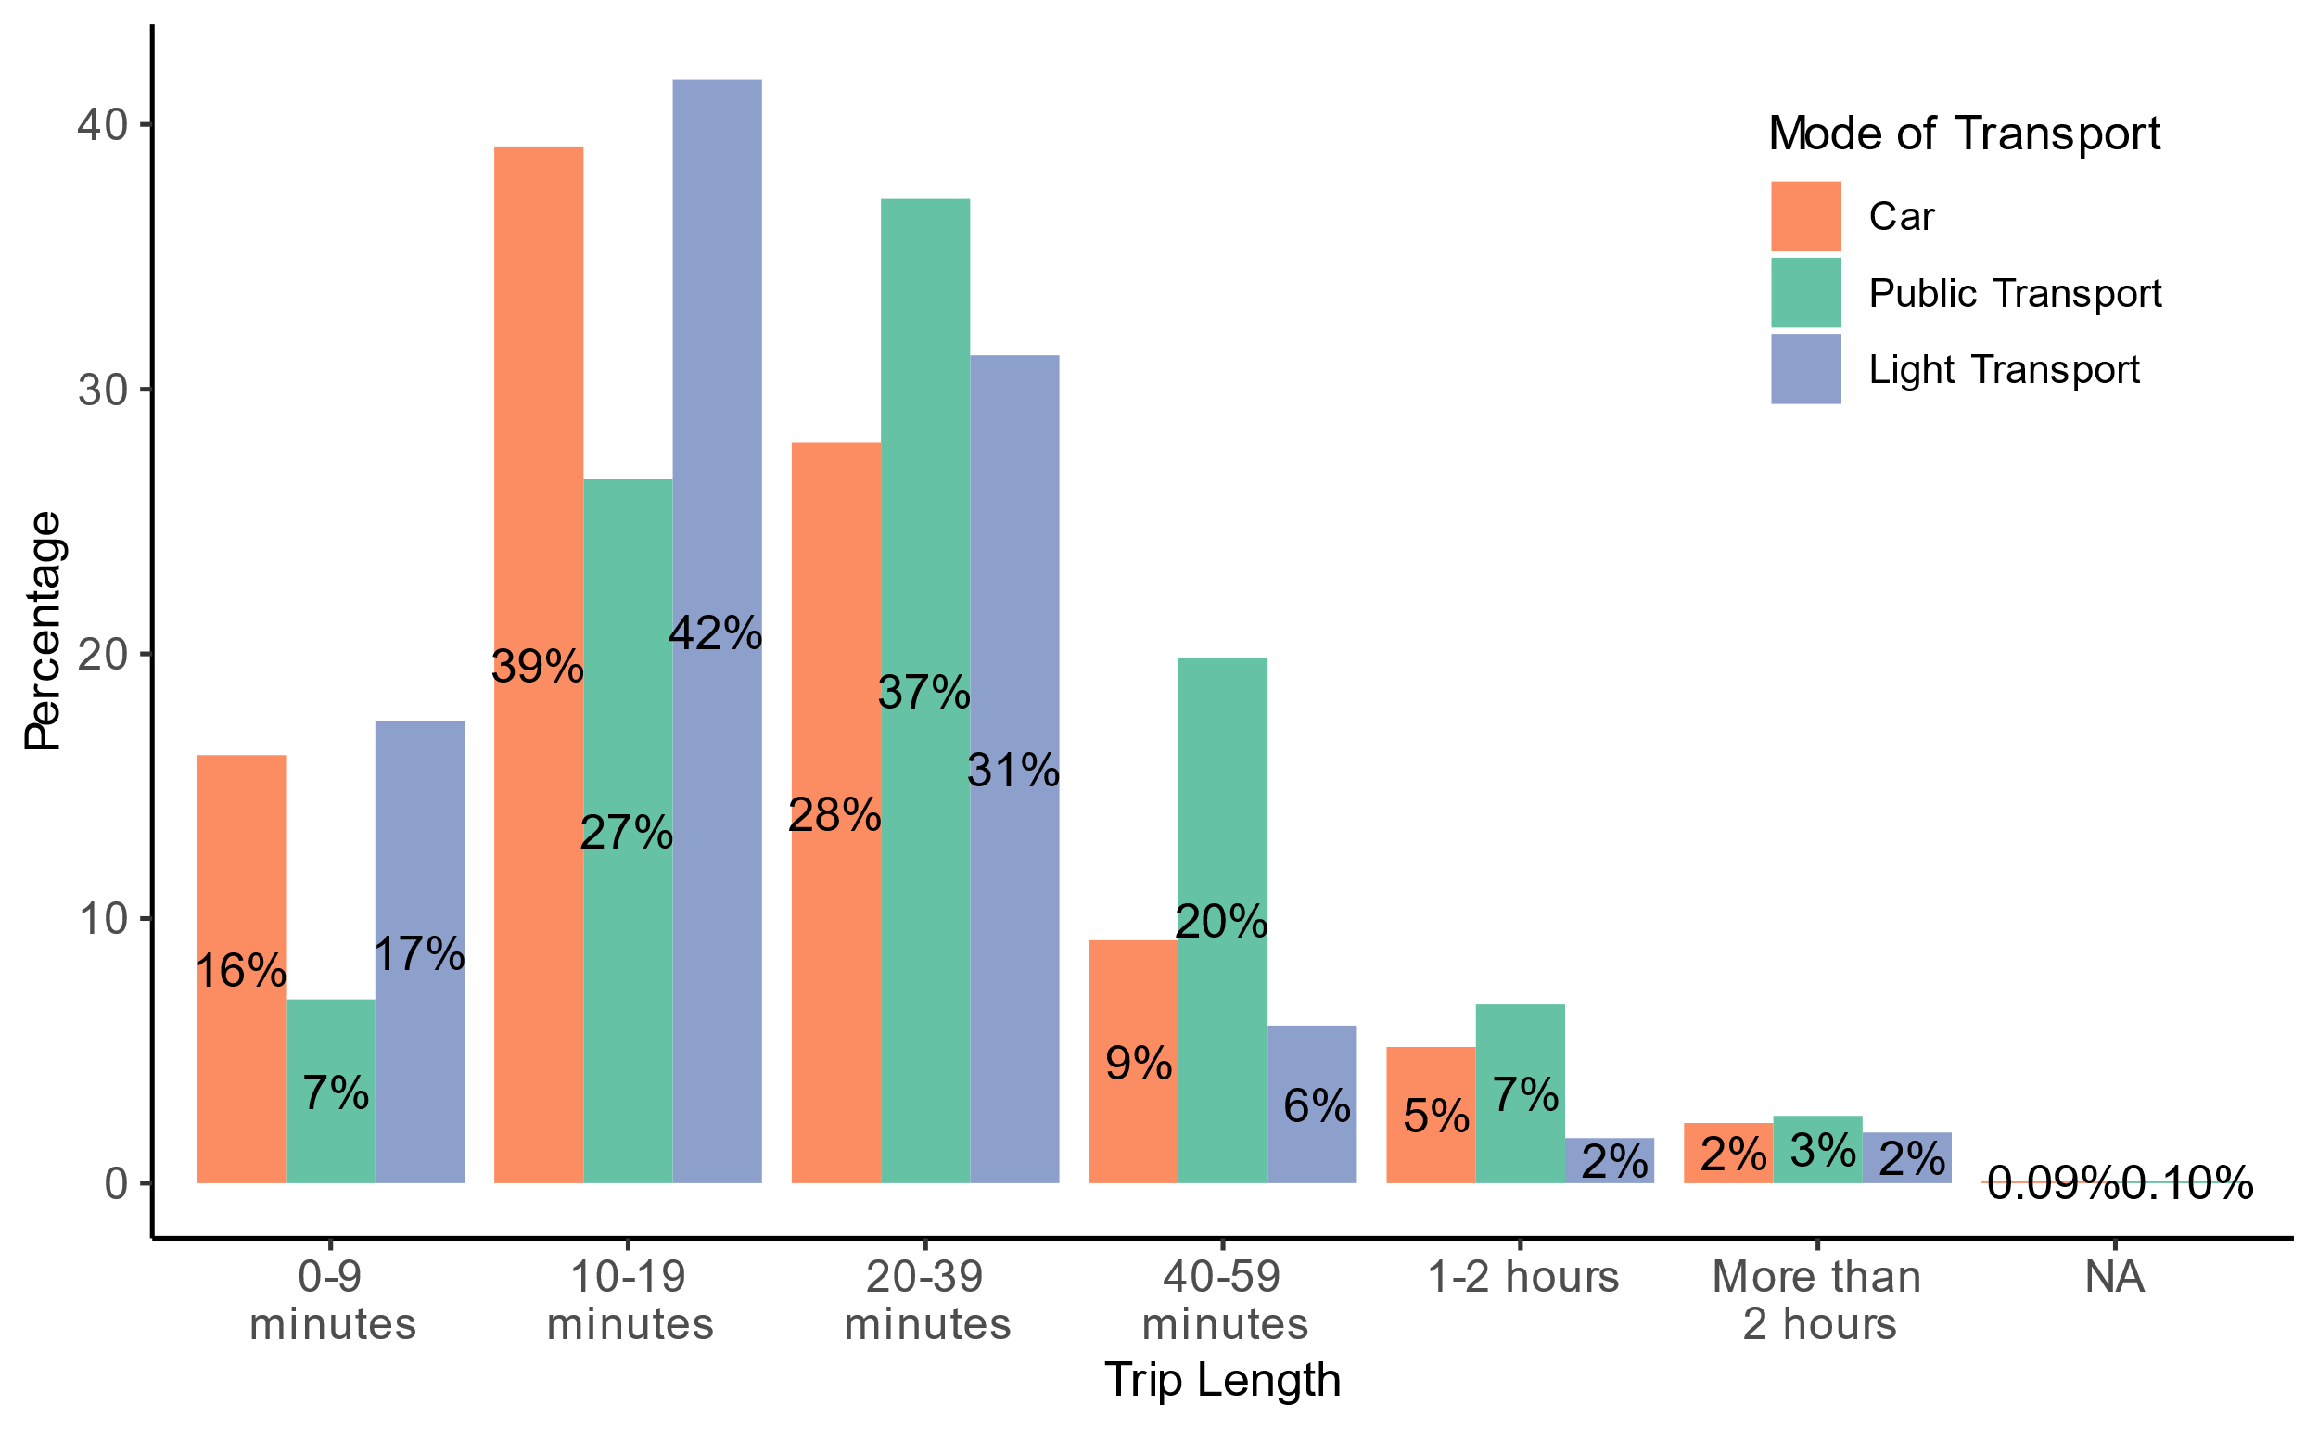

Figure 0.8. Share of trip length for all trips in the main survey.

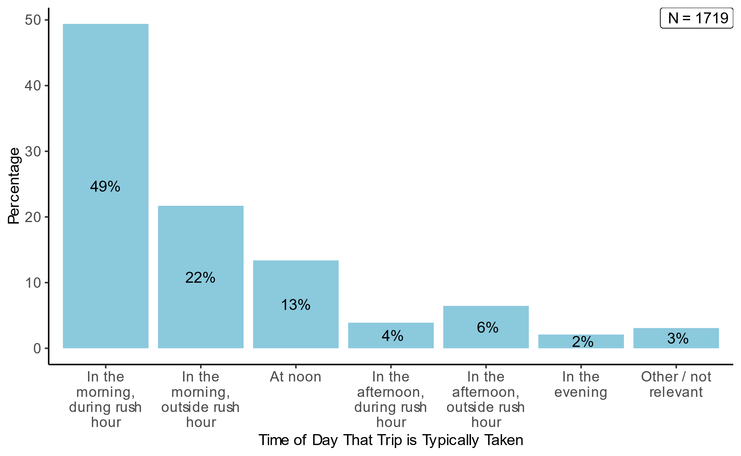

Figure 0.9. Share of the time of day that trip is typically taken for all trips in the pilot survey.

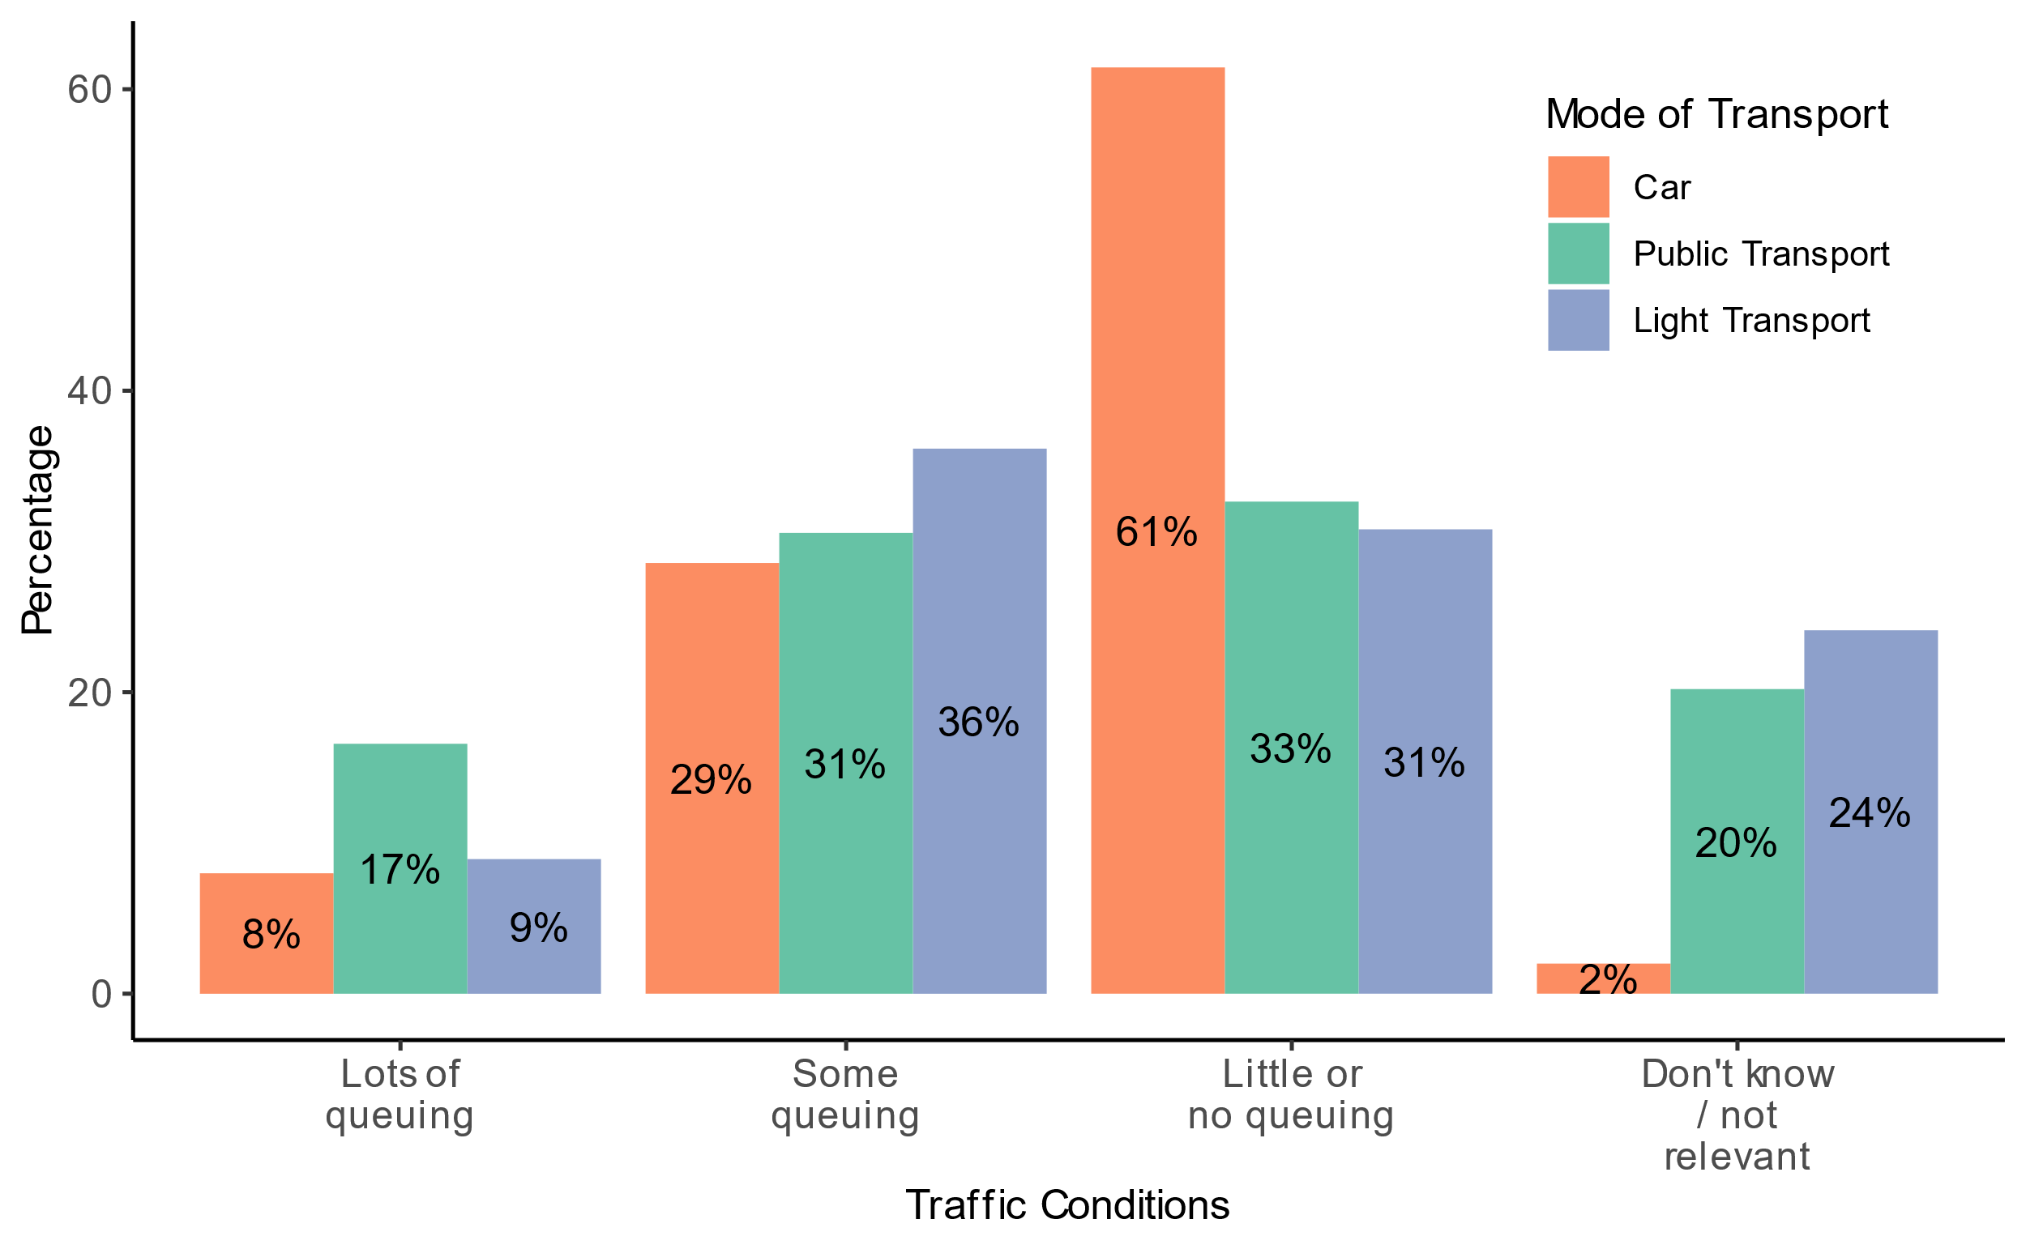

Figure 0.10. Share of observed traffic conditions during trip for all trips in the pilot survey.

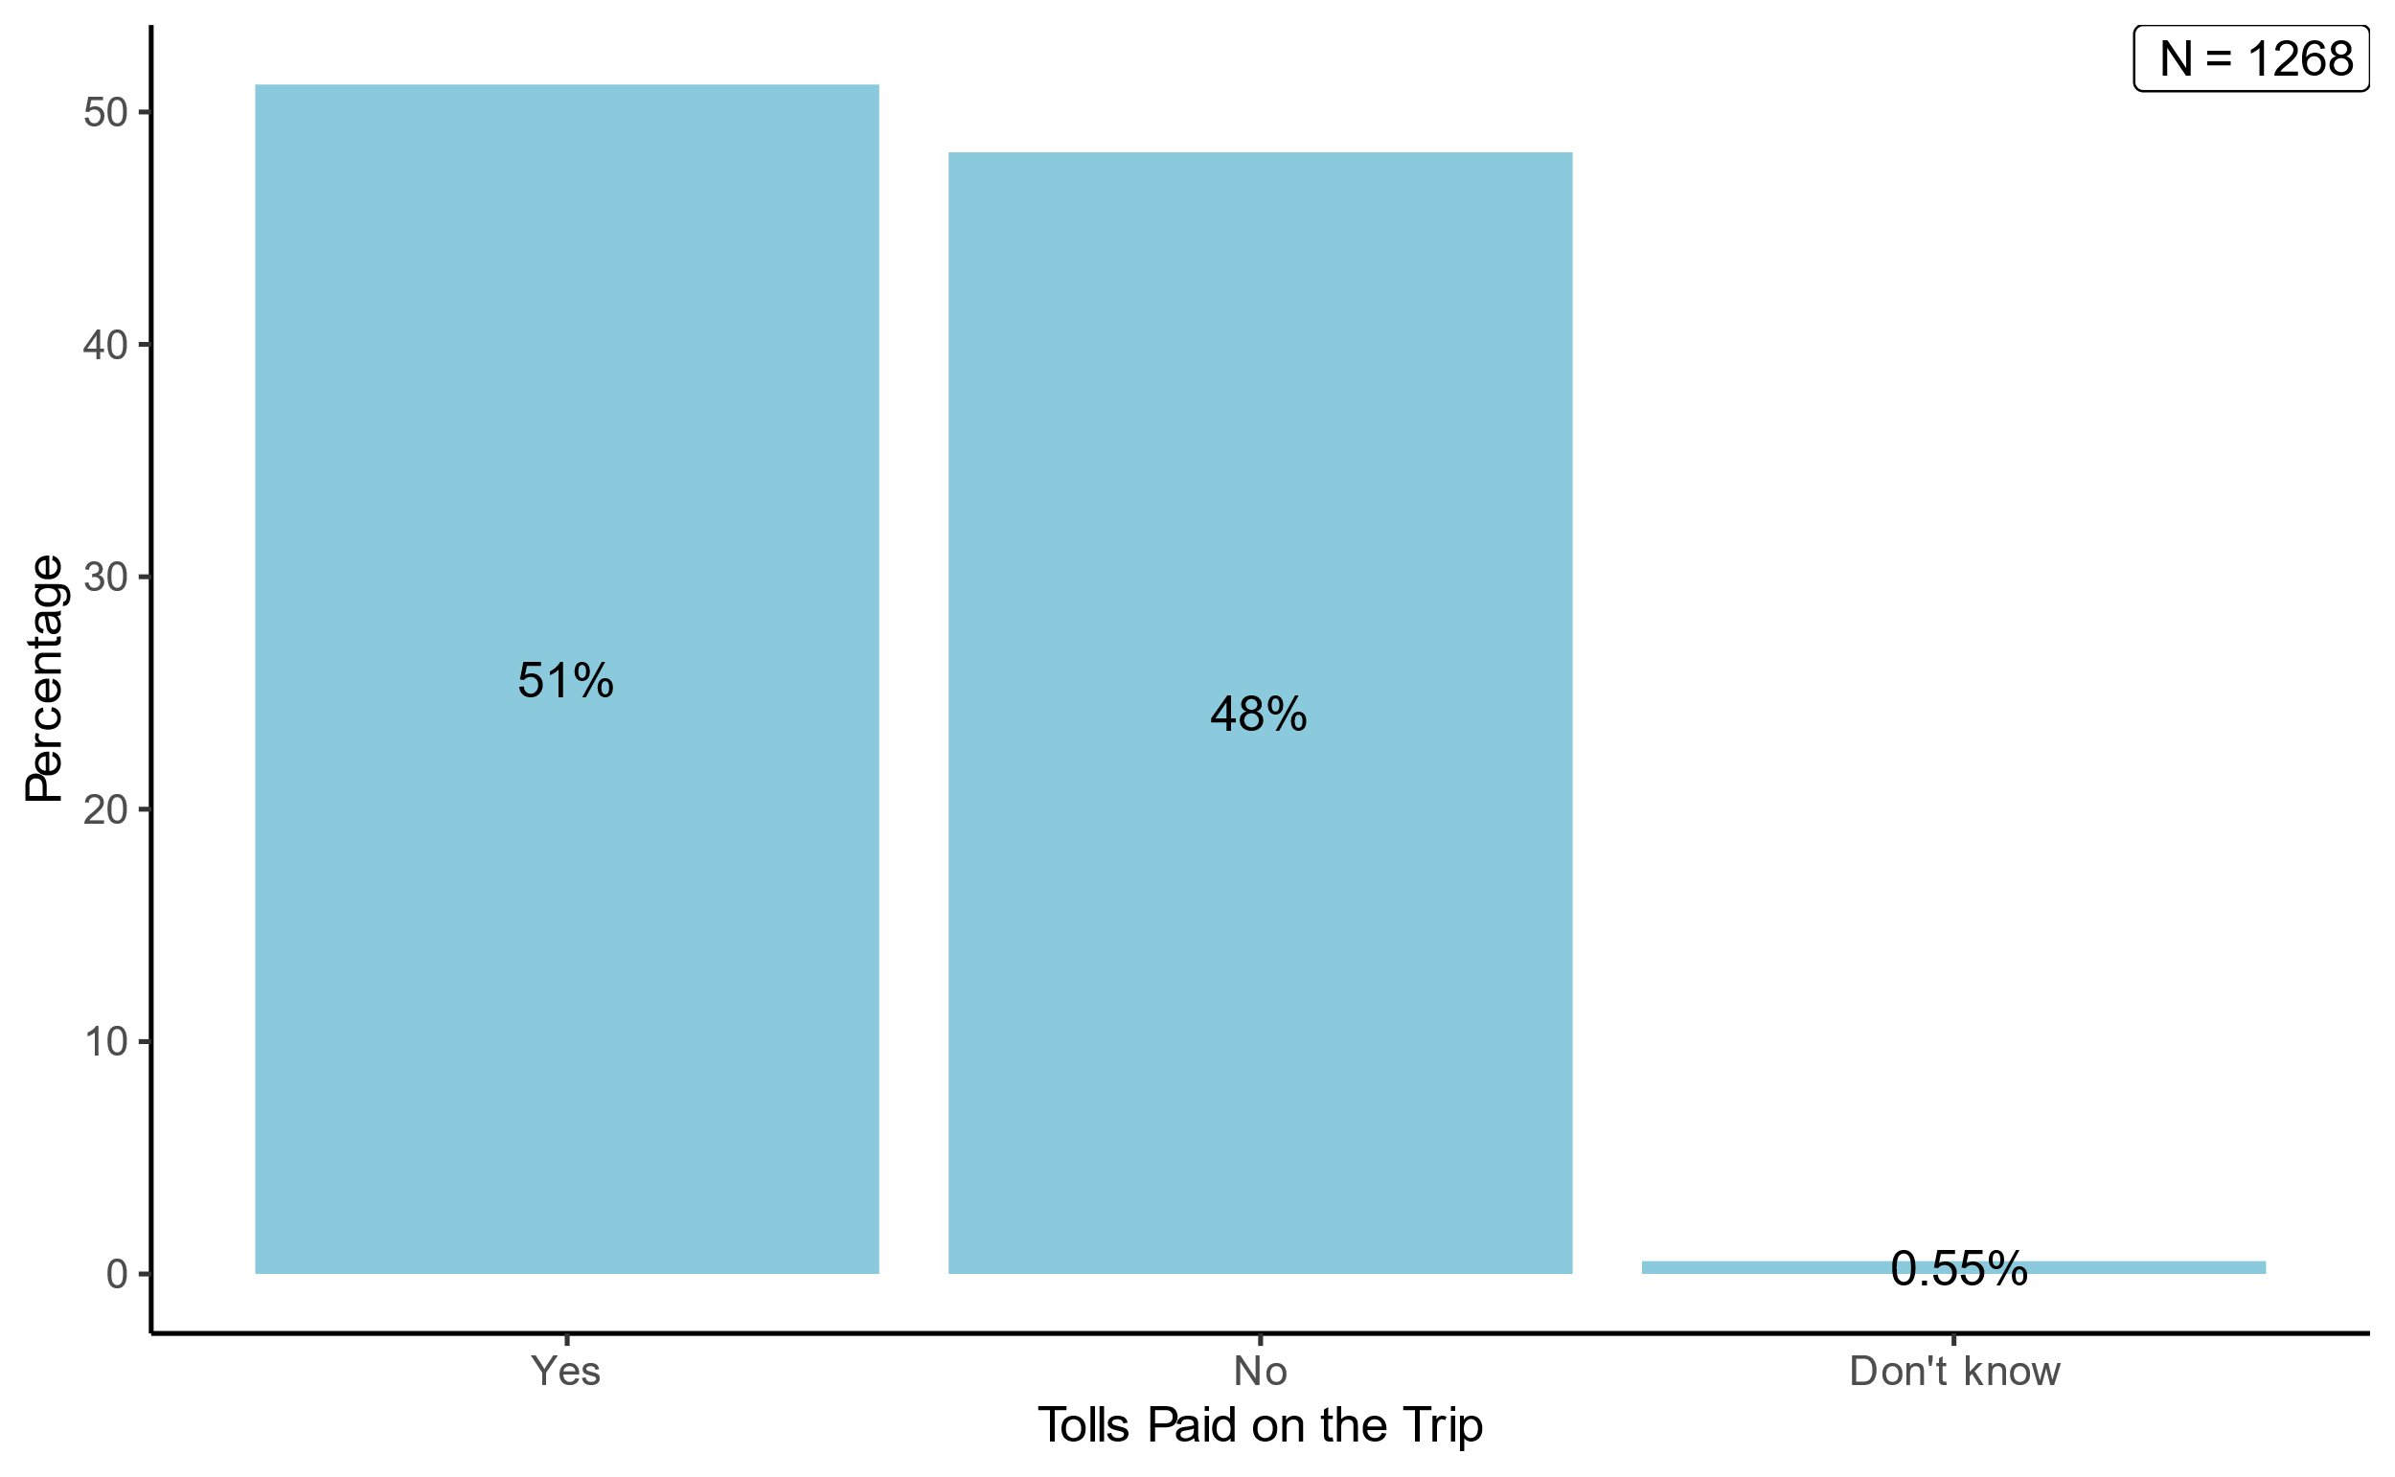

Figure 0.11. Share of self-reported tolls paid on the trip for those who used a private car mode, for the pilot survey.

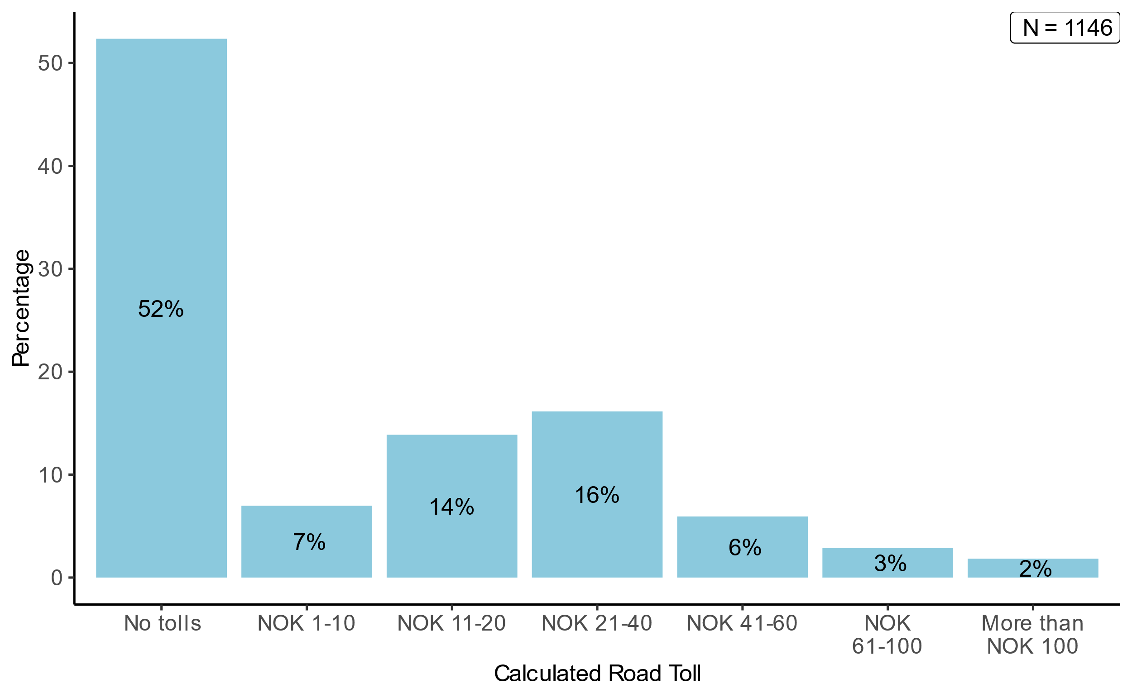

Figure 0.12. Pilot survey respondents’ calculated toll costs for those who used a private car mode.

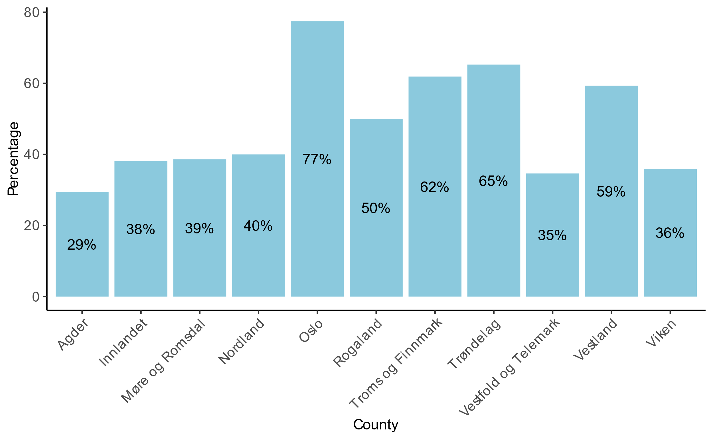

Figure 0.13. Share of those in the pilot survey who pay road tolls (calculated), by county.

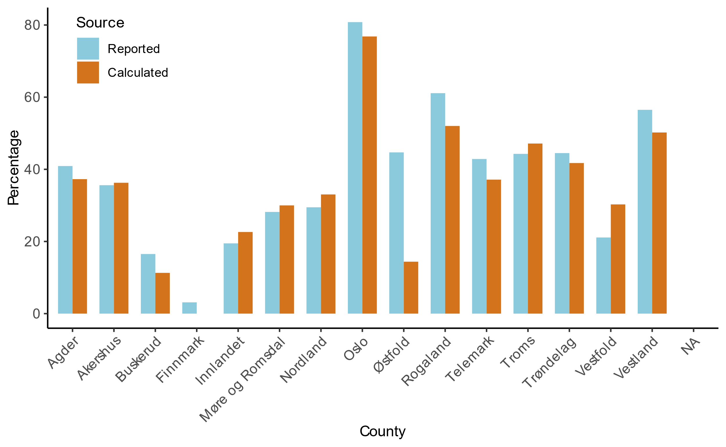

Figure 0.14. Share of those in the main survey who pay road tolls, by county.

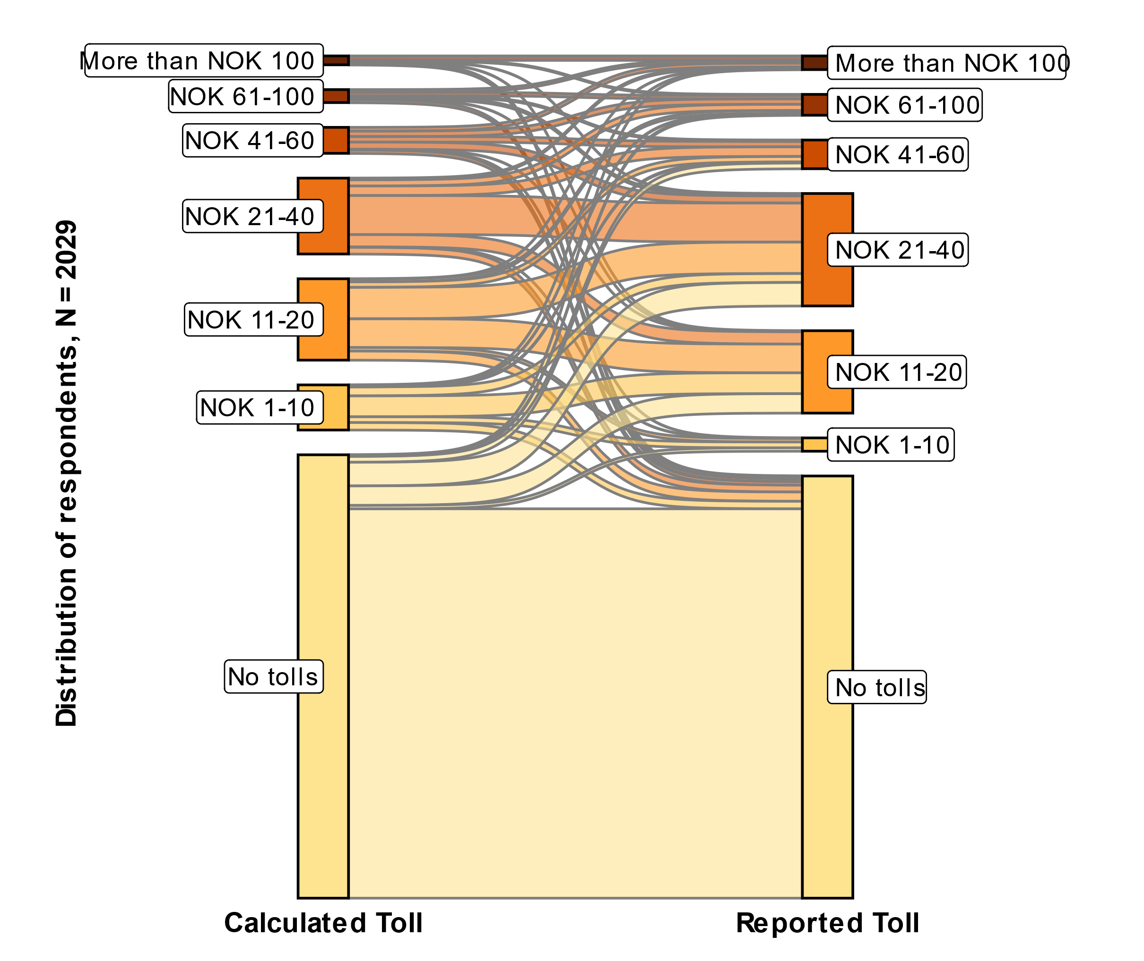

Figure 0.15. Mapping of main survey individuals’ calculated toll costs versus self-reported toll costs.

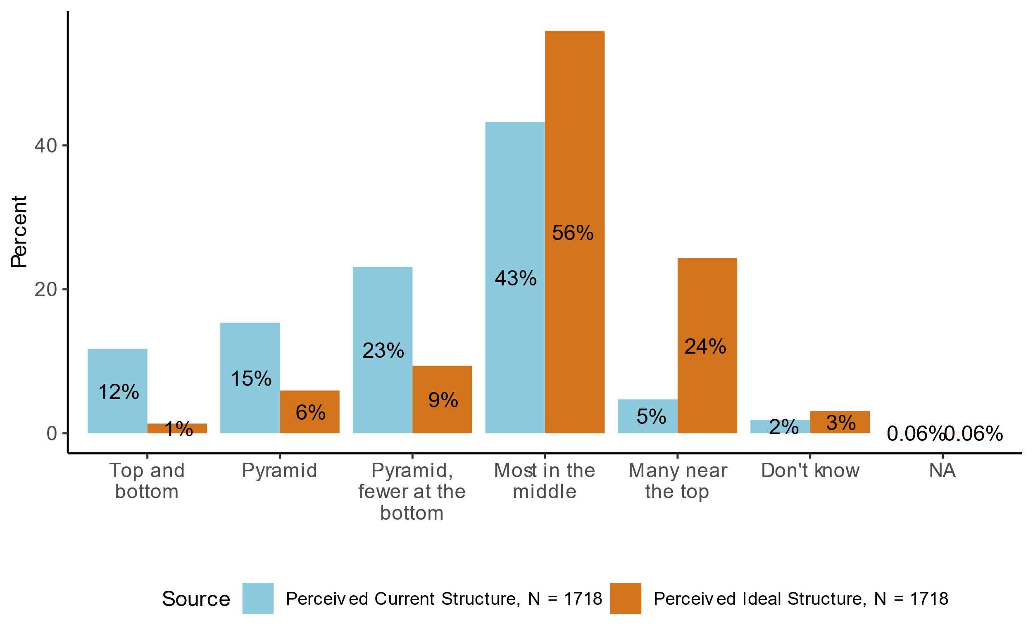

Figure 0.16. Comparison of perceived current and ideal inequality structures, for the pilot survey.

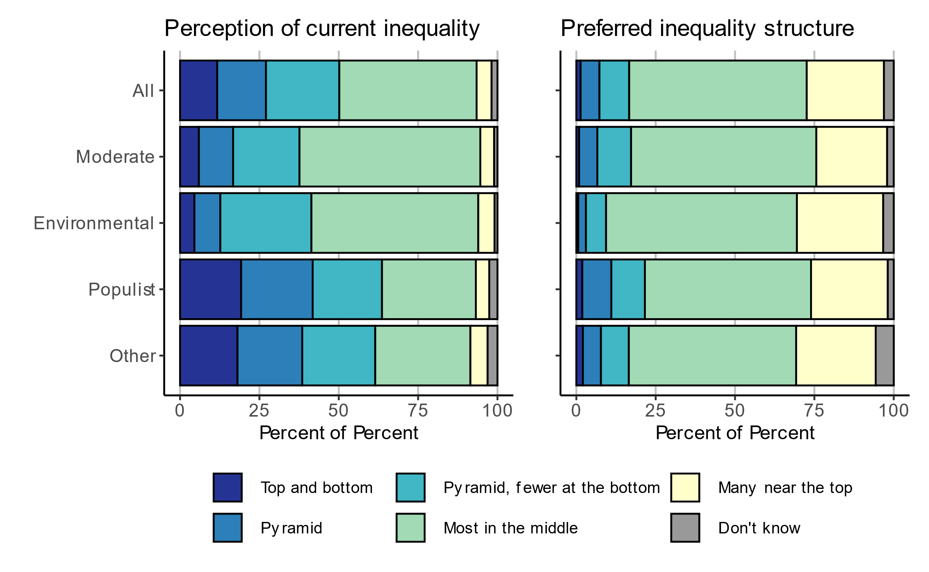

Figure 0.17. Perception of current inequality and preferred inequality structure, by political party, for the pilot survey.

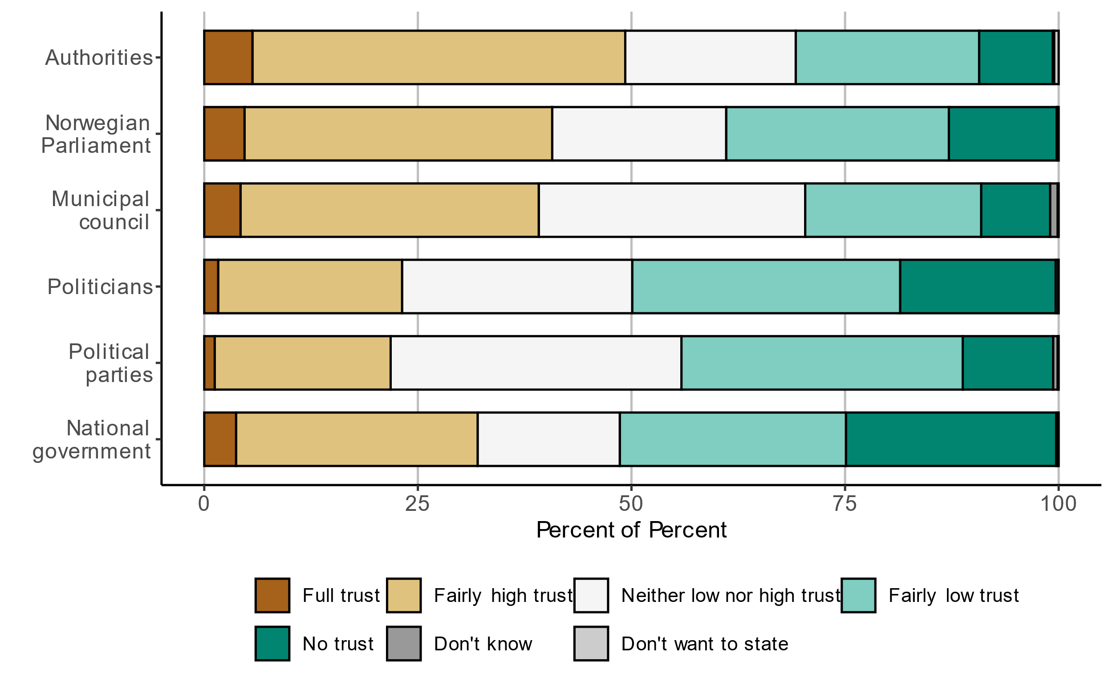

Figure 0.18. Trust in institutions for the pilot survey.

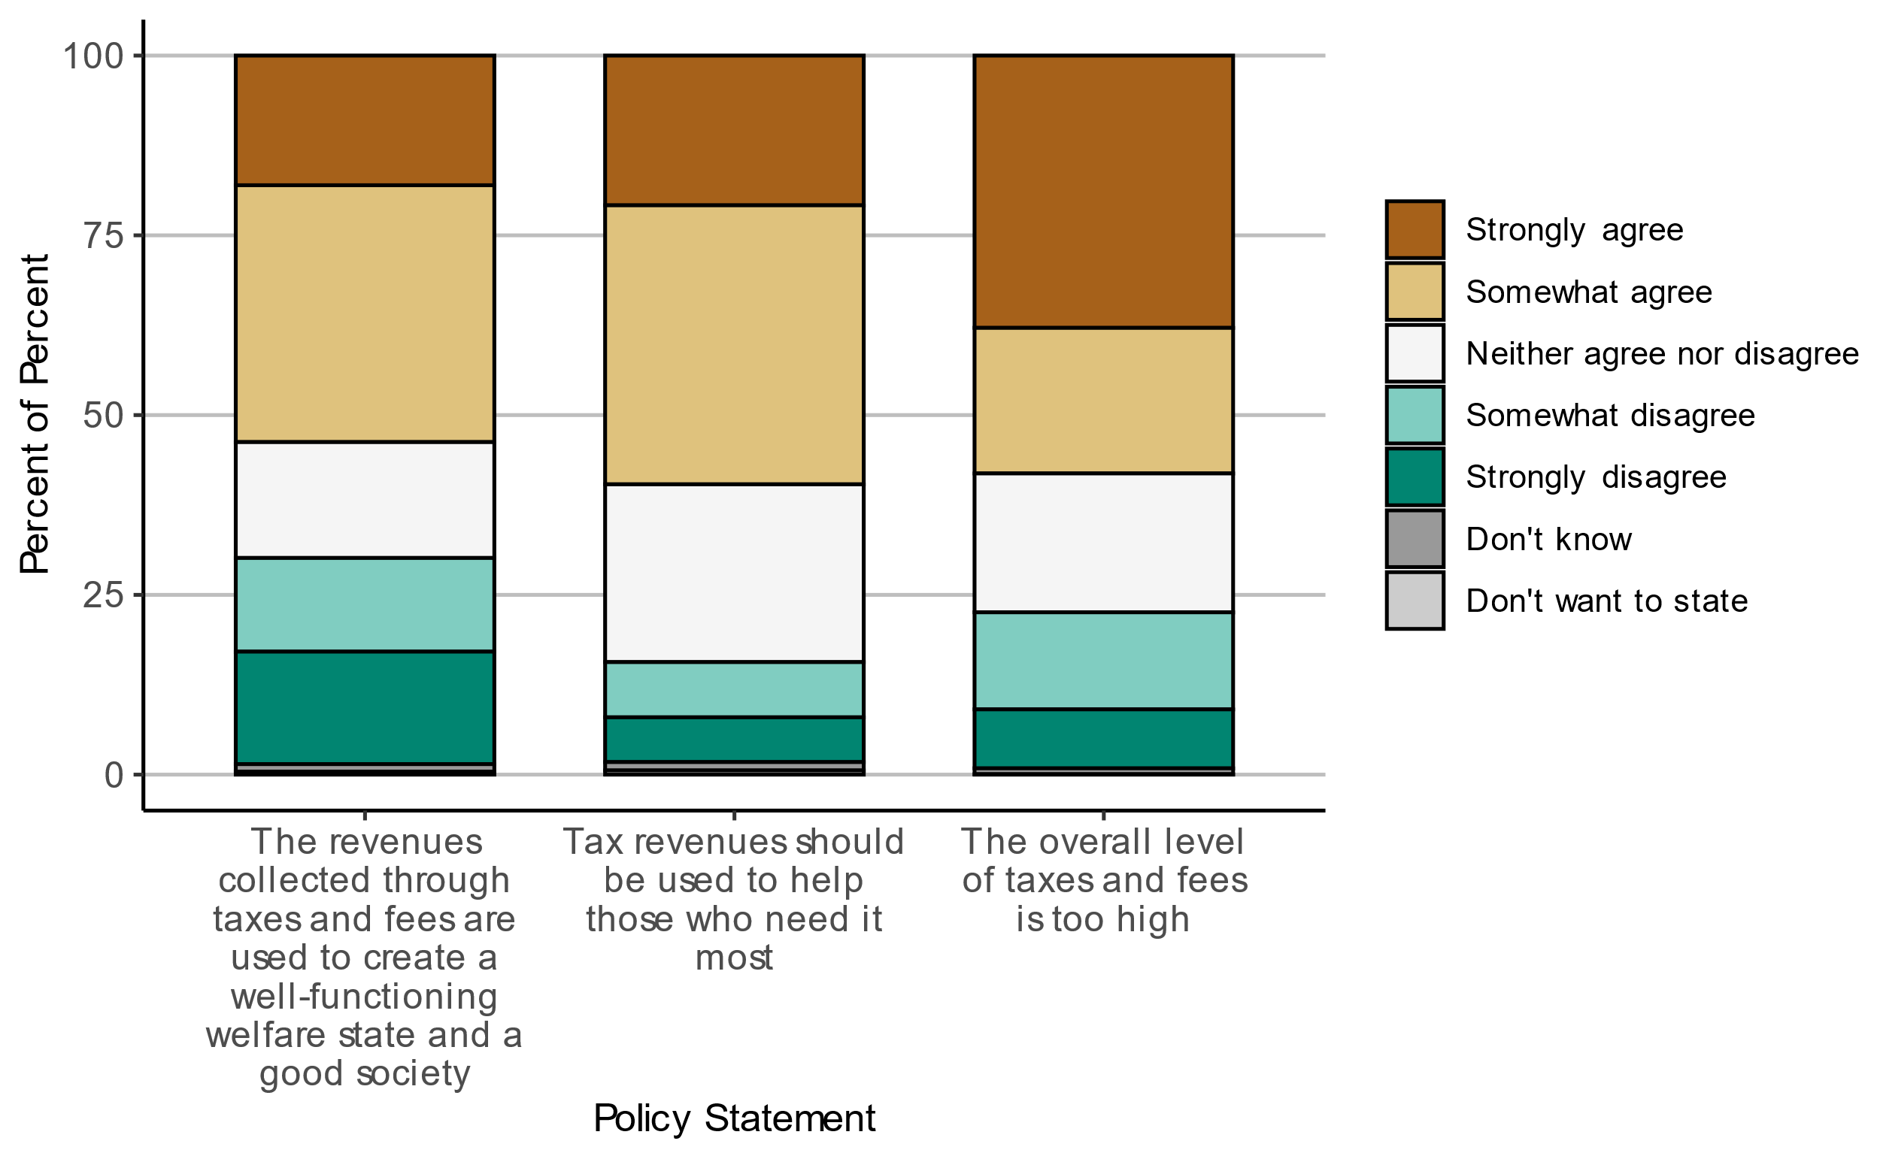

Figure 0.19. Level of agreement regarding various policy statements about taxes and fees, for the pilot survey.

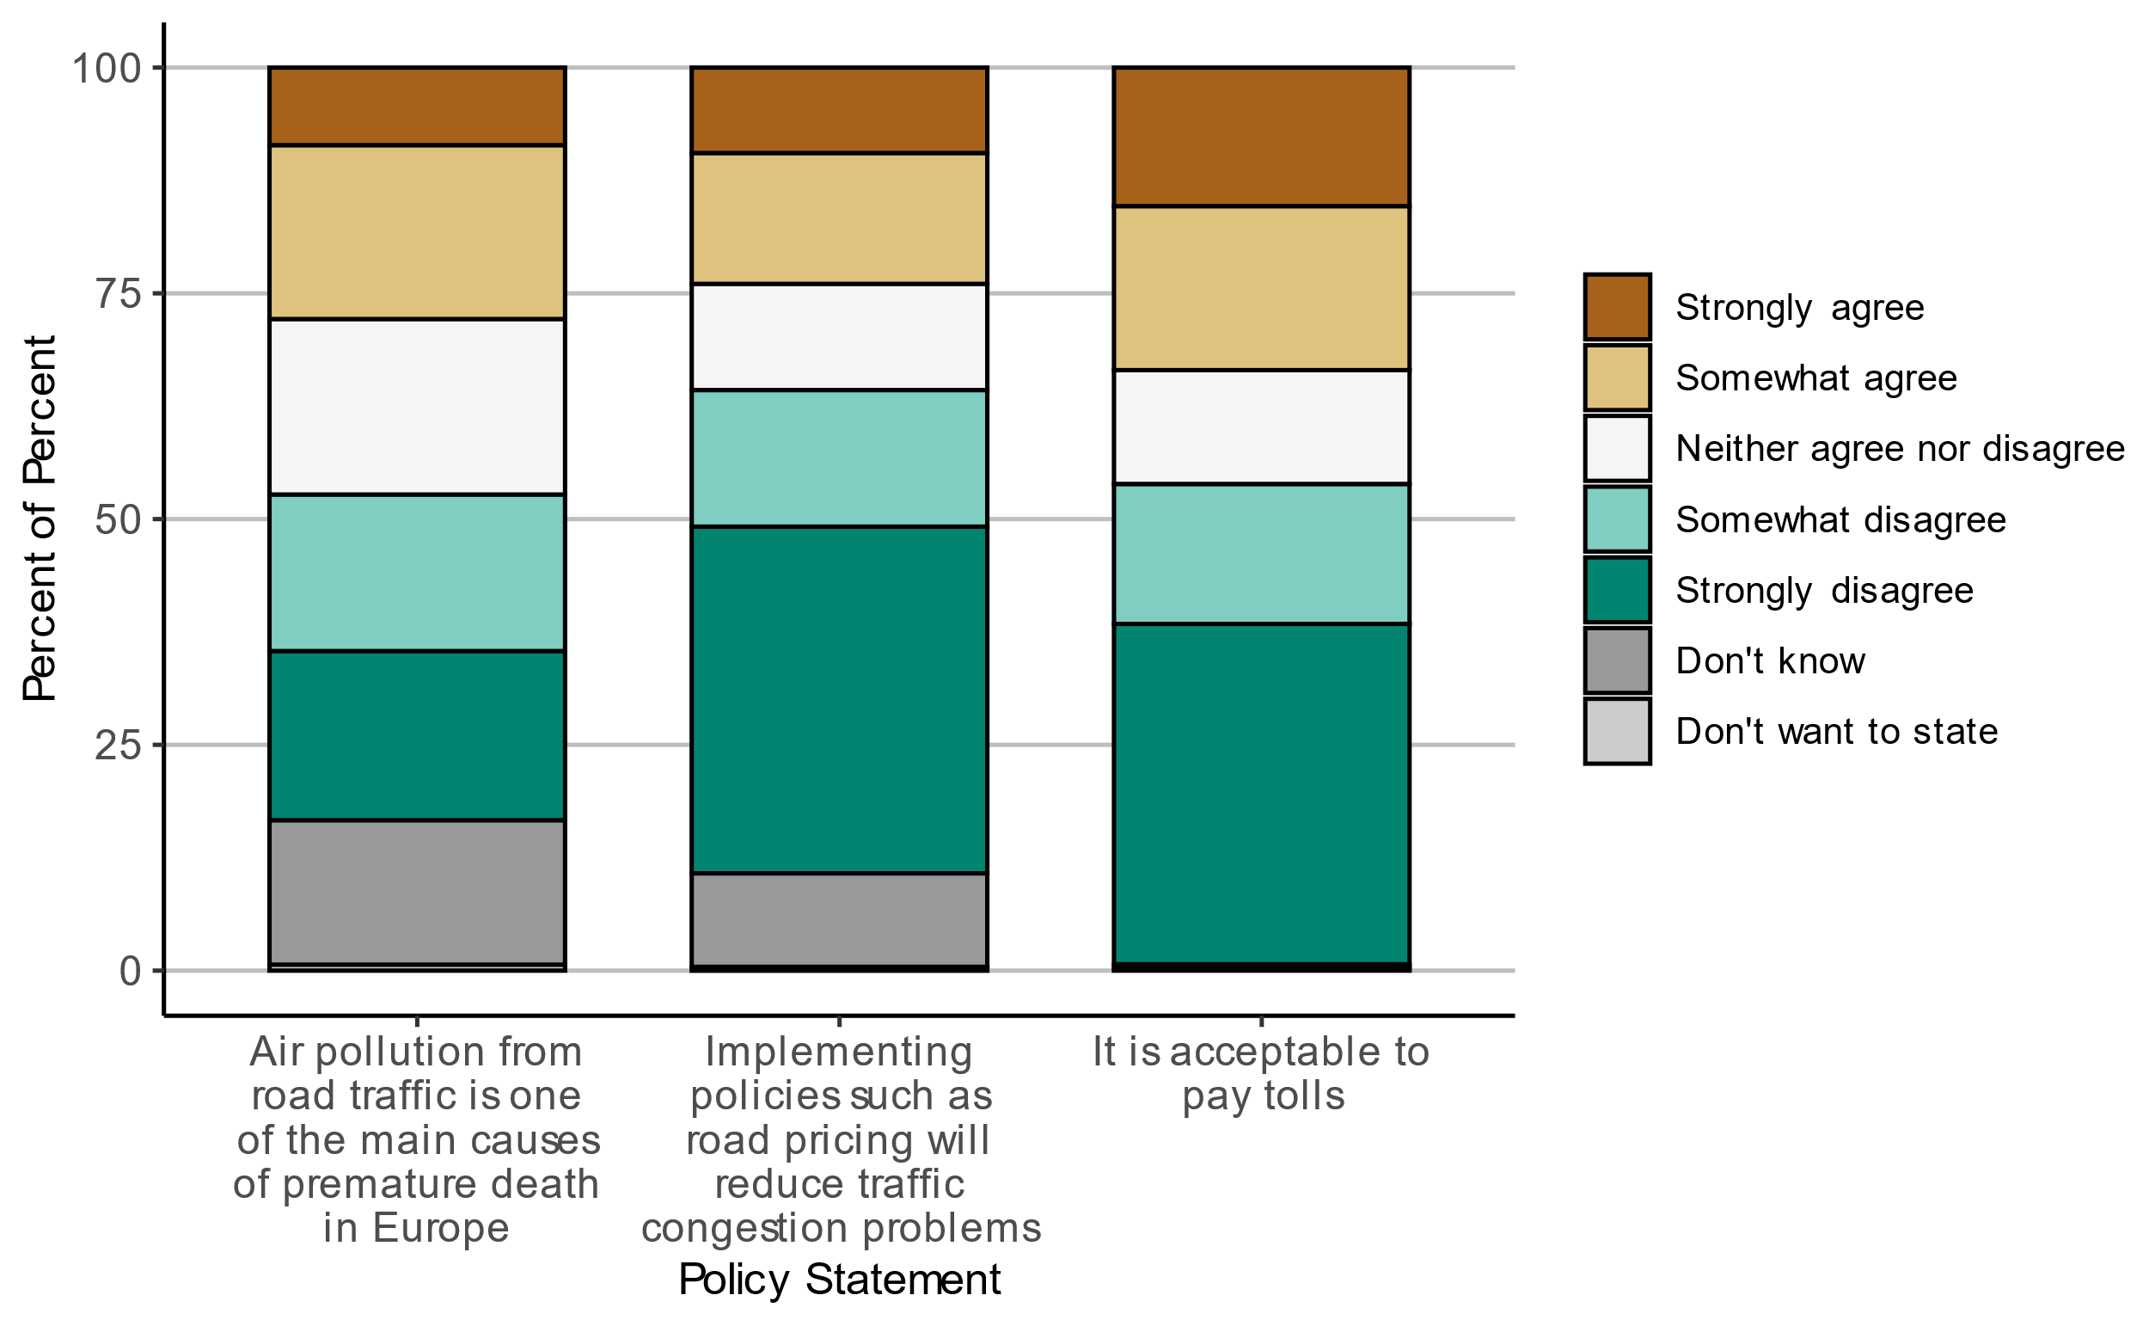

Figure 0.20. Level of agreement regarding various policy statements about road traffic and tolls, for the pilot survey.

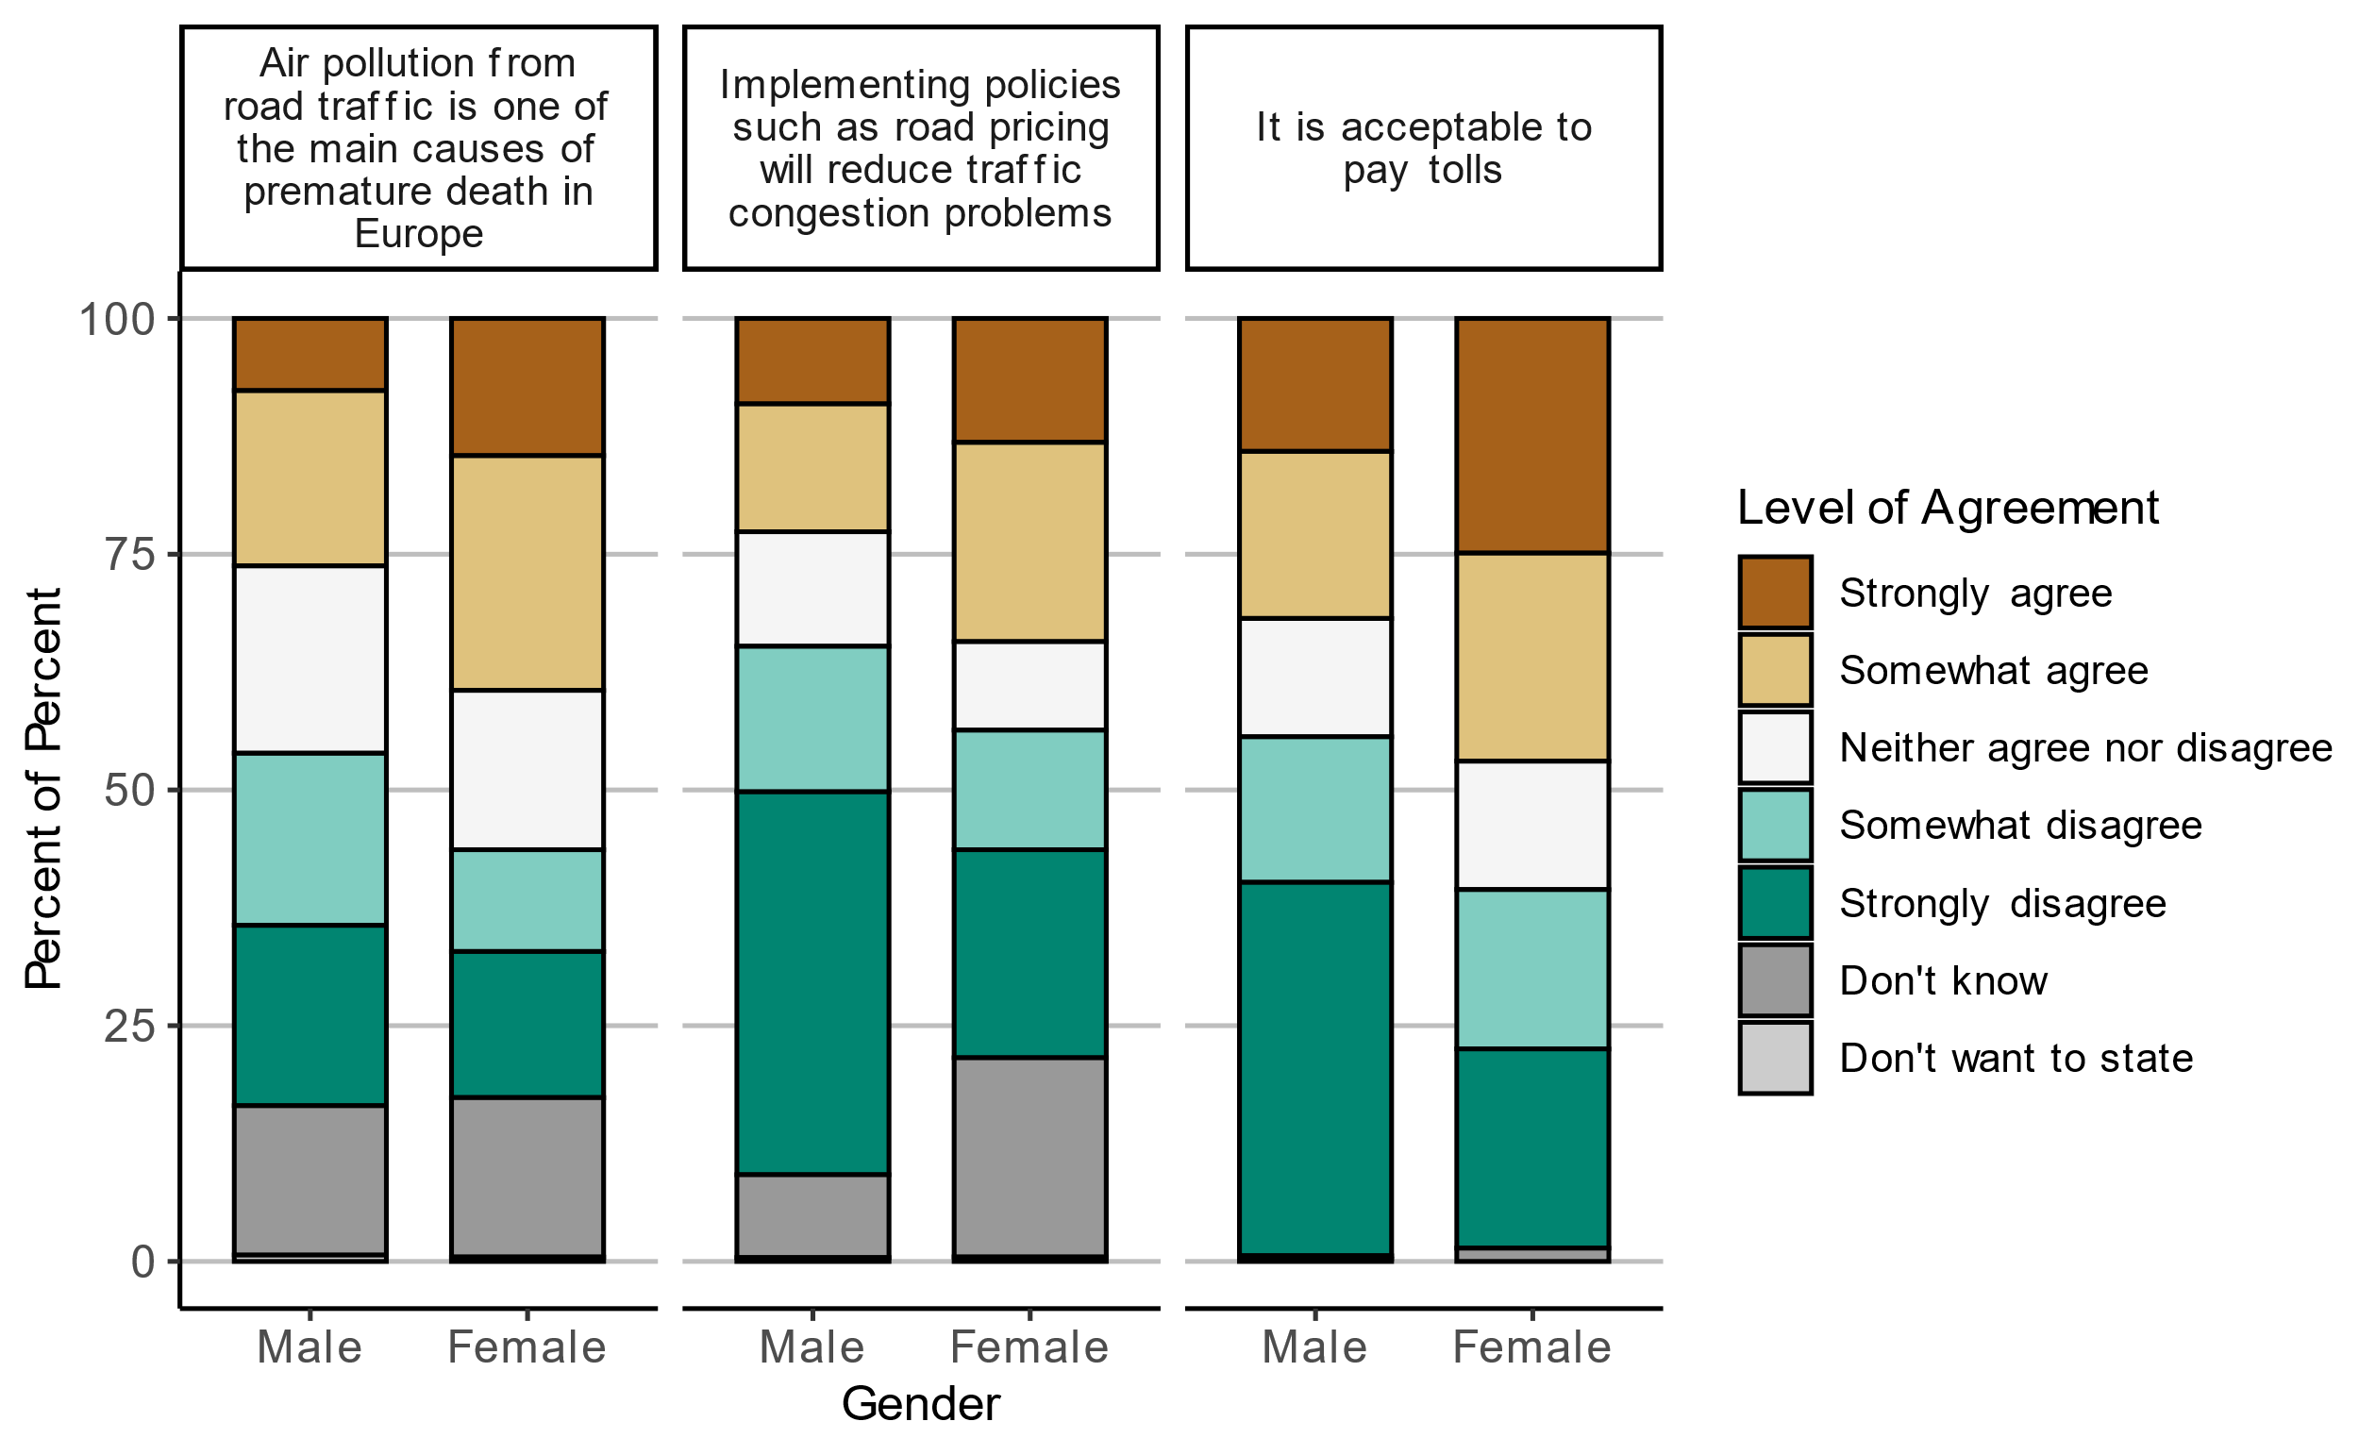

Figure 0.21. Level of agreement regarding various policy statements about road traffic and tolls by gender, for the pilot survey (Males N = 1490, Females N = 213).

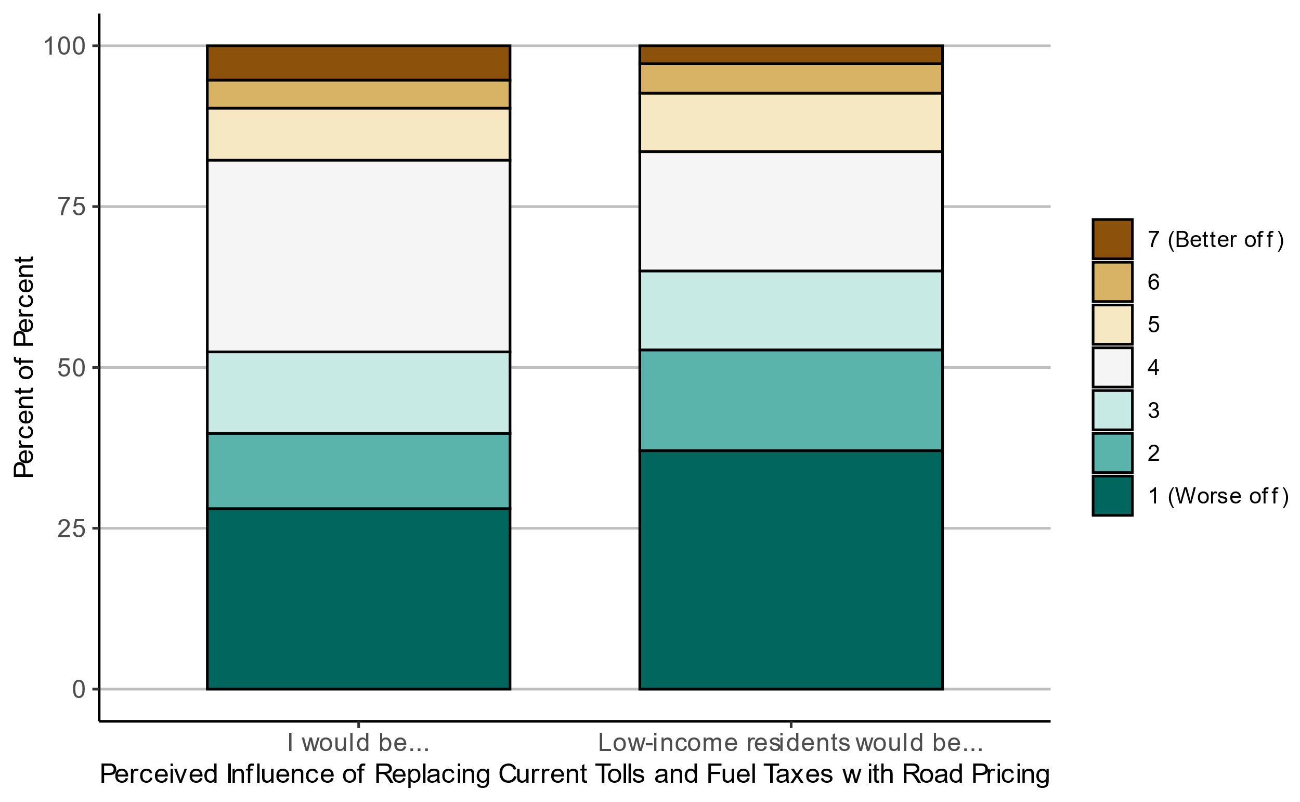

Figure 0.22. Attitudes towards which groups will be better or worse off after replacing current tolls and fuel taxes with road pricing, for the pilot survey.

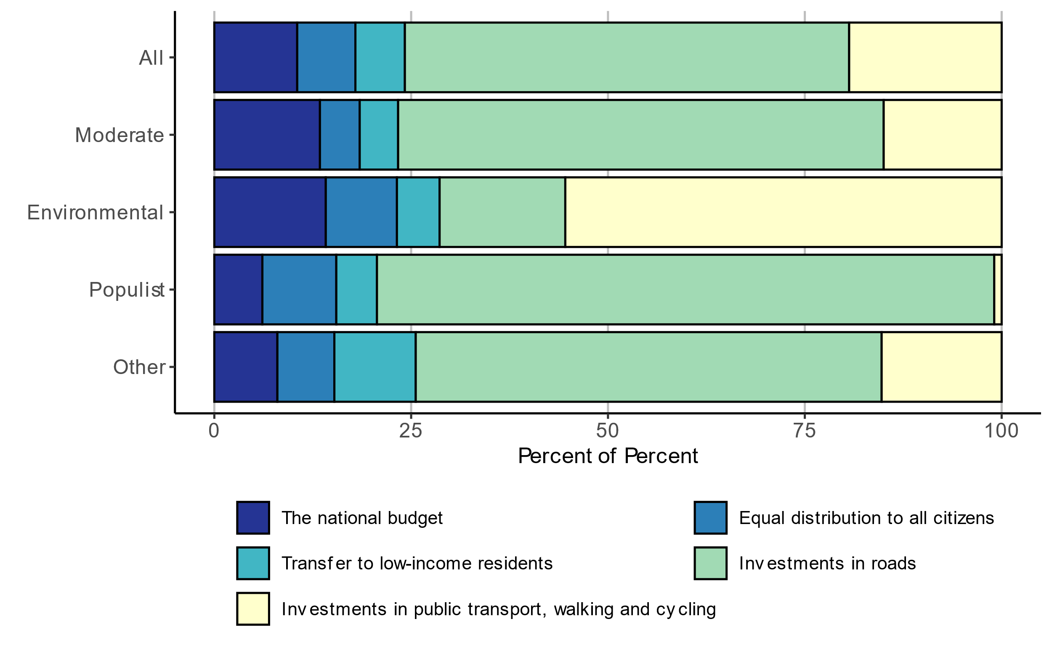

Figure 0.23. Preferences for how revenues from road pricing should be spent, for the pilot survey.

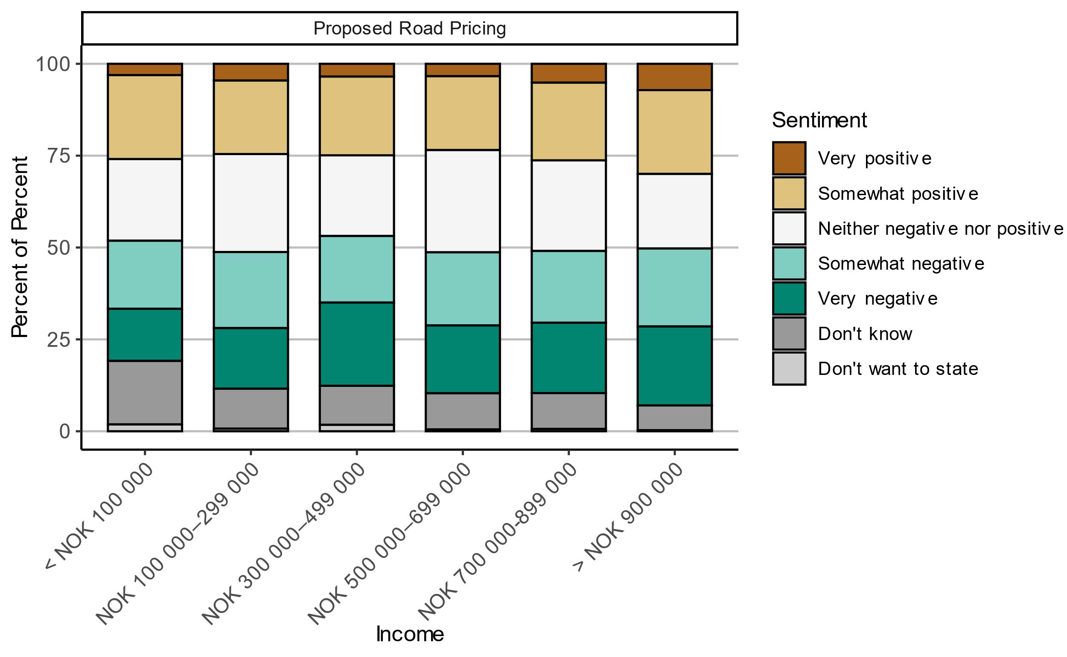

Figure 0.24. Attitudes towards proposed road pricing by income, for the main survey.

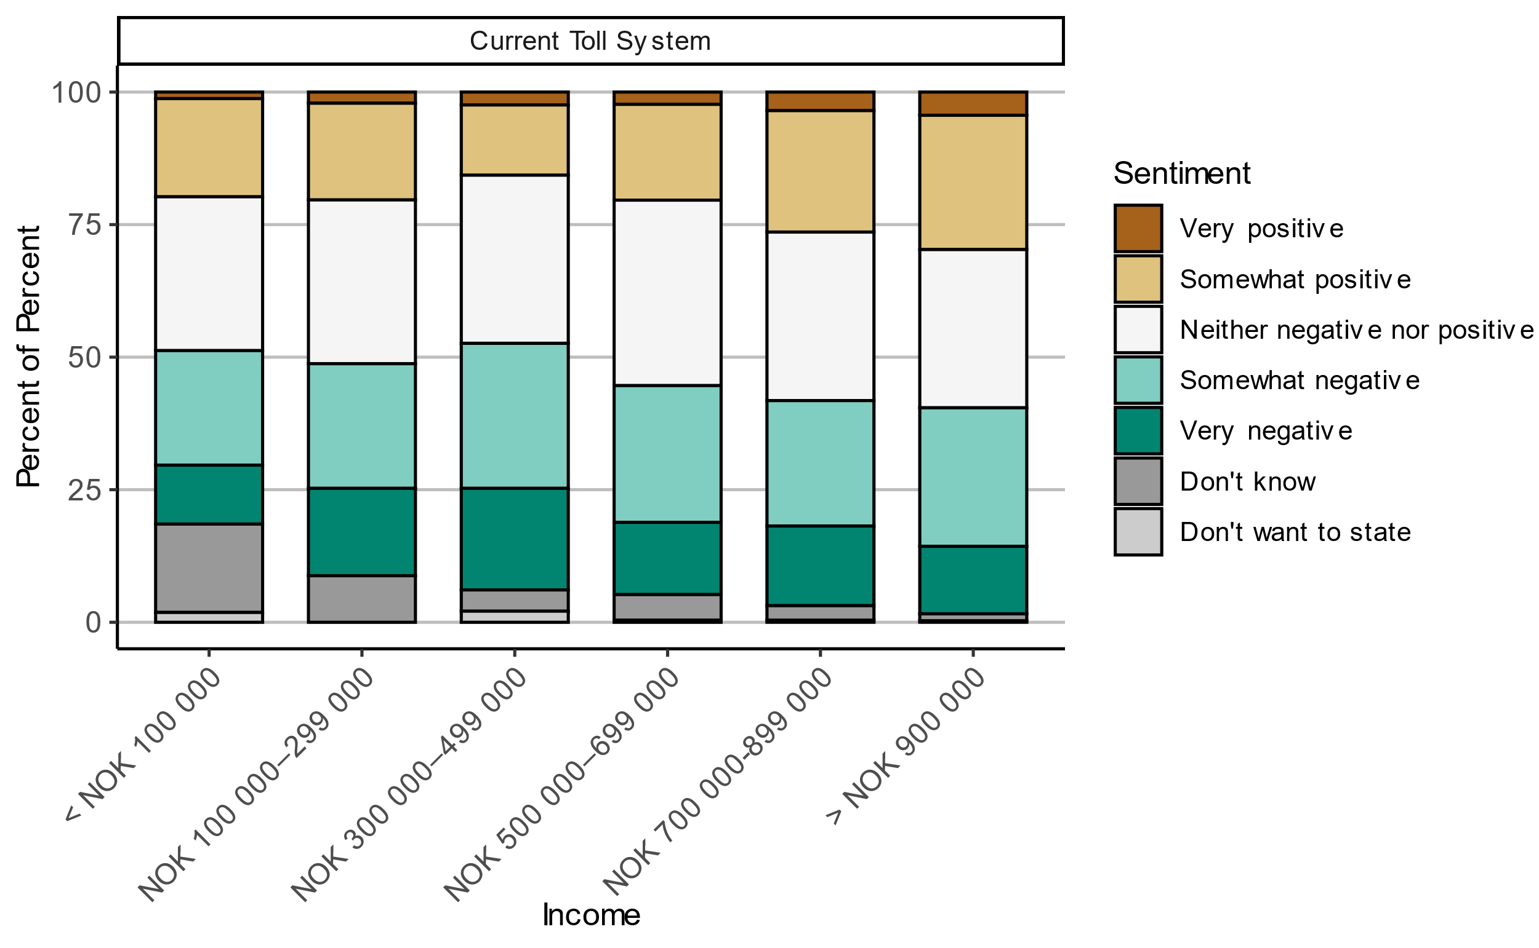

Figure 0.25. Attitudes towards current toll system by income, for the main survey.

TØI is an applied research institute that carries out research and study assignments for businesses and public agencies. TØI was established in 1964 and is organized as an independent foundation. TØI develops and disseminates knowledge about transport with scientific quality and practical application. The department has an interdisciplinary environment with 90+ highly specialized researchers.

The department conducts research dissemination through TØI reports, articles in scientific journals, books, seminars, as well as posts and interviews in the media. The TØI reports are available free of charge on the department's website [www.toi.no](http://www.toi.no).

The institute participates actively in international research collaboration, with particular emphasis on the EU framework programs.

TØI covers all means of transport and thematic areas within transport, including traffic safety, public transport, climate and environment, tourism, travel habits and travel demand, urban planning, ITS, public decision-making processes, business transport and general transport economics.

The Department of Transport Economics requires copyright for its own work and emphasizes acting independently of the clients in all professional analyses and assessments.

|  |  |  |
| --- | --- | --- |
| **Postal Address:**  Institute of Transport Economics Gaustadalléen 21  N-0349 Oslo  Norway  Email: [toi@toi.no](mailto:toi@toi.no) | **Business Address**:  Forskningsparken  Gaustadalléen 21  Web address: [www.toi.no](https://www.toi.no) | [cid:image001.jpg@01D0191A.2EFED0C0](https://emea01.safelinks.protection.outlook.com/?url=https://twitter.com/TOIforsk&data=02|01|Trude.Kvalsvik@toi.no|36774c3c73a54cc5d5de08d65f76d9f6|e55c13c2d2474bb4954020f3d1aed41d|1|0|636801361421835653&sdata=dPL0K/CxP34A0Onyg6VGfFS5iP%2BYOBc2dOYYJXe2r0E%3D&reserved=0) [cid:image002.png@01D0191A.2EFED0C0](https://emea01.safelinks.protection.outlook.com/?url=https://www.facebook.com/toiforsk&data=02|01|Trude.Kvalsvik@toi.no|36774c3c73a54cc5d5de08d65f76d9f6|e55c13c2d2474bb4954020f3d1aed41d|1|0|636801361421845662&sdata=VkAOG7ATwaa5oUnDYOCH6xEvHzZdzXidSsdOrz%2Bu5f4%3D&reserved=0) [cid:image003.png@01D194B0.7C0BFB50](https://emea01.safelinks.protection.outlook.com/?url=https://www.linkedin.com/company/institute-of-transport-economics?trk%3Dtop_nav_home&data=02|01|Trude.Kvalsvik@toi.no|36774c3c73a54cc5d5de08d65f76d9f6|e55c13c2d2474bb4954020f3d1aed41d|1|0|636801361421845662&sdata=CXH9z9XT8gkLwVCQUBraylI7Lu1iWdNxsSwxIg7bH68%3D&reserved=0) |

1. In the case of Norway, a pre-requisite was that road toll revenues should still be earmarked to road toll projects, even if the tolls are collected through the road pricing system. In our survey, we abstract from this and consider all revenues the same but explore public preferences for how the revenues should be used.
2. https://www.toi.no/aplanet/
3. In the Madrid version respondents were not asked about the location of the destination.
4. A sponsored Facebook post means that an organization (in this case, the Institute of Transport Economics) pays Facebook to display its post in the newsfeed of a certain number of users, also users that do not actively follow the organization. Users may be selected based on certain criteria. In our case, we targeted Facebook users in Norway.
5. It is noted that one respondent in the main survey indicated they were born in 1901, which is highly unlikely. However, the respondent’s other responses were reasonable, therefore we did not remove them from the sample.
6. In the survey, respondents are defined as employed if they report this as their main activity. (Those who combine education and part-time employment were instructed to report “Student”.) In official statistics, individuals are defined as employed if employment is one of their activities, also if they have other activities like education of receiving benefits.
7. Some respondents answered that the were planning to buy more than one type of car e.g., both a petrol car and a diesel car). Although the term used in the question was “planning” and not “considering”, it might be that respondents ticked several alternatives if they were planning to buy a car and were considering several options in terms of the type of car.
8. The electric share of new passenger cars in Norway sold in January-September 2024 is 88%. We do not have statistics on the electric share of used cars transactions, but the electric share of the entire passenger car fleet was 24% in 2023.
9. “The 10 largest cities, towns and municipalities in Norway”, Statistics Norway, December 2023. <https://www.ssb.no/befolkning/folketall/artikler/de-storste-byene-og-tettstedene-i-norge>
10. This investigation also considered a road pricing concept with three categories of areas: Major urban areas, other urban areas and rural areas.
11. There are a small number of trips that are not shown on the maps since they lie far outside the municipality boundaries. For example, points in Svalbard are not shown.
12. This implies that the definition of rush hour is subjective.
13. The drawback of this approach is that we exclude respondents who have zero calculated tolls but report positive tolls, but not those who have positive calculated tolls but report zero tolls. This implies that we exclude some respondents who over-report but no respondents who under-report their road tolls.
14. In Norway, all local elections take place at the same time every fourth year, two years after the national election.
15. One notable example is *The People’s Action No to More Road Tolls*, which received considerable support in some municipalities in the local election in 2019. However, this party only received 0,2% of the votes in 2023.
16. The Industry and Business Party was a new party in the 2023 election, and it is not obvious where to place it on the left-right scale. The party describes itself as centrist, but typically argues for lower taxes.
17. Since the two populist parties included here typically do not attack the economic elites in their rhetoric, one might suspect that the respondents perhaps did not consider economic inequality in a narrow sense when answering this question, but rather inequality and elitism more generally.
18. As shown in Figure 0.20 in the Appendix, we observe more very negative attitudes towards tolls in the pilot survey (~38% strongly disagree with “It is acceptable to pay tolls”) compared to the main survey (~15% have very negative views towards current toll system).
19. This means that for instance the price level in rush hour in urban areas could have a positive effect on support in one class, but a negative effect in another class.